Template for REF Contextual Information
1 | Researcher Name | Marice Cumber
2 | Output Title | Accumulate
3 | Output Type | Portfolio
4 | Output Description
Describe the work being submitted for assessment as distinct from the contextual information. If the output is multiple then the description should clearly identify each element and guide the reader in how to navigate them.

This is a portfolio submission. The portfolio is multiple and includes:

- Creative work produced on Accumulate workshops
Podcast recordings made by Accumulate participants
Photographs made by Accumulate participants
Publications made by Accumulate participants
Videos of participants producing creative work on Accumulate workshops

- Externally facing outputs and engagements
The Accumulate Website
Exhibitions of Accumulate participants’ work
Conference Presentations
Press and Media Coverage of Accumulate
Awards and Prizes for Accumulate’s Work
External Funding of Accumulate

- Feedback on Accumulate and Evaluation
Participant, Hostel Support Worker and Audience Feedback
Evaluation of Accumulate Project, Impact and Outcomes

These are also catalogued online here.

5 | Research Narrative
Please respond to each heading, using as much space as you needed:

5.1 Funding (What funding, if any, have you received; How much and who from? How was it awarded: by invitation, competition, open call, etc.? How many applications did the funding body receive? How was your application reviewed? Anything else you can think of that implies that your research idea was of significant interest to your peers?)

Funding
- Grants: These are “open call” grants awarded to Accumulate and the applications for funding are reviewed collectively by committee or board.
2019:
Simmons and Simmons Law Firm Grant: £10,000
Nesta Amplified Grant: £13,000
Morris Charitable Trust Grant: £3,000
The Schroder Charity Trust: £3,300
Greenhall Foundation: £2,000
St James Award: £2,500
2018:
RSA Catalyst Grant: £10,000
Haringay Council Grant: £1,260
Richard and Siobhan Coward Foundation Grant:£500
George Bairstow Charitable Fund Grant: £1,020
Morris Charitable Trust Grant: £5,000
2017:
National Lottery Grant: £10,000
Arts Council Grant: £8,100
Haringay Council Grant: £1,200
2016:
Haringay Council Grant: £1, 200
2015:
RSA Seed Grant: £3,500
2016:
2014:
Arts Council Grant: £4,000

- Corporate Funding

Burns Owen Partnership Funding 2016, 2018, 2019: £4,500 in total
Nano International Sponsorship of Accumulate Scholarship 2017: £4,600
Brickworks Sponsorship of Accumulate Scholarship 2018: £4,600
Straight Forward Design Sponsorship of Accumulate Scholarship 2018, 2019: £9,200 in total.

- Crowdfunding

In 2019, Accumulate succeeded in securing £18,000 via crowdfunding. This was to create The Book of Homelessness (graphic novel created by people affected by homelessness to be produced in 2020/21).

5.2 Introduction (Summarise the state of the art – i.e., what we knew before you started your research. State the puzzle, problem, question you sought to address. State briefly how you set out to answer your question. State in bold terms what you believe you achieved. Explain what lies ahead for the reader.)

It is widely accepted that the act of creativity encourages people to participate, which raises their self-esteem and wellbeing and makes them more open to change. All of this is important in improving people’s health and lifestyle. Participation in the arts also contributes to community cohesion, reduce social exclusion and isolation, and/or make people feel safer and stronger (Department of Health / Arts Council England, 2007, 2014, APPG 2018)
Arts projects exist in hostels and homeless support services and use creativity as a skill development tool and means of engagement for homeless people (these projects include Cafe Art, Streetwise Opera, Cardboard Citizens, Path With Art, Outpost, 240 Project). However, there is little, or no activity, in linking and transferring the creative capital of a creativity university environment with residents of hostels and those living in temporary accommodation.
This research paper, using the Accumulate project as a case study, will investigate the benefits for a group of young, homeless people who engage with educational courses delivered by a creative university.
The paper will cover how the Accumulate became established, its structure and delivery methodology, the measurable social impact it has made and how young, homeless people’s lives have been improved through their engagement and participation in the Accumulate programme and creative education.

5.3 Literature Review (Literature reviews are used to summarize what is known to date, identify gaps your study can fill, and build the evidence to argue for the necessity and relevance of your research. Critically assessing and appraising the literature, acknowledging the strengths and weaknesses of the available studies is important to explicate the rationale for your research and distill your research question(s).)

In 2019 With One Voice commissioned an International Literature Review on Arts and Homelessness which collected evidence and case studies of the impact of this activity on the target audience. The sources in this review were extensive and included government papers, reports and evaluations, academic articles, books and campaigning materials. The review focused on arts and homelessness activities run by artists, tutors, art therapists, youth/community and social workers and also by the participants themselves and evidenced the impact these made in relation to wellbeing, resilience, agency and knowledge and skills.

There was no reference to any arts and homelessness activities run by a creative based university and within a university environment - which the Accumulate project does.

Two of the main findings of this International Literature Review on Arts and Homelessness are

- We have not found any research on the impact of media coverage of the arts and homelessness on public awareness or opinions of homelessness.

- There is more literature on arts and homelessness activity with outcomes relating to increased wellbeing, agency and resilience than there is on activity that increases knowledge and skills. It may be that the volume of arts activity with the objective of increasing knowledge and skills is smaller than that involving the other three outcomes, but we do not know that to be the case.

The Accumulate project and research will evidence the impact made on the Accumulate participants and also the students from Ravensbourne University London who helped on its creative workshops. It will address how being involved with Accumulate changed the students’ perception on homelessness and who the homeless are. Evaluation of the Accumulate project will also focus on the creative knowledge and skills gained by the participants who self-measure their progress against these criteria.

5.4 Research Question (State what you seek to know from your particular research project.)

How can the collaboration and involvement of a creative university with the Accumulate creative project and activities positively impact on the homeless and the non - homeless and how can the knowledge and skills gained further improve the homeless participants’ lives?

5.5 Research Method (Explain how you went about answering your research question. Focus on the primary insight during the process; it is important to show that the research process was a thoughtful and reflective.)

Accumulate is a charity providing creative workshops to people affected by homelessness and was set up in 2014. Its establishment came about through making contact with the North London YMCA Hostel (NLYMCA). The NLYMCA hostel is located in the centre of Crouch End, an affluent upwardly mobile location, and the hostel accommodates 154 young people aged between 16 and 35 who are termed as homeless. The prime motivation behind this contact was to encourage creative activities for the residents at the hostel, with the knowledge that art-based activities provide a recognised, validated tool for self-development and improvement in well-being for people who are homeless (Arts Council, 2015).

The top three support needs of young, homeless people are not being in education,
employment or training (44%), a lack of independent living skills (41%) and mental health problems (35%)” (Homeless Link 2018). These issues are barriers to the NLYMCA residents being able to move towards independence and being able to move out of the hostel. Living long-term in temporary accommodation, such as the NLYMCA, also triggers adverse health conditions including depression, stress and anxiety, due to the insecure housing situation and living conditions, a lack of well-being and poor physical health due to bad diet from the food provided by the hostel canteen (Shelter, 2004).

The creative project and outcome that I proposed to the NLYMCA hostel in early 2014 was to facilitate creative workshops at the hostel and to put on an exhibition showcase afterwards. It was a very simple project proposal that was manageable, feasible and time specific. It was also crucial that the residents were involved from the very beginning, that they helped to shape the project and were able to own the project through their own involvement. This was all part of the user-led approach and customer focus that I was keen to encourage and which would become part of the learning process for the resident participants and their shift towards independence (Crutchfield and Grant, 2008). The residents chose the project’s name - Accumul8 (as there were 8 of them in the room and the hostel is in N8). Accumul8 has now become the Accumulate charity.

The residents at the NLYMCA hostel are classed as homeless and young people in this category are four times more likely to be NEET (not in education, employment or training) than their peers. They also suffer from poor learning skills levels, low confidence and minimal motivation and self-management abilities. Boredom and a lack of meaningful activities reinforce a sense of negativity and risks people opting to move back to living on the streets or returning to, or taking up, crime, drugs or alcohol. (Centrepoint, 2015; Homeless Link, 2012).
The initial project that Accumulate ran, was a one day pop up portrait photography workshop in the hostel canteen.
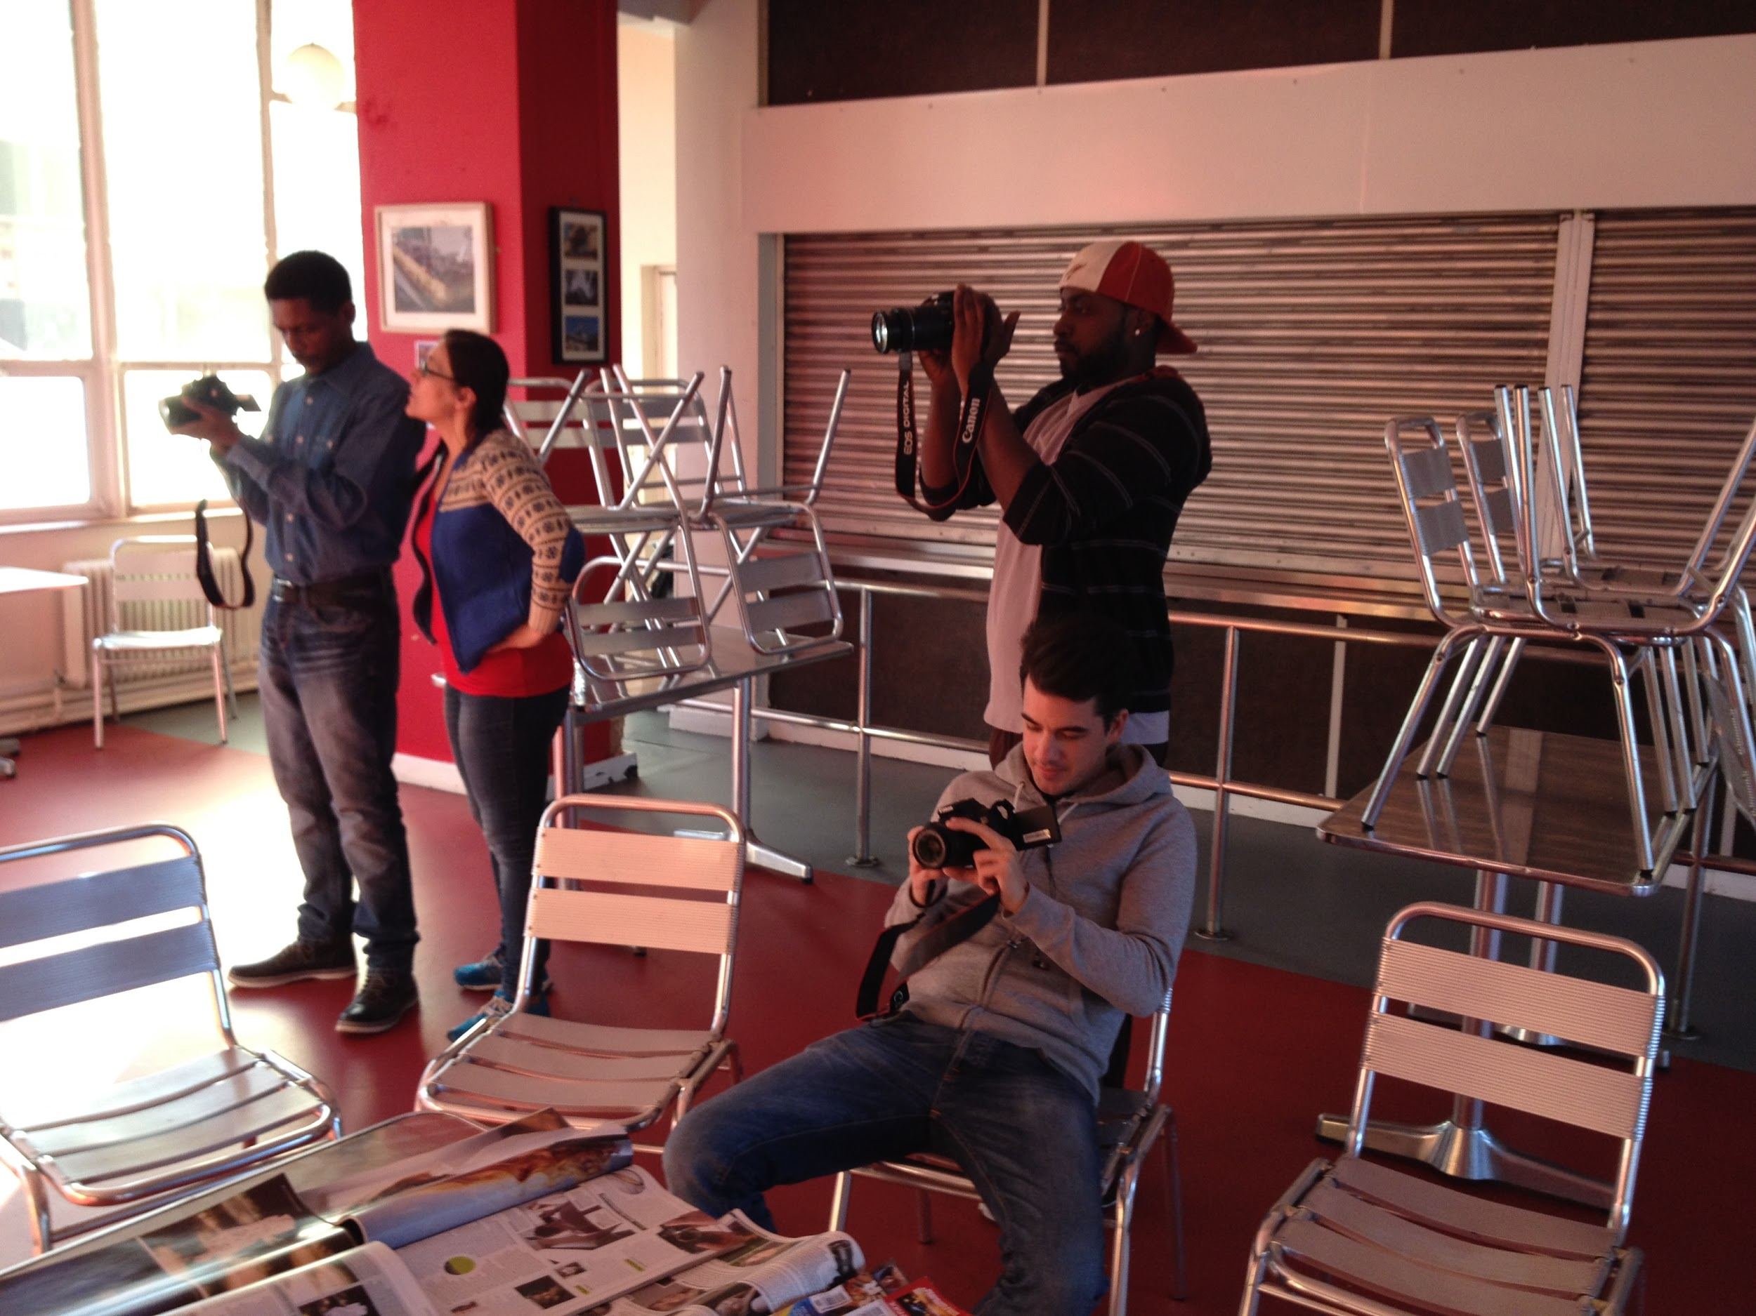
Accumulate Pop-Up Portrait Photography Workshop in a Hostel Canteen.

The residents were intrigued as to what was going on in their canteen space, wanted to take part, got involved and clearly enjoyed the activity and the group energy. Taking photographs provided an immediate participatory activity and my observation of the session provided me with understanding, insight and evidence that digital portrait photography offered more than just a creative activity to this group of young people, namely:

- It didn’t depend on whether someone was “good at art”, everyone could do it
- It was instant
- The photograph could be deleted if not successful
- It was private, just between the photographer and the camera, no one was going to be able to view the photographs if they were not successful
- Holding the camera and taking photographs was an empowering experience
- The photographer was taking control of the situation
- People enjoyed having their portraits taken
- It nurtured communication skills
- People were sharing and showing the photographs with each other
- A sense of well-being, confidence and value was realised by the photographer
- New skills were being taught that were transferable

Witnessing its success and the positive impact that this initial one-off session made provided the impetus to develop the Accumulate programme and provide courses in photography and other creative disciplines including fashion, film making, sculpture, ceramics, writing and drawing, podcasts and textile printing.

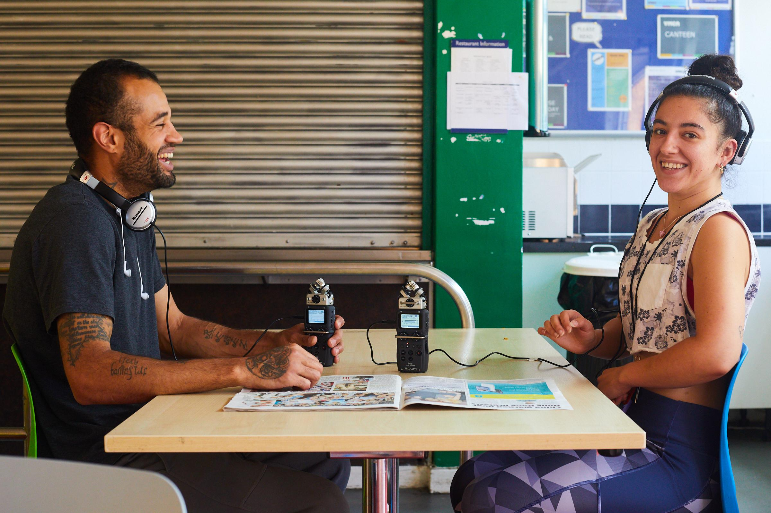
An Accumulate podcasting workshop at the NLYMCA hostel.

I am employed, part time, by Ravensbourne University London, a specialist HEI for the digital, design and creative industries. A casual discussion with a member of the outreach team led to the university supporting Accumulate as part of its outreach and social mobility remit (Ravensbourne 2015). As part of this arrangement, the university agreed to pay for student helpers and tutors for the Accumulate workshops and also lent Accumulate technical equipment, rooms and facilities.

There were obvious financial benefits to Accumulate through this relationship with Ravensbourne, and strategic benefits to Ravensbourne because, as a university, they could include their Accumulate support in their outreach and widening participation obligations. This support by Ravensbourne for Accumulate is reported in the university’s Access and Participation Plan that is submitted to the Office for Students.

However, through observing the student helpers and receiving their casual feedback, knowledge was being gathered that showed that it was not just the Accumulate participants who were benefitting from the Accumulate workshops. The Ravensbourne student helpers who facilitated the Accumulate workshops were also gaining wellbeing, confidence, knowledge and skills and they were gaining maturity and leadership qualities.

In order to test this further, the Accumulate project became a curriculum based activity where, for their assessment, the students would formally self- evaluate their learning experience and how the project had impacted on their knowledge and skills and perceptions of homelessness. These submissions have helped to inform the research outcomes of this project.

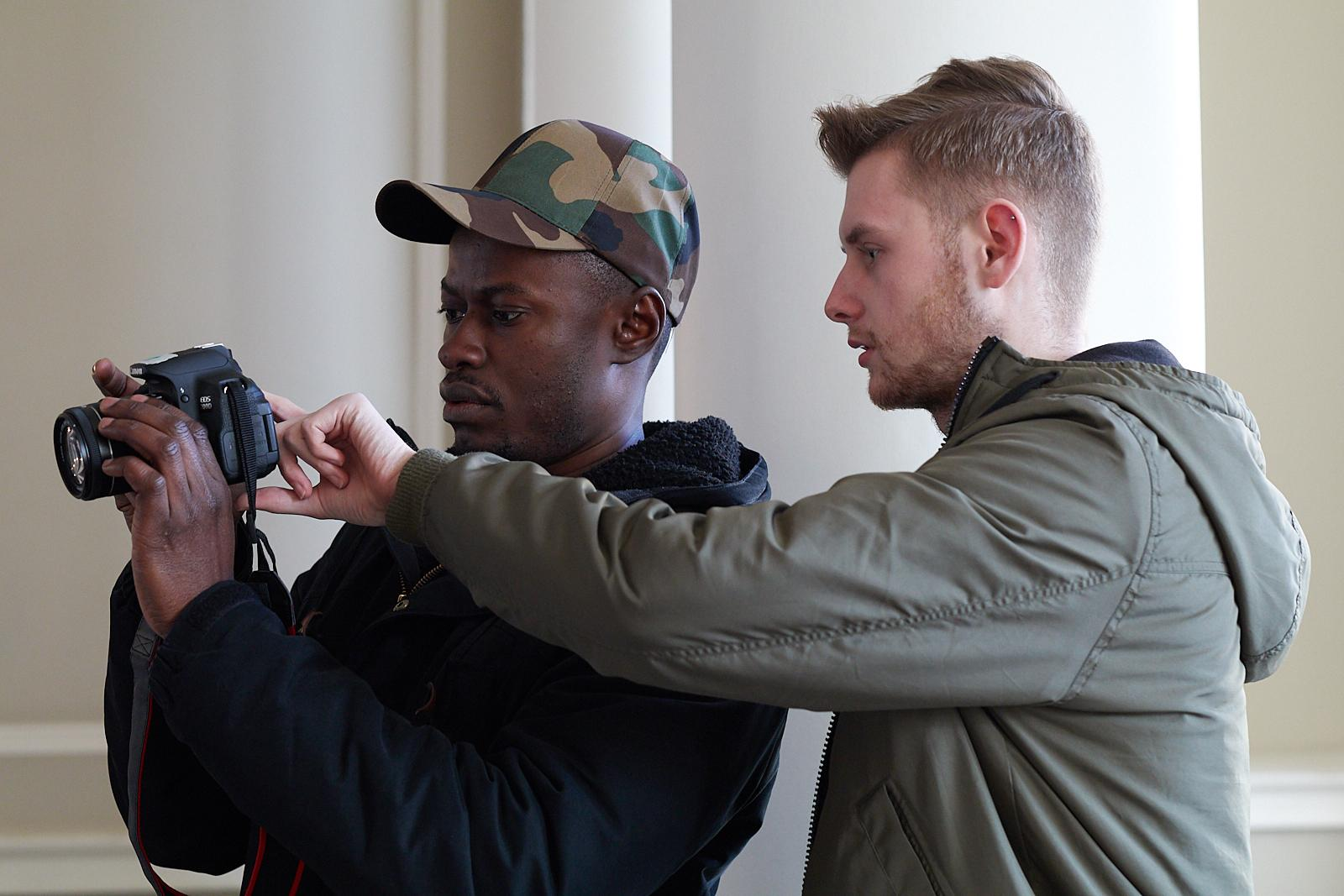
A Ravensbourne photography student assists an Accumulate participant.

Part of the outreach and engagement arrangement with Ravensbourne meant that some of the Accumulate workshops were held at Ravensbourne University London. This introduced the participants into a university environment and gave them an experience of what learning is like at this level. The purpose behind these Accumulate workshops at Ravensbourne was to hopefully inspire the participants to develop their creative knowledge and skills further and progress their education further.

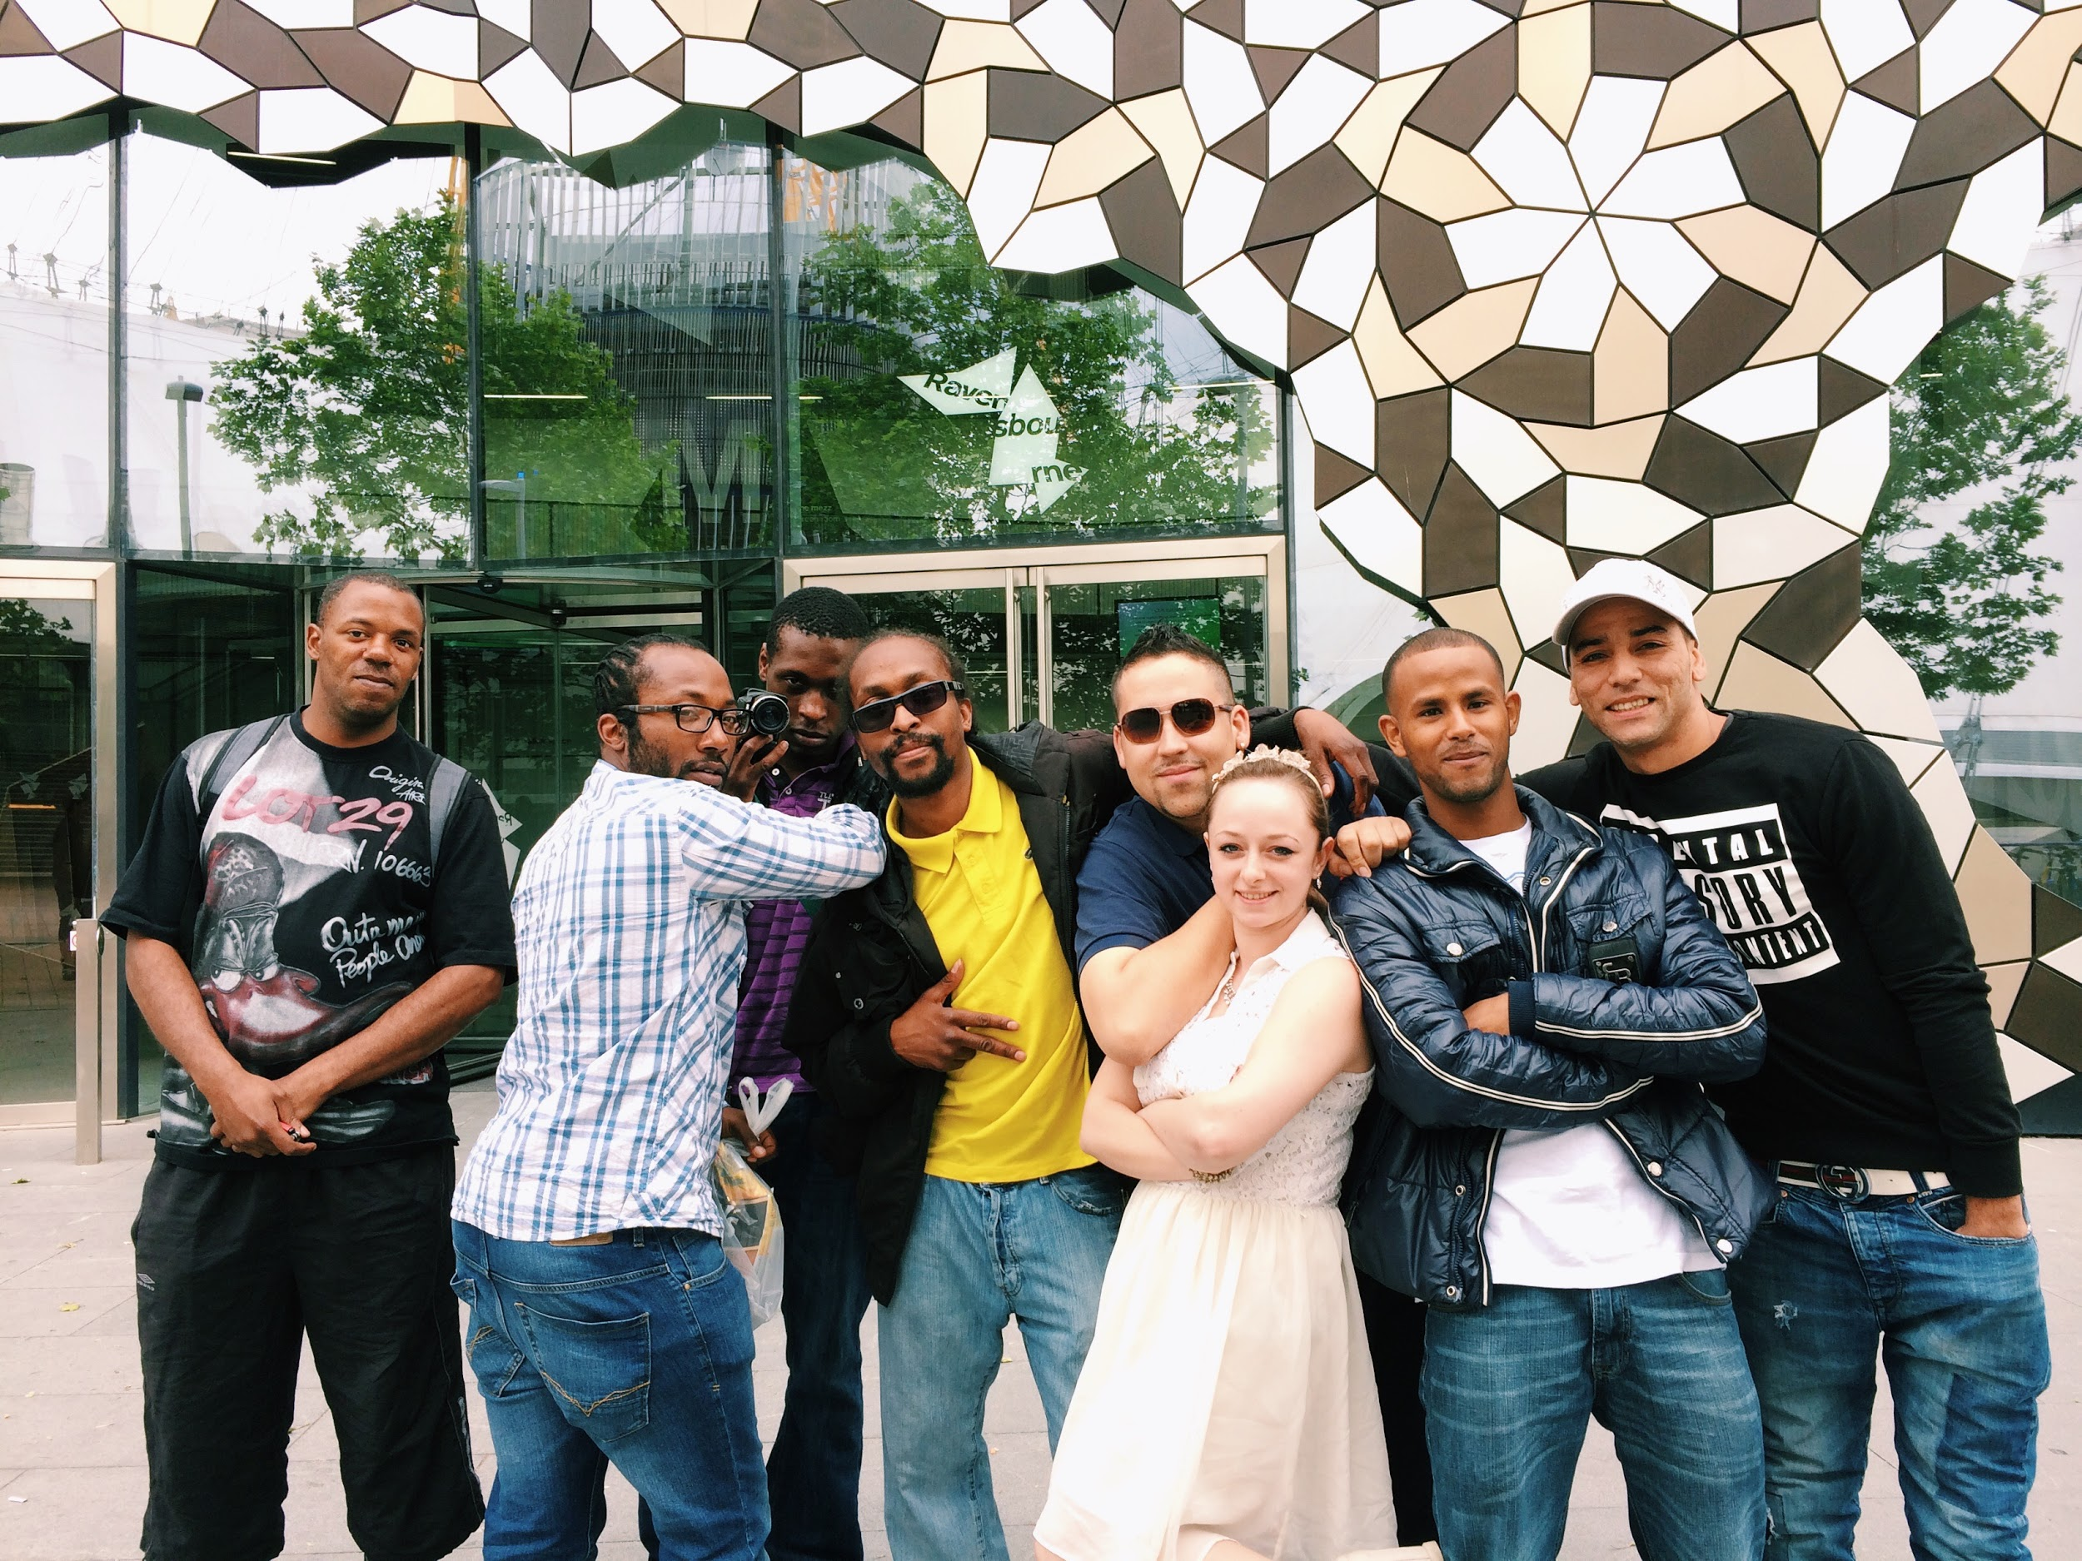
Accumulate Participants on a visit to Ravensbourne University London.

It became apparent that the biggest barrier to any of the Accumulate participants becoming a student at university is the cost of the fees and taking out a tuition loan, £3,600 for an Access course (if over 23 or with level 3 qualifications) and £27,000 for a degree. The Student Finance arrangement which stipulates that the loan does not need to be paid back until their income is over £21,000 p.a is irrelevant when you are trying to convince people, who have no parental support or financial security, are surviving on approximately £26 per week (after they have given £25 to the hostel as a rent contribution) and are living in temporary accommodation, to make such a steep financial commitment. As such, despite encouraging Accumulate participants to apply to Ravensbourne and develop their creative potential, no one actually ever applied. As a result of witnessing this barrier to education and knowledge and skills progression, in 2016 I set up the Accumulate Scholarship to fund Accumulate participants to study on the one year Access to HE course in Design and Digital Media at Ravensbourne University London.
The Accumulate scholarship is a significant project development and brings together the three pivots that anchor Accumulate and which drives its provision, concept, objectives and operation. Namely

- Empowerment
- Creativity
- Education

The Accumulate scholarship would enable an individual, who was once homeless, living in a hostel and who participated in the Accumulate project, to become a student at Ravensbourne University London. It would provide the learning to understand better if participation in the arts and creative activities and the Accumulate project could progress and develop the knowledge and skills of homeless people and overcome their barriers to education.
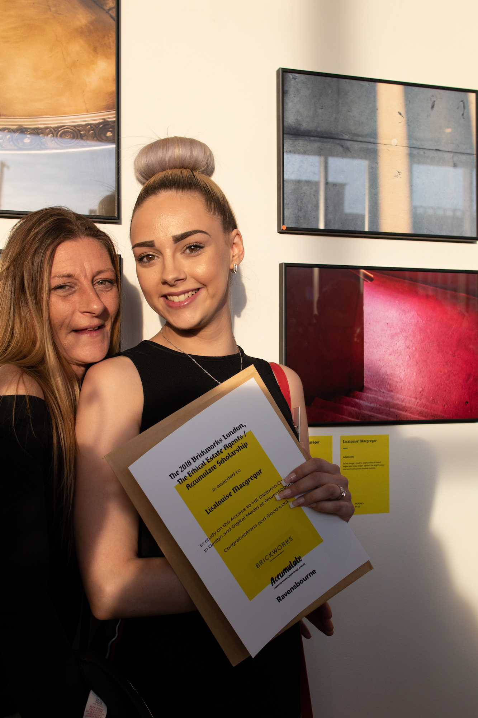
Lisa Louise Macgregor 2018 Accumulate Scholarship winner with her mother after being awarded the scholarship. Lisa Louise has progressed from the Access course and is now studying BA Photography at Ravensbourne. Image taken at Accumulate Exhibition 2018: The Guardian Building, Kings Cross.

5.6 Research Outcome (Explain the intended - and/or unintended - results of your research. What new knowledge and contributions have you brought to the field? What has/can be changed in your field as a result of this research?)

The Accumulate participants were gaining skills, confidence and well-being through their engagement with the Accumulate workshops and were gaining additional positive learning experiences through Accumulate working collaboration with Ravensbourne, which set it apart from other arts and homelessness projects. A formal evaluation in 2018 gathered more insight to understand where the triggers were and how much difference participation in Accumulate was making to these homeless people’s lives. This extensive evaluation gathered evidence of the impacts made:

SUMMARY OF IMPACT OF ACCUMULATE 2018 ON PARTICIPANTS:

Participants were asked questions and self - evaluated themselves against set criteria, creative learning development as well as skill gains.

Motivation
Motivation looks at the questions of resolve and pushing oneself, and feelings of enthusiasm. The results for these questions show overwhelming ‘Strong Agreement’ or ‘Agreement’ with statements of positive outcomes.

I feel like I pushed myself to produce good work.
- 84.2% of participants strongly agreed or agreed to this statement.

Similar outcomes were achieved for the statement Once I start something I like to finish.
- 94.7% of participants strongly agreed or agreed to this statement.

The majority had positive responses to I feel enthusiastic about my future
- 83.4 % strongly agreed or agreed to this statement.

Asked about Continuing to try, even when things go wrong,
- 84.2% strongly agreed or agreed to this statement.

The outcomes suggest that engagement in an ongoing activity is both sustained and motivated by having personal goals and a sense of purpose, and can lead to developing persistence and becoming forward looking. Answers to further questions suggest the importance of the social (including working in teams and learning from each other) and enjoyment elements as motivational.

Statements from participants regarding Motivation, taken from written feedback and aural commentary:
Jahmel (6:47-6:58) I’m going forward feeling very positive, looking forward…
Isaac (10:49) …the start of something good – I have the job now, opening the venturing for my future, having my own restaurant
Abubakar (3:30) I’m looking to have my photos in an art gallery… if I continue I am gonna be number one, so that’s what I’m hoping
David (5:00) I’m gonna get where I wanna go in life and nothing’s going to get in the way.
Nisha (15:00) I’ve lived most of my life in darkness… (I’ll) keep going towards the light.
LisaLouise (The Ravensbourne scholarship)… was a big incentive to work just that little bit harder…
Olive (booklet) I was committed to my own personal development on the project… My motivation gave me strength.

Self-Efficacy
The questions of self-efficacy, or ability to believe in one’s capability, formed the largest section and overlapped with Motivation, but also included questions about making decisions about development, confidence and time/self-management.

I use my time well
- 94.8% strongly agreed or agreed to this statement.

I feel happy to be involved in creative activities, even if my other friends aren’t interested
- 100% strongly agreed or agreed to this statement.

I usually do what I think is best for my own development
- 94.7% strongly agreed or agreed to this statement.

I feel good about myself
- 100% strongly agreed or agreed to this statement.

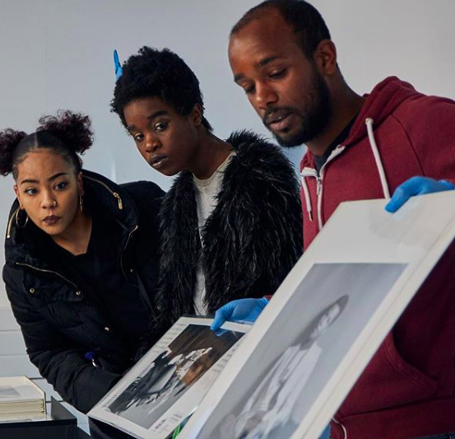
Accumulate Participants learn about black history at an archive session at Association of Black Photographers.

Statements from participants regarding self-efficacy
LisaLouise (booklet) Accumulate has really helped me realise what it is I want to do later on in life… as time has gone by I’ve become more comfortable and confident… it has helped me take bigger steps to getting over my anxiety issues.
Peter (1-1.49): Definitely boosted my confidence… I’ve made loads of new friends, talk to loads of new people.
Zakariah (4:70) Every week I learn more and more… it has changed for me everything.
Ahmed (5.33) I was scared it was too hard to take pictures… but it’s getting better now.
Olive (11:40) I have gained back my confidence – I don’t want to miss it, it helps me move on. I feel proud of myself.

The outcomes suggested a transformation in some degree in each of the participants responding. There is a spread across the question regarding time management, however, there are indications of learning about self-management for most. Time will tell if the positive attitudes and outcomes will be sustained and the extent to which resilience and self-efficacy traits will persist. However, the opportunity to experience self-efficacy has been indicated as having an impact on future actions and developments.

Creativity
The questions in this category asked about attitudes towards creative activity and development of skills related to creative thinking, criticality and participation.

I feel proud to have made something myself
- 100% strongly agreed or agreed to this statement.

I like being able to express my own ideas
- 100% strongly agreed or agreed to this statement.

I could use my imagination to solve problems
- 100% strongly agreed or agreed to this statement.

I was able to think for myself in the project
- 94.8% strongly agreed or agreed to this statement.

The outcomes suggested that being involved in creativity was a significant factor in transformative learning and developing individual’s agency and empowerment. Experiential learning, in particular learning through making, has been shown to be deeper and more long lasting. Participants indicate through the survey and interview responses about the photography course that they valued these opportunities and in some instances felt they have been life and world view changing.

Statements from participants regarding creativity
Zakariah: When you take a photo you can say about what’s in your mind, you know, what you feel.
Jahmel – I was just hoping to find new knowledge or new experiences… I found a new love basically because it’s another way I can express myself… it’s tapping into my artistic side.
Anushan – I learned how to explain myself by the photos… I’m thinking how can I show the world who I am.
Max – With photography we can see the world differently… this project has taught me about photography and how it is an art.
Yuan – The Accumulate workshops have… provided me with much needed creativity and a supportive structure without putting me in any box but allowing me to develop freely.

Specific Technical/Transferable Skills
The Accumulate participants responded to statements regarding the development of their technical and transferable skills, results as below:

- I feel confident in the technical aspects of photography
63.3% strongly agreed or agreed to this statement.
- I feel confident in communicating with other people
78.9% strongly agreed or agreed to this statement.
- I feel confident in relating to other people
84.2% strongly agreed or agreed to this statement.
- I enjoy working in a team
79% strongly agreed or agreed to this statement.

The anecdotal data below also suggested that the impact on participants has been around discovery of photography as a medium for viewing and interpreting the world and ‘photographer’ as a creative identity.

The transferable skills are also noted as having significant impact in communication, building relationships and working in a team. All of these are essential personal skills requirements for employment. Participants have also noted this as significant in overcoming anxiety, fear and isolation and are experiences and skills that they can take forward.

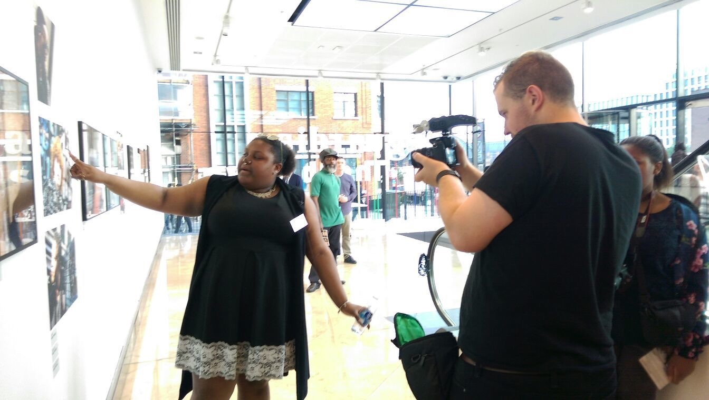
Accumulate participant, Jamilla Ford-White, talks about her work at the Accumulate Exhibition, 2016, The Guardian.

Statements from participants regarding skills
Lisalouise – The course has helped me better myself, not just my photography.

Patricia - I very much enjoyed the course, the vast differences of opinions and you know a whole group of people can take a picture in the same place as we've proven and everybody's picture is telling a different story.

Anushan- I'm not much of a talker so I want to show my feelings and everything by the photo so now I can talk like 1 2 1 like 2 to 1 but I can't talk with all people a lot of people… Nowadays I can stand and talk by my photo (in the exhibition).

Peter – Before if I was in a big group I wouldn’t speak to anyone, but now I’ve made loads of new friends, talk to loads of new people.

Learning gathered from a far longer programme in 2018 and with a more diverse selection of creative activities helped to inform the learning for the future development and plans of Accumulate.
As a result of this, in 2019 the Accumulate course delivered over five creative disciplines and with five partners. It could be termed as similar in thinking to the rationale behind an arts foundation course where students experiment and explore their creativity in a broader context with the aim of them selecting one option for a degree option.
These disciplines and external partners were as follows:
- Photography: Autograph, Association of Black Photographers
- Fashion: Somerset House and Levi’s
- Zine making: Youth Club Archive
- Sculpture: The BBC and Art UK
- Podcasting: Ravensbourne University London and Nesta
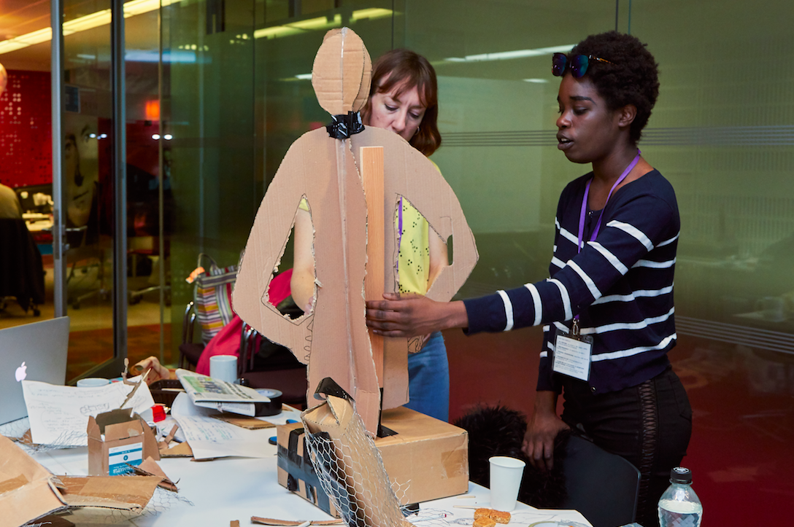Accumulate Sculpture Workshop in Collaboration with The BBC and Art UK.
It also became evident, through observation and informal discussion, that participants became more connected to the project over time, that they were building strong friendship bonds with each other, and the students who were facilitating the sessions, over the duration of the course and their resilience and ability to experiment through trust increased. This trust was evidenced in the willingness of the Accumulate participants to try yoga, which was beyond the perceived comfort zone, but showed how much their confidence had increased and that they trusted and were comfortable with each other to the extent of trying something new, a physical art form, and being able to experiment and explore their creative abilities further. A sense of “safe place” was created, that was not to do with their personal circumstance but due to their interest in creative learning and personal development and wanting to explore this further.
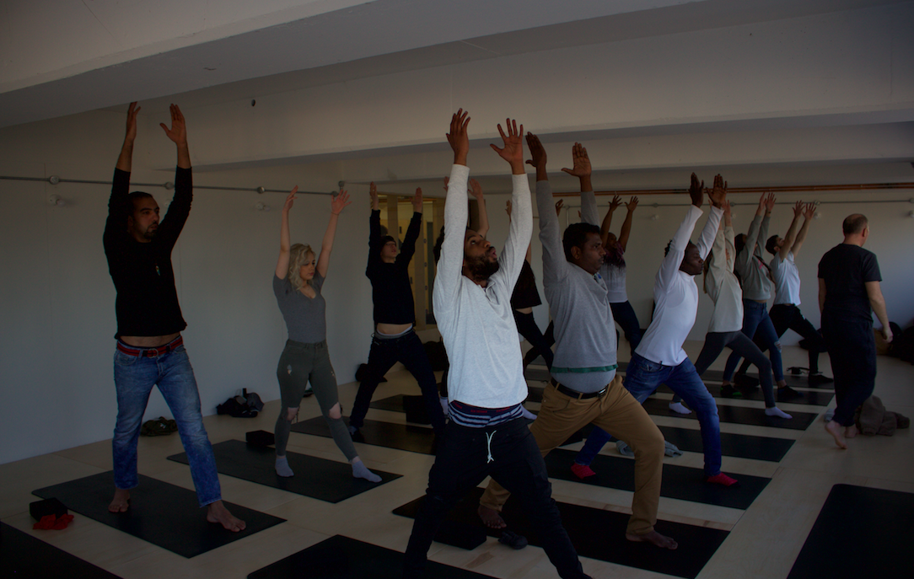
The Accumulate Participants doing Yoga at Peckham Levels Studios.
Students from Ravensbourne had always helped on the delivery of the Accumulate workshops. The process for recruiting these students was via talks on the project that were delivered to 2nd year students. The Accumulate student helpers were paid for their input.

However, it was the outgoing, confident students that were getting involved with Accumulate or those that didn’t have ongoing external obligations (caring or working) and so had the time available. The benefits to the students that did get involved with Accumulate, went beyond financial. They too were building their confidence, gaining leadership, organisation and team skills and were able to add community related experience to their cv which would give them an advantage if they wanted to persue work in this field. More needed to be done to ensure a wider group of students could benefit from engaging with Accumulate and the skills development.

In 2019, the Accumulate offer for students was reconfigured and converted into a curriculum based course for second year students would receive 15 credits for. This innovation opened up the Accumulate project to a wider student demographic and across all courses. The students were assessed on their learning and reflection on their engagement with this project. The uniform learning and reflection across all students was that the realisation that the young people on the Accumulate project who were classed as “homeless” were no different to them and the only difference that the students felt that they had was “opportunity”. They understood more about the extensiveness of homelessness, that it is not just street homeless and that a passion for creativity can build communities across groups that would not normally be in contact with each other or even friends. The skills they cited as having developed through their engagement with Accumulate included self-discipline, time-management, organisational skills, project management and delivery, communication and team-work. All valuable assets for the students to include in cv’s, use as examples in interviews and use in the workplace. The students that were involved with Accumulate understood more about social action, how creativity can produce social good and how their skills can be used to improve people’s lives, for some it even influenced their career decisions to consider teaching, youth and community work as a career.
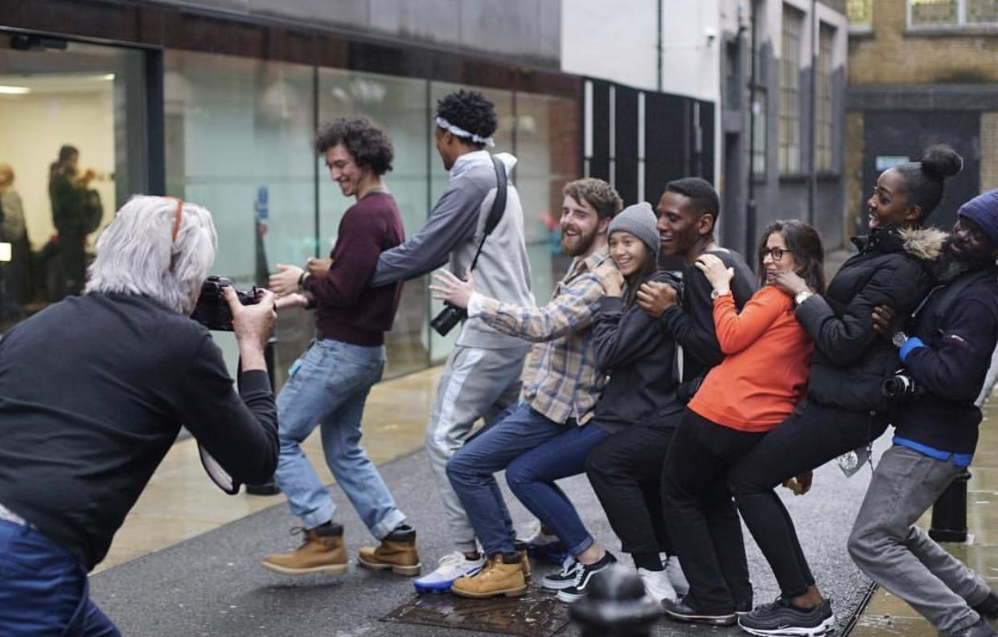
Ravensbourne Students and Accumulate Participants together at The Autograph Gallery, Shoreditch.

Student Feedback on their involvement with Accumulate, Quotes taken from their assessment self-evaluation and across key learning areas.

Changes in Perceptions of Homelessness

“Before starting Accumulate I had a very closed mind when it came to the concept of homelessness. When I thought of homelessness, I always thought of the people who sit out in the streets of central London begging for money. However, little did I know there are different forms of homelessness out there. Accumulate introduced me to people who are living in hostels and temporary accommodation in London. I found it inspiring to hear their stories and the things that affected how they lived their day to day lives.”
“When I first started on this project, I'm embarrassed to admit my ignorance of understatement on the reality of homeless people. When I thought of homeless people the only thing that would pop up to mind was of beggars on the streets or even refugees that couldn't speak the local language. These people, yes, are homeless, but I failed to identify a much more common category of homeless people, and they are people just like me, that didn't have as much luck as I did. “
“The discovery of the participants, their experiences and their attitude towards the opportunity offered stunned me. They were highly involved and expressed interest in all the fields, pitching and developing very inspiring ideas from a unique perspective.”
“My thoughts changed drastically. The discovery of the participants, their experiences and their attitude towards the opportunity offered stunned me. They were highly involved and expressed interest in all the fields, pitching and developing very inspiring ideas from a unique perspective.”

Personal Impact
“For me personally this elective helped me expand my vision, working close to those people who are trying to do the same as me, even coming from a harder background and less tools.”

“As someone who personally suffers from depression it helps put into perspective how sometimes my thoughts need to be present and be grateful for what I have as things could be a lot worse.”
“By attending these workshops it’s also encouraged me to make time for my own creativity like drawing and photography which I used to do when I was younger.”
“I loved it! I could discuss with them or help them with the camera and used the knowledge that Othello taught me 3 years before, and I had this enjoyable feeling to believe that in 2-3 years they might be doing the same thing as me, sharing the tips that I was providing them at that time.”
“While I was working on this project, I wasn’t in one of my best personal situations and the challenge this project has supposed to me, has served me in a way, as a therapy, as I had focused on learning and experimenting in a new artistic way which has helped me going through it.”
“I left each session feeling that I did something fulfilling as I was helping people who had a journey that was less fortunate than mine and doing this could have somebody’s day, month and life have such an impact that it can make their journey for them a better one in the coming future it’s a great feeling.”
“I had met so many people that didn’t give their best or did not care about their work because they had a fall back plan that they could do if they didn’t pass or worst case scenario they could just move back in with their parents until they could find work. However, whenever these participants were given a task from one of the lecturers, they fully committed to it and were very focused on their work.”

“When I began working with Accumulate I was very shy and found it hard to talk to anyone unless it was necessary. However what inspired me was the fact that they looked to me to help them.”

Skills and Employability Development
“For a lot of the participants, and myself involved, communicating ideas with a lack of self-confidence seemed like an impossible task. Yet, with the guidance and support of everyone in the room, we all managed to help one another voice our own creative ideas.”
“My participation has taught me new skills in a range of creative areas through adapting, teaching and learning from all those in attendance.”
“By being assigned duties that may have first seemed small, such as picking up lunch, collecting and returning kit, taking the register, I have now learned the importance of every single operational element to make a functional and successful product.”
“As a film student it was super important for me to take each task with confidence and work well with absolutely anyone. The more I worked with these new people the more I was able to radiate confidence and leadership which has been super helpful for me.”

“When I began working with Accumulate I was very shy and found it hard to talk to anyone unless it was necessary. However what inspired me was the fact that they looked to me to help them.”

“ Accumulate has allowed me to develop better leadership skills as well as the diverse grouping and workshop topics has allowed me to freshen up some old skills like camera technical terms and composition of a good photograph.”
“I am now able to confidently communicate original ideas and support others to create their own.”
“I also improved the following skills: social and practical skills, time management and organisational skills, how to problem solve, team management which will help me with my creative discipline. “
“I gained various skills that I could apply to my future career. I have improved on my conflict management and team management skills. I also developed my teaching skills during this course. A fair few attendants came to me looking for technical advice or for solutions to technical problems they were having. This forced me to try and think of ways that I could explain what they needed to know without overburdening them with technical words that they would not understand.”

“One of the final things I have realised during this elective is the importance of putting yourself out there. Whenever I was given the opportunity to help out in any extra ways during the workshops, I immediately jumped on it.”
“Being able to come out of my comfort zone and help lead, assist and support diverse groups in creative areas that I am both passionate and new to has given me life-long skills that I can apply to both my daily life and my future endeavours. It has given me team management skills alongside encouraging creative ideas of styling as seen within all the workshops topics. “
“The more I worked with these new people the more I was able to radiate confidence and leadership which has been super helpful for me.”
The benefits of creativity.
“I am able to also understand the need to encourage people to be creative as it’s the best outlet for most situations and how it can sometimes even just help organise your thoughts and emotions.”
“I understand now that the arts can improve your mental health and wellbeing by empowerment and self-identity.”

“People of all types need art.”
“By the third Photography workshop it was beginning to feel like there was a real sense of comradery with all the attendants as they shared ideas with each other and worked off of them. It was incredible how these workshops were able to allow people to come out of their shells and express themselves openly with others.”

Change in Career / Employability

“Doing this elective has been one of the most rewarding projects I have done so far with my time at Ravensbourne. Because of this, I may decide to search for jobs like this in the future, paid or voluntary. I had a lot of fun working with people and would enjoy doing it again given the opportunity.”

“Before joining the process, I knew that my abilities and expertise were useful in certain areas but I did not know how much they could be applied to those outside of commercialised industries.”

“I have thoroughly enjoyed tutoring and assisting others in creative areas by giving technical and conceptual guidance. So much so that I aspire to continue to do so within my future whether this be by continuing workshops or considering a career later on in teaching creative subjects.”

The development of the Accumulate Scholarship Programme:

The plan to set up the Accumulate scholarship was to overcome education and financial barriers for young, homeless people to be able to progress their creative education at university level. However, despite my enthusiasm for this scheme, there was no track record or indication that it could be a success and whether Accumulate participants had acquired the correct level of ambition, knowledge and skills to be able to persue this opportunity, be accepted onto the Access course at Ravensbourne and fulfil all the academic course requirements to pass the course.

Through the Accumulate scholarship scheme, the following creative education progressions has actually happened:
2016: 1 Accumulate participant became an Access student at Ravensbourne
2017: 4 participants became Access students at Ravensbourne with 1 progressing on to a degree
2018: 4 Accumulate participants became Access students with 1 progressing onto a degree
2019: 4 Accumulate participants became Access students with 2 progressing onto degrees.

The Accumulate scholarship means that a young, homeless person can advance the knowledge and skills they gained on the Accumulate course and become a student at Ravensbourne. They also have the option of becoming an Accumulate student helper for the next group of Accumulate participants attending the Accumulate courses. Through this system, the Accumulate graduate can give back and share their skills and knowledge to future Accumulate participants - creating more social impact and knowledge transfer through the Accumulate model of using creativity as a tool for empowerment and personal fulfilment.

This innovation of scholarship provision and support sets the Accumulate project apart from other arts and homelessness projects. It focuses completely on knowledge and skills, how these are progressed, gained and transferred by the Accumulate participants. It is a unique example of the value and impact of Accumulate in collaborating with a creative led university to use and exploit its creative capital to encourage disenfranchised, non-traditional and marginalised individuals into Higher Education, advance and progress their knowledge and skills and create positive life transition, social impact and good that did not exist before.

5.7 Conclusion (Summarise the project as a whole; this is essentially a repetition of the introduction, the first being in the future tense and the conclusion in the past. Make sure that you finish it with a repetition of what contribution your project has made to understanding and what might be the next research step.)

This research paper, which used the Accumulate project as a case study, investigated the benefits for a group of young, homeless people with educational courses delivered by a creative university.
By covering how the Accumulate became established, its structure and delivery methodology, the measurable social impact it has made and how young, homeless people’s lives have been improved through their engagement and participation in the Accumulate programme and creative education, it has shown that universities can enhance and add value to the existing provision of arts and homelessness projects and workshops. By linking and transferring the creative capital of a creativity university environment with residents of hostels and those living in temporary accommodation larger gains can be achieved. These gains were not just for the participants, but for the university students who helped on the workshops and for the university who increased their outreach activities, widened participation and the diversity of student in take. All of this, will ultimately benefit the sector and creative industries as a whole.
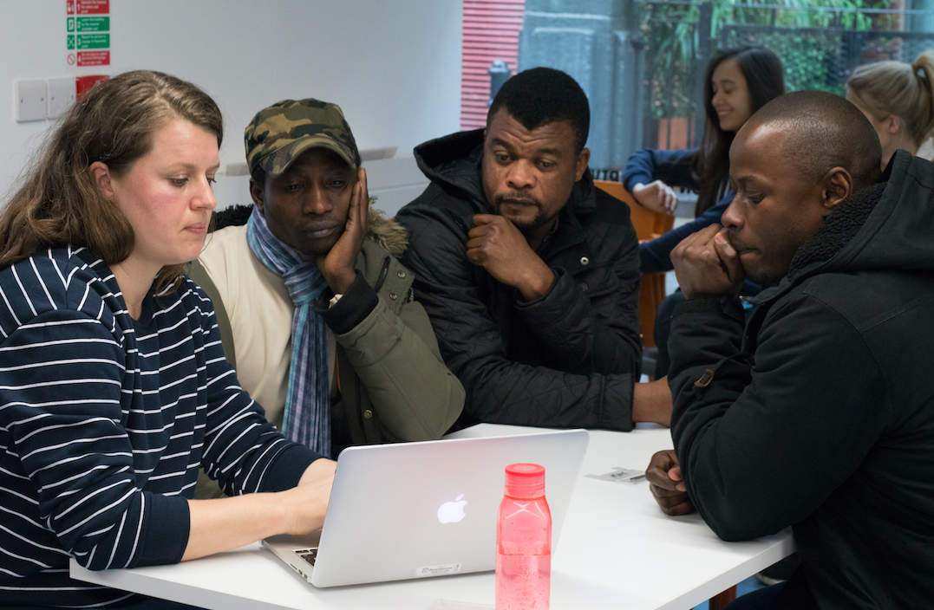
Ravensbourne Photography Tutor, Celine Marchbank, giving portfolio reviews to Accumulate Participants.

My own learning gathered through the process of running and innovating within the Accumulate project has taught me about the eagerness of learning from the Accumulate participants. They knew they were gaining knowledge and skills and wanted to secure more. It was also apparent that through Accumulate offering a more diverse selection of creative disciplines that the project was functioning as an informal learning provider delivering a similar offer as an arts foundation course. In order to reflect this new learning provision and the Accumulate participants’ level of engagement over more ambitious, longer and challenging creative courses, it was decided to rebrand Accumulate as The Art School for the Homeless. A more apt description of what was being offered, the level of tuition being provided and the learning experience gained.

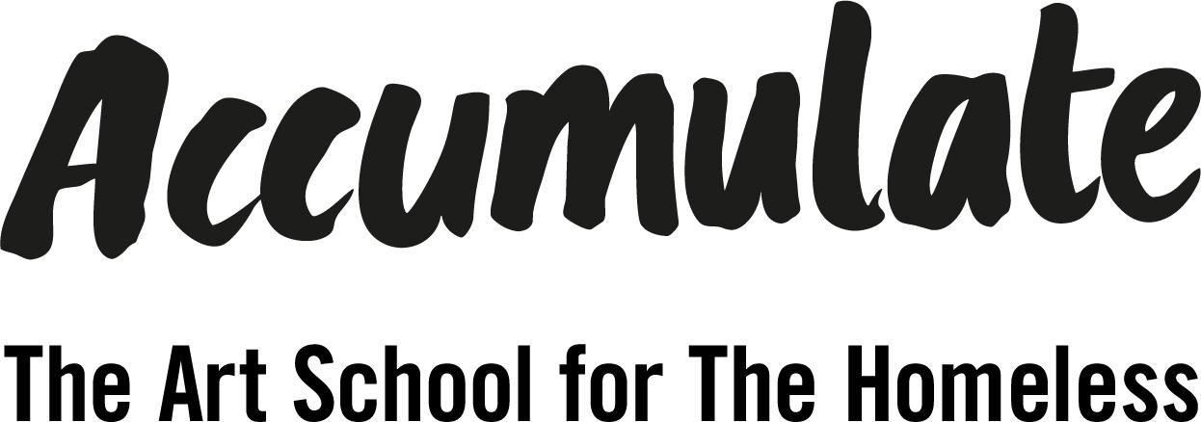

6 Dissemination
(Conventional outputs, being stamped with international ISBN and ISSN numbers, are accessible from anywhere in the world. The public exchange of creative outputs, however, is typically localised and temporary. So, how have you gone about widening the audience for you work – e.g. additional exhibitions, artists’ talks, invited presentations, reviews and critical receptions etc.?)

Exhibitions of Accumulate Participants’ work produced on Accumulate creative workshops:
2020: Exhibition “No Judgement”: London Art Fair
2019: Exhibition “Youth Culture”: Autograph
2019: Exhibition “Accumulate is 5”: London Art Fair
2018: Exhibition “Decay 3” House of St Barnabas
2018: Exhibition “Displacement”: The Guardian
2018: Exhibition “Decay”: London Art Fair
2017: Exhibition “Made By Us”: The Guardian
2016: Exhibition “Moving Forward”: The Guardian
2015: Exhibition “Living on the Edge”: Hornsey Town Hall
2014: Exhibition: North London YMCA Gym Reception

Films of Accumulate Creative Workshops, work made on workshops and Exhibitions:
2020: Accumulate - making of Sound Judgement podcast channel
2019: Accumulate - Fashion Collaboration with Ted Baker
2019: Accumulate - Art School for the Homeless
2018: Accumulate Exhibition “Displacement”: The Guardian
2017: Accumulate - Using creativity to empower young, homeless people
2016: Accumulate Exhibition “Moving Forward”: The Guardian
2014: Accumulate Exhibition at North London YMCA Hostel

Film of Accumulate participants talking about the work they produced on the workshops:
2018: Participants talking about their work and the impact of Accumulate

Publications made by Accumulate participants:
2019: Decay Zine, issue 4, made in collaboration with Youth Club Archive and Accumulate participants.
2018: Decay Zine, issue 3, made in collaboration with House of St. Barnabas trainees
2017: Decay Zine, issue 2, made in collaboration with Evolve Housing Residents
2016: Decay Zine made in collaboration with North London YMCA Hostel Residents

Podcasts made by Accumulate participants:
2019: Sound Judgement: 6 Episodes

Films made by Accumulate participants:
2015: “Warm Day in Haringay” (made with London Met University)

7 Reception
(How has your work been received - e.g. awards; prizes; invitation to show work; invitation to talk about your work; invitation to apply for funding; critical reviews, essays, etc. further funding; anything else.)

Awards:
2018: Festival of Learning: Highly Commended
2018: Creative Review: Creative Leader
2016: Social Entrepreneur of the Year: Leadership Awards
2015: Point of Light Award, Prime Minister’s Office

Conferences and Invitations to speak about Accumulate:
2020: Creative Change Makers: Creative Conscious
2019: Rights in Focus: Autograph
2018: Social Making: Plymouth College of Art
2018: Mini Making: Plymouth College of Art
2018: Homelessness: The Design Museum

Press Coverage:
2020
The Big Issue 2020
2019
The Big Issue 2019
Stylist Magazine 2019
The National Student 2019
Verge Magazine 2019
Accumulate collaboration with BBC and Art UK: BBC website 2019
BBC London News 2019
The Evening Standard 2019
2018
Creative Review 2018
Creative Review 2018
Creative Review 2018
Shutterhub 2018
The Guardian 2018
2017
The Guardian 2017 (4 page spread)
The Guardian 2017
Wallpaper Magazine 2017
Creative Boom 2017
Creative Review 2017
2015
The Guardian 2015
Media Coverage documented on the Accumulate Website

Young Men’s Christian Organisation, a Christian faith organisation that provide temporary accommodation to both men and women along with other services, such as gyms, to the general public.
NEET is an acronym for young people who are Not in Education, Employment or Training
See https://www.gov.uk/repaying-your-student-loan/when-you-start-and-finish-repaying

