© 20XX IEEE. Personal use of this material is permitted. Permission from IEEE must be obtained for all other uses, in any current or future media, including reprinting/republishing this material for advertising or promotional purposes, creating new collective works, for resale or redistribution to servers or lists, or reuse of any copyrighted component of this work in other works.

Triple Helix in Higher Education in the U.A.E.: Current Standing and Research Directions
Dimitrios Xanthidis,  Computer and Information Science  Higher Colleges of Technology  Dubai, U.A.E.  dxanthidis@hct.ac.ae  https://orcid.org/0000-0002-1349-5749 | Christos Manolas,  The Screen School, Media Works  Ravensbourne University  London, U.K.  xmanolas@gmail.com  https://orcid.org/0000-0003-0057-8374
Ourania Koutzampasopoulou Xanthidou,  Computer Science and Information Technology  University of Malaya  Kuala Lumpur, Malaysia  xarania@gmail.com,  https://orcid.org/0000-0002-2659-7138 | Sujni Paul,  Computer and Information Science  Higher Colleges of Technology  Dubai, U.A.E.  spaul@hct.ac.ae  https://orcid.org//0000-0002-4863-1333

Abstract—The observation that the skills and attributes of Higher Education graduates in the U.A.E. are not matching the requirements and needs of the local industry and government is rather common and publicly expressed on several occasions. This has a number of implications in the local job market, with the most obvious of being that the management of the local businesses, especially the large ones, are hesitant to hire graduates. One of the questions arising from such a situation is whether the local Higher Education Institutions (HEIs) offer the correct curriculum in their programs in order to meet the needs of the local industries and government organizations. The aim of this study is to contextualize the current standing of the main pillars of Higher Education in the country, namely: accreditation of the local educational institutions, the educational institutions themselves, the local industry and businesses, and the local society in its entirety. Based on this foundation, it is expected that this study will function as a guide for more thorough and structured studies exploring the implications of the observed discrepancies between higher education delivery and local demand. Ultimately, such efforts will enable local HEIs to create and deliver programs that are much more in line with corporate demands and government strategic plans in the region.
Keywords—Higher Education, Academic Curricula, Graduates’ skills, Graduate’s attributes, U.A.E.

Introduction
Based on the concept of Triple Helix of university-industry-government [1], modern higher education systems would generally revolve around four (4) main pillars: a) governmental directives and procedures formed by an accreditation body and its recommendations and frameworks, b) the education and training of individuals to acquire certain skills, c) relevant industry requirements with an emphasis on the local business environment, and d) the society as a whole. In any given context, studying each of these pillars individually, and the dynamics and relationship between them, would allow for the development of a solid understanding of what the current state of the system is and, subsequently, of possible future opportunities and challenges.
It is, thus, both relevant and timely to undertake an analysis of the current state of affairs in relation to the educational system in the U.A.E. as a whole, with a view to establish a solid understanding of future possibilities, and outline areas of interest for action and further study. Ultimately, this could provide a clear idea of what the role and impact of the educational sector may be in the rapidly changing contemporary technological, industrial and cultural landscape.
The current study aims at outlining the basic structure and role of each of these four pillars in the U.A.E., and, subsequently, at defining key areas for further study, and possible directions of future developments, while taking into account global trends in the educational, technological, industrial, and social contexts.
The first part of the study outlines how some of the structures through which governmental directives and procedures, long-term strategies and goals function, in a global and local basis. In the second part, the role of the higher education institutions within the environment created by the various regulatory, industrial and social factors is outlined. The third part focuses on aspects of the local industrial and business environment, and its requirements in terms of human resources and skills. The fourth part aims at contextualizing the general needs and concerns of the local society, and the potential related future directions and challenges in today’s rapidly changing and increasingly technological environment. Finally, the changing landscape of teaching and learning is briefly discussed, with an emphasis on emerging trends and technologies that have the potential of radically transforming and shaping both the delivery and knowledge subjects of higher education.

Accreditation
Although the accreditation and regulation of higher education systems varies across different regions, it is frequently the case that the general directions, aims and recommendations are provided by one or more high level bodies, institutions, or committees. For example, in the European Union, most countries within the European Higher Education Area [2] operate under the European Association for Quality Assurance in Higher Education [3] and ‘agree to and adopt reforms on higher education on the basis of common key values’, a process that allows ‘countries, institutions and stakeholders of the European area to continuously adapt their higher education systems making them more compatible and strengthening their quality assurance mechanisms’ [2]. Consistency and comparability among the systems and qualifications of the various different countries is ensured by means of common frameworks and standards, such as the European Qualification Framework (EQF) and the National Qualifications Frameworks (NQF) under the general context of the European Commission [4]. Such systems commonly use a common grade-based scale that allows each region or country to conform to the global requirements of each level of training and qualification (e.g. EQF), while implementing and running regional content and training [5].
In the United States, although there is no single authority that is solely responsible for the accreditation and regulation of the higher education system, both the U.S. government and non-government bodies like the Council for Higher Education Accreditation (CHEA) provide nationwide guidance and accreditation regulation using global recommendations and classifications of training levels and qualifications [6].
In the U.A.E., accreditation and recommendations in relation to higher education is covered by the Commission for Academic Accreditation [7]. The CAA is ‘the Federal Government's Quality Assurance Agency charged with promoting educational excellence across diverse institutions of higher learning in the UAE. Through licensure of post-secondary educational institutions, and accreditation of individual programs, the CAA strives to assure high quality education, consistent with international standards’ [7]. No local institution of higher education, whether public or private, can be recognized unless its programs of study are accredited by this Governmental organization.
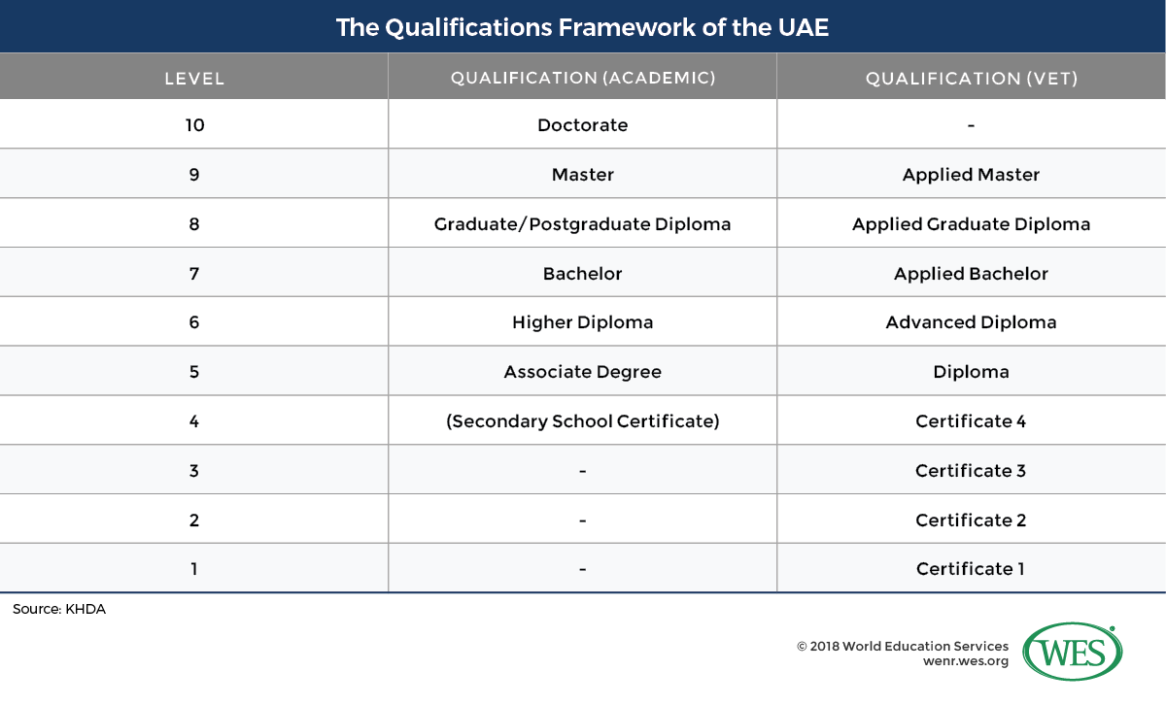
In addition to this local organization, the higher education system is also subject to other international organizations that provide accreditation to local institutions around the world. Among the most important are ABET (Accreditation Board for Engineering and Technology) [8] focusing on the various fields related to Engineering and Technology and AACSB (Association to Advance Collegiate Schools of Business) [9] focusing on the various fields related to Business.
Fig. 1: Academic qualification scales in the QFEmirates framework [10]
Such organizations and international accreditation bodies, and similar ones operating on a regional basis with a narrower scope, lay down the procedures to be followed in the academic system. At the same time, they evaluate current standing and recommend possible corrections and amendments, as necessary, while they also set a reference for the status and global equivalence of the offered degrees. An example of this in the context of the U.A.E. is the establishment of the ‘national qualifications framework (QFEmirates) in order to benchmark qualifications, define learning outcomes, ease the transfer between academic programs, and facilitate the international recognition of Emirati credentials’ ([10], Fig. 1). Their role is of critical importance, as not only they indirectly indicate to prospective students of higher education institutions the level of quality of the various programs on offer, but also they provide a structured and objective reference point for educators and students, as well as all other interested parties, such as prospective employers or the society as a whole.
It is, thus, appropriate to try and understand the vision of the officers of such organizations, and in particular of the Commission for Academic Accreditation [7], regarding the local higher education, as well as the directives and recommendations they enforce on the local institutions and the expectations from them. It is expected that this, in turn, will allow local HEIs to establish an informed and structured approach towards teaching and learning that is in line with the intentions and vision of both the local and global accreditation and regulatory bodies.

The Institutions
The second pillar of modern higher education system is the higher education institutions themselves. According to Cybermetrics Lab, a research group belonging to the largest public research body in Spain [11], a conservative estimate of the total number higher education institutions on a global scale would be in the region of 26,000, with reasonable claims that this number may be as high as, or in excess of 40,000 [12].
In the U.A.E. according to a related QAA report, in 2017 there were over 100 such higher education institutions, ‘enrolling approximately 140,000 students, with tertiary enrolments steadily growing year on year’ [13]. Three of these institutions, namely the United Arab Emirates University, Zayed University and the Higher Colleges of Technology, belong to federal government, while the rest are private, although some may have access to government funding [13]. In all cases, the majority of these institutions (74%) are accredited by the CAA and/or by related international bodies (26%) like the aforementioned ABET and AACSB [7-9] (Fig. 2). Many of these institutions are also either affiliated (i.e. directly or indirectly belong to a mother institution in the U.K., the U.S., or elsewhere) or associated (i.e. offer joint programs with other international institutions) with higher education institutions abroad.

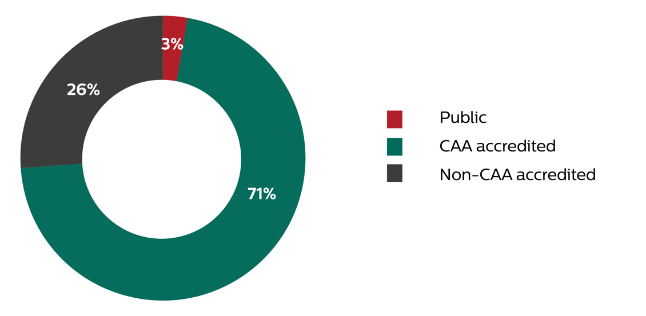
Fig. 2: Types of Higher Education Institutions in the U.A.E. [13].
As mentioned, it is usually the case that the majority of higher education institutions, both on a global and a regional context, attempt to follow relevant recommendations from international highly reputable organizations, as in the cases of the joint effort of IEEE and ACM focusing on the Information Technology Curricula in 2017 [14] and that of ACM & AIS in 2010 [15]. Such recommendations frequently include information on the content of the educational programs. Although it is generally the case that attempts are being made for most educational programs to follow this information as closely as possible, considerations regarding the required competencies and industry needs of each region and/or country, and of the unique characteristics of the local society also need to be made. Ultimately, the efforts made by the higher education institutions should aim at offering programs that cover all possible fields and directions that the new generation of the local workforce might need, not only in the present day, but also, and more importantly, in the years to come.
U.A.E. universities are not an exception to this, as they operate under the same global context and framework. One of the main challenges for the local U.A.E. institutions is to fully understand and address the needs of the industry and business sectors and, subsequently, of the local society, and adjust the offered programs accordingly. In the U.A.E., the Higher Colleges of Technology (HCT), in an organized effort to address the above, implemented the HCT 4.0 strategy [16]. The strategy aims at bridging possible gaps between the local academia and the industry and business world by focusing on the better preparation of the graduates for their integration and contribution to the local work force. In a broader context, it is expected that with the objective framework and reference points provided by the aforementioned global and local accreditation and recommendation bodies and organizations, and a solid understanding of the needs of the local industry and society, the local institutions will be in a position to develop and provide educational programs that are informed, relevant and future-proof.
Further study in this direction should aim at reviewing the current state of teaching and learning in HEIs in the U.A.E. more thoroughly and investigate whether and how it matches both the strategic vision of the regulatory and accreditation bodies, and the requirements of the industry and business sectors. Related research projects have been already proposed, and have been reviewed and approved by the relevant bodies within the U.A.E. This It is expected that this should provide a broad and detailed view on how such institutions operate, and allow for the examination of whether the models and frameworks currently in use are the optimal ones for providing the training needed by the local industry and business, and envisaged by the regulatory authorities.

The Local Industry and Business Ecosystem
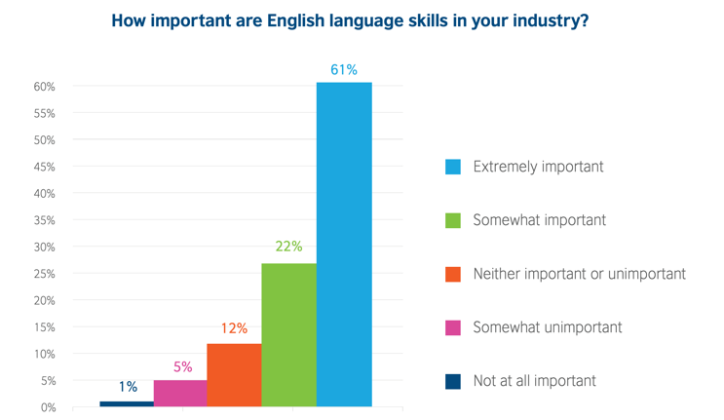
Addressing the needs of the local industry and business is one of the top priorities of the local higher education system. Anecdotal evidence and accounts of personal experience, although not formally expressed, indicate that one of the most serious complains of the local industry is that hired graduates are not matching the technical skill requirements for the jobs they are offered. This is also reflected in relevant academic and institutional studies, such as in Karnov and Khalaf’s [17] study on the employment gap in the engineering sector in the U.A.E. the studies carried out by the British Council regarding the required skills of U.A.E. graduates both today and in the future [18, 19]. This apparent gap in terms of the desired skills and these acquired during higher education studies seems to exist despite the fact that such skills are supposed to be offered as part of the curriculum of the related degrees. In this case, the inconsistencies between the actual industry needs and the skills and education offered by the educational institutions are an obstacle that could be preventing Emiratization policy to promote local skilled individuals in quality jobs throughout the country. An in-depth analysis of key industrial, business and economic sectors in the U.A.E. may be beneficial in this context, aiming to quantify and contextualize the exact requirements and expectations in terms of skills and knowledge of the graduates entering each sector (Table 1), [20].
Economic sector | Sector contribution to the GDP for 2017 (in per cent)
Extractive Industries (including Crude Oil and Natural Gas) | 29.50%
Wholesale and Retail Trade; Repair of Motor Vehicles and Motorcycles | 11.70%
Financial and Insurance Activities | 8.60%
Construction and Building | 8.40%
Transformative Industries | 8.30%
Public Administration and Defense; Compulsory Social Security | 5.80%
Real Estate Activities | 5.70%
Transport and Storage | 5.40%
Electricity, Gas and Water | 3.20%
Information and Communications | 2.90%
Table 1: Contribution of most prominent sectors to GDP in the U.A.E. [20]
Fig. 3, 4: Responses from U.A.E. future jobs prospects survey [18]

As part of analyzing the connections and relationship between education and the local industrial and business sectors, it is also important to look at the employment status and career progression of the graduates. Indeed, as Dr. Abdullatif Al Shamsi, president and CEO of Higher Colleges of Technology, recognized in his vision and directive of HCT 4.0, only 5% of the Emiratis are employed in the private sector when 65% of the local vacancies are offered by private entities. Interpretations of this fact may vary, but it can be claimed that a possible reason behind this could be a gap between what the local industries need and what the local institutions deliver in terms of the graduates’ attributes and skills [16].
As an example of possible ways of addressing this, the HCT 4.0 vision and new strategy is targeting precisely such a potential gap. It aims to reformulate its programs so that they adhere to the general vision of ‘No Emirati left behind’ and ‘Technical Leaders’, that is both exciting and beneficial for the local society. Additionally, it recognizes the need for diversification within the local economy and aims at preparing the new generation of Emiratis to explore other avenues outside employment at the public sector and accepting the challenge of becoming entrepreneurs [16].
In addition to the existing condition of the industrial and business sectors, in a rapidly changing global landscape one has also to take into account how new and emerging sectors and areas of activity may affect the local environment. A relevant study carried out within the context of the Abu Dhabi Sustainability Week initiative identified 5 driving forces towards ‘shaping the future of jobs and skills’, namely: rapid technological progress, drive towards sustainability, socio-demographic shifts, personal purpose and responsibility and changes the business and the economy [21]. In terms of desirable training outcomes for prospective graduates, such changes would result, among others, in increasing demand in certain skills and competencies, for example STEM related and English language qualifications (Fig. 3, 4). A relevant study focusing on the future skills within the U.A.E. carried out by the British Council reported that ‘individuals with skills in engineering, research and development, product design and marketing will be the most in-demand in industry sectors like manufacturing, energy, and TMC’ [18]. The study also highlights that various soft skills are rather high in the priorities list of prospective employers, in addition to basic technical skills and competencies.
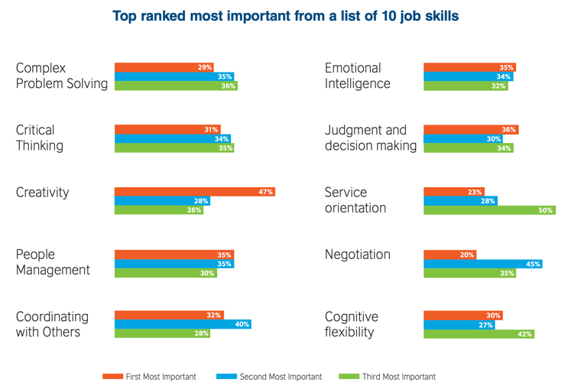
Based on these observations, it is suggested that a thorough and structured analysis of the possible future demands of the local industry should take into account both the nature and unique characteristics of the U.A.E. industrial and business landscape, as well as the evident general trends within the ever-changing global landscape.
Further work may be needed in this area with the aim of establishing an in-depth understanding of the present and future needs of the local industry and business sectors in terms of graduate skills and specialization. Such work could utilize extensive surveys in order investigate if there is a consensus among high ranking industry and business officers in relation to a) whether current HEI graduates possess the skills and specialization needed by the industry, and b) what skills and specialization may be needed in the future that are not required at the present time. The observations made during such a study are expected to benefit HEIs, as it will allow them to better assess and structure their teaching and learning models and processes in line with the requirements of the local industry and business.

The Local Society
The fourth pillar of higher education is society itself. The relationship between higher education and the local or global society is multifaceted and complex, and can be contextualized and analyzed on many levels. From this perspective, it is beyond the scope of this study to attempt a thorough analysis of all the possible aspects of such a topic. However, in the midst of the rapid technological transformation taking place on a global scale, it is relevant to discuss how the U.A.E. local society may be affected and transformed by the emerging technologies and technological trends.
It is true, today more than ever, that the emergence and the rapid developments of Information Technologies, such as Big Data (and Analytics), Cloud Computing, Sensors and Wearables, Artificial Intelligence (Machine Learning and Deep Learning), Blockchain, Visualization, Internet of Things, or Virtual and Augmented Reality are raising serious concerns as to the direction societies are moving towards in the near future. For instance, the rapid developments of the technology of Sensors and Wearables, as well as the efficiency of the RFID-based authentication raises concerns related to Information Privacy, among the main pillars of the Human Rights of individuals [22-24]. Similarly, the increasingly intense and broad discussion about Smart Cities, Smart Homes, and Smart Health [25, 26] is suggesting the difficulties in deciding what kind of societies we want to have in the future. The humanization of robots and the robotization of humans [27] and the intrusion of Artificial Intelligence in everyone’s life is also triggering a deep discussion on the ethics and morality that our societal systems of the near future should follow. Last but not least, the rapid advances in Virtual, Augmented and Mixed Reality has led to an ongoing broad discussion regarding the technological, perceptual, creative and cultural impact of the introduction of such technologies to the masses [28, 29].
With this in mind, it is expected that decisions regarding the curriculum of the higher education offered to the new generation of students would not be a matter of concern solely for the technical personnel of Information Technology and the business professionals, but also for society leaders and those in a position to influence social trends in general. Ensuring that proper checks, validation and balance are in place when it comes to deciding what should be included in the curriculum would be a measure of safe-guarding and nurturing future societies.

Emerging Teaching and Learning Environments
While attempting to put the relationships and interactions between these four pillars into perspective, one should not disregard the changes taking place in teaching and learning on a global scope, as a consequence of the rapid technological advances. While the accreditation and government bodies can ensure that a solid regulatory framework is in place, and institutions can make sure that they take into account the industry and local society needs when developing their programs, the delivery format and platforms through which these programs are delivered also needs to be examined thoroughly. Technological advances have already led to a number of changes in the way educational programs are delivered over the past decades. Examples of these changes include the use of centralized administration network systems [30], online tutorials, distance learning [31], automated examinations or virtual classrooms and teleconferencing [32]. Considering current global trends and research interest, it becomes evident that even more dramatic and radical changes in the way we interact, teach and learn could be introduced by the increasingly sophisticated Virtual and Augmented Reality systems (VR/AR).
Arguably, the ultimate goal of a study focusing on the relevance and practical value of teaching and learning in HEIs is that, once the regulatory, industrial, business and social needs, trends and challenges, and the relationships between them, are put into perspective, informed and constructive recommendations and observations are made in terms of how HEIs could respond to them. As part of this response, one should not fail to acknowledge and address the rapid transformations in training, teaching and learning introduced by the rapid global technological advances.
In this context, further work in this area should aim at exploring both the possibilities offered, and the challenges posed, by the use of advanced technological platforms and tools (online and distance learning, automated examinations and training, teleconferencing, virtual classrooms) as a means to deliver the necessary training and skills that will fulfil the outlined regulatory, industrial, professional and social requirements. Most importantly, in the midst of the ongoing radical transformation of the global media industries, such a study should specifically explore the opportunities these technologies may provide to the educational sector in general, and HEIs in the U.A.E. in particular.
A timely example of this is how the introduction of commercially viable Virtual and Augmented Reality (VR/AR) systems is currently transforming many industrial sectors and activities around the world, including education. Extensive research has been conducted in this area focusing on various aspects of the technologies in the educational context, such as their perceptual and cognitive implications [33, 34], their effectiveness as a teaching and learning tool [35, 36], or their content delivery potential [37]. In the scope of the current study, it is suggested that the role and impact of such advanced technological systems should be part of the discussion, evaluation, analysis, and development of educational systems and of education delivery as a whole. By embracing such technologies early on, and incorporating them in the design and delivery of the educational programs U.A.E. institutions offer, not only the latter will be at the forefront of global developments, but also will assist in safe-guarding and future-proofing the offered courses. Additionally, structuring the courses around such platforms could, potentially, allow for expansion of the U.A.E. educational offerings to a much broader pool of students and learners via the options of remote access and distance, off-campus teaching, learning and delivery.

Conclusion
This preliminary study paper is laying the ground for a subsequent research project related to the triple helix of higher education in the U.A.E. The main focus of this effort is on how the four pillars of education are affecting the final higher education product: the attributes of the local univeristy graduates. By studying each of these pillars separately, as well as the relationships between them, one can make better decisions in terms of whether and how the skills and training offered by HEIs match the regulatory, industrial, professional and social demands.
Research projects associated with the above have been already proposed, and have been reviewed and approved by the main local regulatory and administrative authorities within the U.A.E. The main research themes and questions to be addressed in these projects are the following:
- Whether current HEI graduates possess the skills and specialization needed by the industry.
- What skills and specialization may be needed in the future that are not currently required.
- How can advanced emerging delivery methods and technologies be used as a means to deliver the necessary training and skills that will fulfil the outlined regulatory, industrial, professional and social requirements.
Based on the background established and the knowledge acquired during the proposed further studies and research projects, it is expected that informed observations and suggestions could be made in relation to the training, teaching and learning requirements in local HEIs, in line with the current and future regulatory, industrial, professional and social requirements and needs.

References
[1]. Stanford University. The Triple Helix concept: Triple Helix Research Group; 2020 [Available from: https://triplehelix.stanford.edu/3helix_concept.
[2]. European Higher Education Area and Bologna Press. Roma, ITALIA: EHEA; 2019 [Available from: http://www.ehea.info/.
[3]. European Association for Quality Assurance in Higher Education (ENQA). About ENQA Brussels, Belgium: ENQA SECRETARIAT; 2019 [Available from: https://enqa.eu/.
[4]. European Commission. Learning Opportunities and Qualifications in Europe: European Commission; 2019 [Available from: https://ec.europa.eu/ploteus/search/site?f%5b0%5d=im_field_entity_type:97.
[5]. Quality and Qualifications Ireland (QQI). QUALIFICATIONS FRAMEWORKS - A EUROPEAN VIEW Dublin, Ireland: European Qualification Framework; 2018 [Available from: https://nfq.qqi.ie/qualifications-frameworks.html
[6]. Council for Higher Education Accreditation. CHE A at a Glance Washington, DC 20036, USA: CHEA Council for Higher Education Accreditation; 2019 [Available from: https://www.chea.org/sites/default/files/2019-08/CHEA-At-A-Glance_7.19.2019v2.pdf.
[7]. COMMISSION FOR ACADEMIC ACCREDITATION. Mission and Objectives United Arab Emirates: Ministry of Education; 2019 [Available from: https://www.caa.ae/caa/DesktopDefault.aspx?tabindex=1&tabid=60.
[8]. ABET. Approved Criteria for the 2018 – 2019 review cycle Baltimore, MD 21201, USA: ABET; 2019, Apr 1st [Available from: https://www.abet.org/approved-criteria-for-the-2018-2019-review-cycle/.
[9]. AACSB International. Who We Are Tampa, Florida 33602 USA: AACSB International 2019 [Available from: https://www.aacsb.edu/about.
[10]. Kamal K. Education in the United Arab Emirates: WENR - World Education News + Reviews; 2018, Aug 10 [Available from: https://wenr.wes.org/2018/08/education-in-the-united-arab-emirates.
[11]. Spanish National Research Council (CSIC). Consejo Superior de Investigaciones Científicas Madrid, Spain: CSIC; 2019 [Available from: https://www.csic.es/en.
[12]. Sowter B. How to Claim a Place Amongst the Top 1% of World Universities? London, United Kingdom: QS Quacquarelli Symonds Limited; 2019 [Available from: https://www.qs.com/claim-place-amongst-top-1-world-universities/.
[13]. The Quality Assurance Agency for Higher Education. COUNTRY REPORT: The United Arab Emirates U.A.E.: The Quality Assurance Agency for Higher Education (QAA); 2017, May [Available from: https://www.qaa.ac.uk/docs/qaa/international/country-report-uae-2017.pdf?sfvrsn=25caf781_6.
[14]. Sabin M, Alrumaih H, Impagliazzo J, Lunt B, Zhang M, Byers B, et al. Information Technology Curricula 2017Information TechnologyCurricula 2017: Association for Computing Machinery (ACM)
IEEE Computer Society (IEEE-CS); 2017, Dec 10 [Final Curriculum Report, 2017 December 10]. Available from: https://www.acm.org/binaries/content/assets/education/it2017.pdf.
[15]. Topi H, Valacich JS, Wright RT, M.Kaiser K, J.F. Nunamaker J, Sipior JC, et al. Curriculum Guidelines for Undergraduate Degree Programs in Information Systems: IS 2010 Curriculum Guidelines; 2010 [Available from: https://www.acm.org/binaries/content/assets/education/curricula-recommendations/is-2010-acm-final.pdf.
[16]. Shamsi AA. A Tale of Two Journeys. U.A.E.: Higher Colleges of Technology; 2019, March.
[17]. Kranov AA, Khalaf K, editors. Investigating the employment gap: What employers want from engineering graduates. 2016 IEEE Global Engineering Education Conference (EDUCON); 2016: IEEE.
[18]. British Council. FUTURE SKILLS SUPPORTING THE UAE’S FUTURE WORKFORCE: British Council; 2018 [Available from: https://www.britishcouncil.ae/sites/default/files/bc_futureskills_english_1mar18_3.pdf
[19]. Langton J. UAE youth must raise their game to find the careers of the future, report shows Abu Dhabi, U.A.E.: International Media Investments FZ LLC; 2018, March 6 [Available from: https://www.thenational.ae/uae/education/uae-youth-must-raise-their-game-to-find-the-careers-of-the-future-report-shows-1.710506
[20]. UAE Government. Economy and Vision 2021 Dubai, U.A.E.: UAE Government; 2019 [Available from: https://www.government.ae/en/about-the-uae/economy
[21]. Abu Dhabi Sustainability Week. ADSW - FUTURE SKILLS - 2030 REPORT: Abu Dhabi Sustainability Week; 2019 [Available from: https://masdar.ae/-/media/adsw/the-week/youth-4-sustainability/adsw-future-skills-2030-extended.pdf.
[22]. Cecchinato ME, Cox AL. Smartwatches: Digital Handcuffs or Magic Bracelets? Computer. 2017;50(4):106-9.
[23]. Corcoran P, Costache C. Smartphones, biometrics, and a brave new world. IEEE Technology and Society Magazine. 2016;35(3):59-66.
[24]. Kurkovsky S, Syta E, Casano B. Continuous RFID-enabled authentication: Privacy implications. IEEE Technology and Society Magazine. 2011;30(3):34-41.
[25]. Almeida VA, Doneda D, da Costa EM. Humane Smart Cities: the need for governance. IEEE Internet Computing. 2018;22(2):91-5.
[26]. Amft O. How wearable computing is shaping digital health. IEEE Pervasive Computing. 2018;17(1):92-8.
[27]. Bryson J, Winfield A. Standardizing ethical design for artificial intelligence and autonomous systems. Computer. 2017;50(5):116-9.
[28]. Arnhem J-Pv, Elliott C, Rose M. Chapter 3: Hardware and Software for AR/VR Development by Philip Ballo. Augmented and Virtual Reality in Libraries. 1st ed: Maryland: Rowman & Littlefield; 2018.
[29]. Menin A, Torchelsen R, Nedel L. An analysis of VR technology used in immersive simulations with a serious game perspective. IEEE computer graphics and applications. 2018;38(2):57-73.
[30]. Oxford University Press. Learn about Virtual Learning Environment/Course Management System content Oxford, U.K.2016 [Available from: https://global.oup.com/uk/orc/learnvle/
[31]. The Open University. Distance learning United Kingdom: The Open University; 2019 [Available from: http://www.openuniversity.edu/what-is-distance-learning.
[32]. CAE Computer Aided USA Corp. VoluxionCAE E-learning solutionsEducational Platform (LMS,LCMS,VCR)
All your training is possible in one place: CAE Computer Aided USA Corp; 2019 [Available from: https://www.cae.net/lms-language-schools-features/.
[33]. Daniela L, Lytras MD. Editorial: themed issue on enhanced educational experience in virtual and augmented reality. Virtual Reality. 2019:1-3.
[34]. Sun R, Wu YJ, Cai Q. The effect of a virtual reality learning environment on learners’ spatial ability. Virtual Reality. 2019;23(4):385-98.
[35]. Hodgson P, Lee VW, Chan JC, Fong A, Tang CS, Chan L, et al. Immersive Virtual Reality (IVR) in Higher Education: Development and Implementation. Augmented Reality and Virtual Reality: Springer; 2019. p. 161-73.
[36]. Garzón J, Pavón J, Baldiris S. Systematic review and meta-analysis of augmented reality in educational settings. Virtual Reality. 2019:1-13.
[37]. Kraus M, Kibsgaard M, editors. A classification of human-to-human communication during the use of immersive teleoperation interfaces. Proceedings of the 2015 Virtual Reality International Conference; 2015: ACM.

