Visual Artists and Virtual Production: Potentialities, Challenges and Novel Approaches
Lee McQueen, Panos Raptis and Richard Whitby
Ravensbourne University London

Abstract
Virtual Production (VP) techniques are claimed to be changing areas of filmmaking but how might an artist from outside these industries and these modes of production use them? VP has been promoted as an accessible filmmaking technique in recent years. However, as a specialist area of filmmaking, and one built around meticulous planning and pre-visualisation, what barriers might a new, non-filmmaker, user experience? Is it possible to achieve satisfying results on a relatively limited budget? In our practice-based project, an artist brought an experimental approach to making and a conceptual interest in the techniques themselves, rather than a way to achieve pre-visualised shots and looks. The focus was not on evaluating VP’s effectiveness as a production pipeline, but on how VP constraints and assumptions are navigated and challenged by an artist from outside established film/media production practices.

Keywords
Visual Artists, Experimentation, Virtual Production, Accessibility

Premise and Research Question
Virtual Production (VP) has been framed as an accessible, solution-oriented film production methodology, emphasising efficiency and creative control through previsualisation (Gardner, 2021; Pires et al., 2022). In this project the authors aimed to explore VP as an experimental and learning space in which a visual artist’s creative practice and experimentation highlights tensions, assumptions, and alternative possibilities within established production methods.
The central research question was:

Is virtual production accessible enough to allow experimental creative practice outside of industry-standard methods?

The following paper includes a 10-minute video, embedded below, that serves to document the process, and the experiences and reflections of the participants. We intend this to be watched at the point that the reader encounters the video, before returning to the text for our conclusions; we will also quote from interviews included in the video where relevant, citing by timestamp.

Context
Virtual Production combines real-time rendering engines, camera tracking, and LED display technologies to enable in-camera visual effects and real-time decision-making (Chanpun, 2023; Hitchen et al., 2023). Within industry practice VP is often framed in terms of efficiency, creative control, and risk mitigation through detailed previsualisation (Willment and Swords, 2023). In public-facing and promotional material for VP production and workflows, it is almost always VP workflows built around shooting in LED-volume studios being represented, with tethered virtual and physical cameras; we consider this the ‘hyped’ version of VP, and it is also the most familiar image to non-filmmakers and film students (Deloitte Global, 2022; Industrial Light & Magic, 2020; Netflix Production Technology Resources, 2022).
Literature on VP has largely focused on technical innovation, pipeline development, and industry case studies. While some research explores creative skills development and decision-making within VP environments, this work typically assumes practitioners who are already trained in film or television production. Other studies have incorporated projects by musicians, theatre makers etc, as ‘untrained’ ‘outsiders’ to VP – however, they are often provided extensive access to costly infrastructure (Hanney et al., 2026; Markova, 2025). Others, such as cases in Barnett et al. (2025), use facilities owned and controlled by University departments carrying out the research. To address a gap in existing research, our study intentionally replicates the ‘real world’ challenge of allowing only limited access to expensive studio time and focuses on the work of an artist without specialist technical knowledge and film production training.
Artists working with moving images often engage with new technologies in an experimental way and are often later seen as having pushed a medium forward – for example: Salvador Dali and Luis Buñeul’s surrealist use of editing in Un Chien Andalou (1929), Andy Warhol’s use of extreme long takes in Empire (1965) or Nam June Paik’s experiments with the Sony Portapak, such as ‘Button Happening’ (1965). In contrast to established film workflows, artists frequently value open-ended experimentation, process-driven enquiry, and conceptual engagement with tools and technologies. Artists often operate at smaller scales when compared to film production, with greater autonomy and fluidity between roles (Rees, 2011: 2); it is this frequent tendency to be quick adopters of new technologies that suggested visual artists as a useful group with whom to test the accessibility of current VP processes.

Within our project, artist Kitty Clark said that the creative work would function ‘as long as everyone’s ok with [...] we don’t actually know exactly what it’s going to be’ (5:00). For such practitioners, VP’s emphasis on meticulous preplanning and precise technical coordination between different specialists and different physical (and virtual) sites potentially hinders exploratory modes of working, where a final outcome can emerge through the creative process. We posited that these factors might challenge the artist’s experimentation and are representative of the barrier of entry for new and non-specialist filmmakers, and students, providing useful insight in education and training contexts (Boutellier and Raptis, 2023).

Research Design
The project centred on a facilitated practice case study based at Ravensbourne University London, in April and May 2024. Artist Kitty Clark was selected following interview and portfolio review. Her background included small-scale experimental work and 3D modelling for virtual reality projects, but she had no formal training or experience in live-action film production.

We were interested in testing a version of VP adhering to the industry conventions and close to the most prominent and marketed image of VP (such as Industrial Light & Magic, 2020; Netflix Production Technology Resources, 2022), so we built the project planning 3 days of asset development and one day filming in a studio with an LED volume. In order to maintain relevance to the most prominently marketed version of VP filmmaking practice and our own pedagogical context teaching film, we introduced two stipulations:

1. produce video footage as the outcome; think of the studio as a studio, rather than a rehearsal room or exhibition space.
2. use a physical camera tethered to a virtual camera.

An Unreal Engine specialist, Chris Jorna, was recruited as a technical facilitator. His role was framed not as instructor but as collaborator to support the artistic intention. The researchers acted as facilitators and observers.

Rather than the researchers or Chris Jorna ‘onboarding’ the artist, she was asked to independently research VP and to document her findings (and share these using a collaborative digital board – Figure 1 and in video).
We also avoided prescribing ‘boundary artefacts’ such as shot lists or detailed storyboards, which Hanney et al (2026: 4) suggest act as scaffolds in creative-practice work in VP residencies. This risked introducing challenges for Kitty later on, particularly during the shoot. However since they are part of core methodologies prescribed within conventional filmmaking, we did not want to impose them to avoid biasing the findings. Asking our artist to research VP independently allowed us to assess the impact of prominent narratives about VP. In our design, we also wanted to see how far Kitty’s own experience and approach would take her.

The project was completed in three stages:
Stage 1. Research and Ideation
Rather than training the artist to replicate conventional VP workflows and achieve specific filmic outcomes, we encouraged exploratory engagement.
Preparatory research revealed the artist’s interest in questioning constraints and affordances of VP rather than realising previsualised shots, and an early optimism of what was achievable shaped by published material of VP: expansive environments, seamless blending of real and virtual with apparent creative freedom.

Ideation and further research was also recorded on the same Miro board, for analysis and reflection by the researchers.

Stages 2 and 3 consisted of creative work. Behind-the-scenes video, interviews from the artist and technical specialist and group discussions became materials for a video (completed October 2025; embedded below), produced as both documentation and analytical artefact.

Stage 2. Experimental Development
This happened at RUL over three days, involving the creation of digital assets intended for LED deployment. This phase was iterative and marked by tension between artistic exploration and optimisation requirements.
Stage 3. Studio Test
This was a single-day LED volume shoot at Target 3D, London. This functioned as a critical research event, revealing temporal compression, economic pressure, and infrastructure-driven decision-making.

Video Embed https://vimeo.com/1125826201/42be1694c5

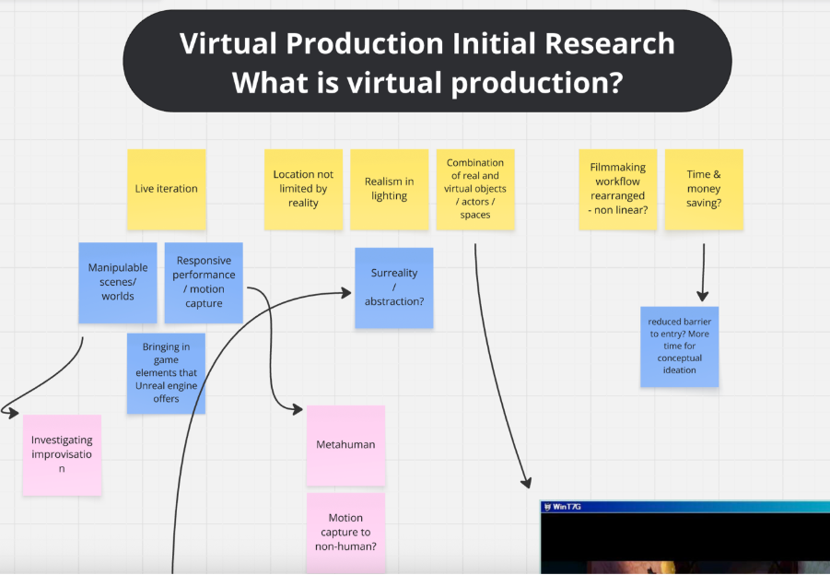
Figure 1: Screen shot; detail of Miro board used by Kitty Clark to collect research into VP, and later her own ideas and plans.

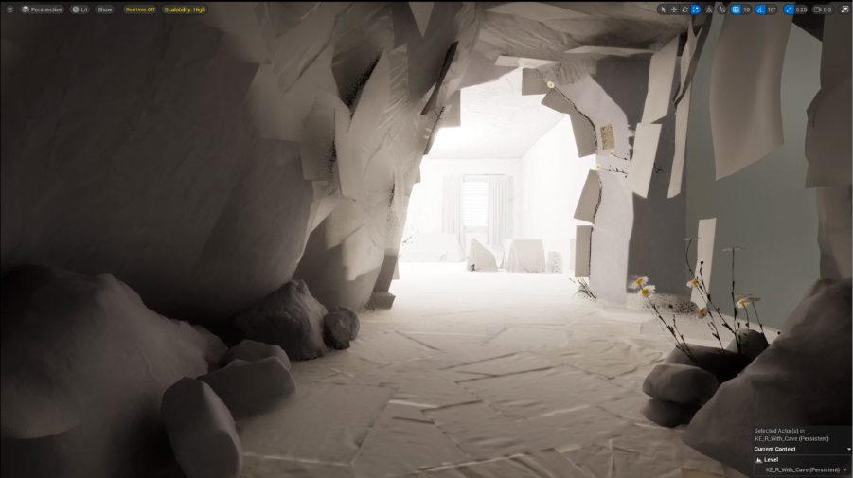
Figure 2: Completed virtual environment in Unreal at end of stage 1

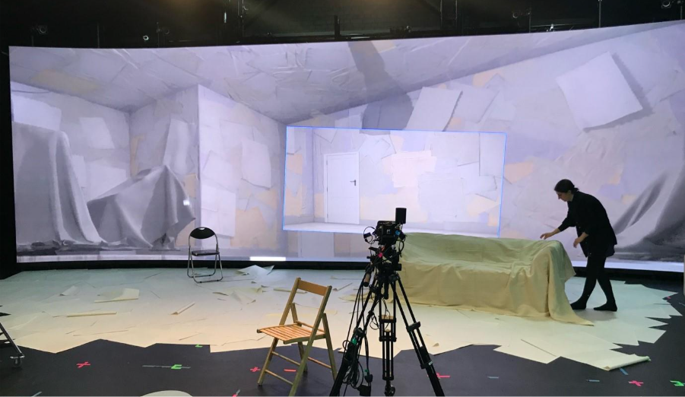
Figure 3: Stage 2, studio shooting day (Kitty Clark dresses set)
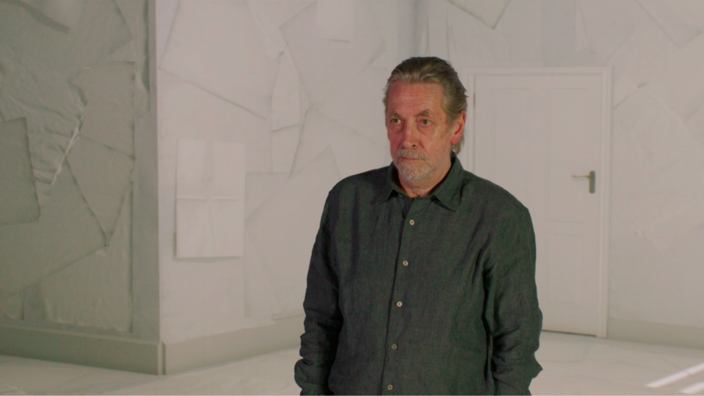
Figure 4: Still from final footage after shooting day

Findings outline
Whilst our video shows that the artist achieved moments of technical and creative success, and Kitty reports learning about the techniques, it also reveals the friction and challenges encountered throughout the process, including:

- Previsualisation vs. Experimentation: VP’s reliance on detailed previsualisation conflicted with the artist’s preference for working responsively and allowing ideas to evolve through making: ‘I thought we’d have a bit more flexibility in trying things out in a rapid way’ (5:20).
- Technical Intermediary: The technical skill requirements of VP systems positioned the Unreal Engine specialist as an essential intermediary, raising questions about creative control, dependency, and access.
- Practice Mismatch: The collaboration with a technical specialist highlighted a mismatch of creative approach between that of a solo practitioner (the artist) and a film production member (VP and Unreal expert) In the video Chris Jorna states that ‘[Kitty] was really open to suggestions; not too strict about having it to look a certain way’ (5:48), then in contrast Kitty stating that ‘there was times when he was trying to pull it in a certain direction that isn’t what I necessarily wanted’ (7:36).
- Scale considerations: The high cost and logistical challenges of LED volume studio time limited opportunities for experimentation; again, Kitty ‘thought we’d have a bit more flexibility in trying things out in a rapid way’ (5:20). The infrastructure designed for large productions clashed with the needs of a solo practitioner, highlighting how VP environments implicitly embed assumptions about team size, budget, and production hierarchy.
- Democratisation narrative: The published material promoting democratisation and accessibility of VP led to a misrepresented sense of potential and creative freedom: Kitty wrote ‘reduced barrier to entry?’ on our Miro board (Figure 1). The artist points out the challenge of changing things on the fly and the limiting nature of the available digital assets (‘actually there are certain things that you just can’t find’ [3:58]), despite feeling initially excited by the potential. The artist ultimately concludes in the video that creative freedom is not available without iterative learning – which is a level of access unlikely to be available to anyone outside conventional productions, and therefore suggests that VP is not yet accessible to ‘outsiders’.
- Conceptual thresholds: The central challenge of the spatial logic in VP and the interdependence and twinning of the virtual and physical spaces during previsualisation and production is a conceptual threshold in VP. While withholding an introduction to this concept, as well as to VPs affordances and limitations – as per the research design and methodology – the artist still succeeded in attaining this threshold, through the development process Kitty says there is ‘a background and then there is also the real physical space…you have two visualisations happening at the same time with slightly different characteristics and needs)’ (4:45). Despite limiting the onboarding for the artist, this threshold was crossed independently through development and exploration.

Significance and Contribution
Our findings suggest a nuanced answer to our research question. Real-time engines such as Unreal Engine can provide rich spaces for experimentation and creative ideation in simulated environments. At the end of stage 2, our artist was excited by what had been created, although this experimentation required working with an expert technician; a collaboration that the artist was ultimately unsatisfied with. Stage 3 (the studio shoot) was viewed on reflection as ‘a bit of a fail’ by the artist (7:00). Based on this project, we find that the wider VP ecosystem and specifically LED volume production – with its economic pressures, technical mediation and workflow rigidity – remains significantly less accessible to solo, non-specialist and experimental practitioners; those not trained in film workflows and unused to ‘boundary objects’ on which these still rely. By reflecting on the barriers faced by a non-specialist practitioner, the research contributes to the broader debate about access and inclusivity in technologically-intensive creative fields. These frictions generated critical insight into how VP needs to be reimagined as a more exploratory space when approached from outside film industry practices. Unlike technological developments such as the Portapak (see above), VP – at least, the most visible version involving Volumes and studio shooting – cannot currently be ‘picked up’ and played with. The results challenge the narratives of VP as inherently enabling or democratising but also highlights the potential of the simulated environment of a real-time engine. For example, despite many frustrations Kitty was still excited by the possibilities of future work using Unreal engine. These insights are particularly relevant to the development of skills training and higher education curricula; in art and design contexts where experimental practice is central, and ‘industry standard’ workflows are rapidly changing.

Limitations and Further Research
The design and methodology, explained above, was controlled by the researchers to focus towards the intended research question.to avoid biasing and constraining the artist towards existing workflows, the researchers chose to withhold the scaffolding of conventional boundary objects such as storyboarding and orientation to VP’s spatial logic. The findings indicate success in synthesising this concept and further research might further determine the potential of VP to support experimental practice and learning for solo practitioners and in an educational context.
The role of the potential practice mismatch between a solo practitioner and a structured production crew is particularly acknowledged in the determination of the findings. Further exploration could provide insight into the potential practice mismatch and alternative or complementary workflows and tools (e.g. a foundational player for VP) that can mitigate the reliance on meticulous planning, previsualisation and technical mediation.

Bibliography:

Barnett, T., Bevan, J., Mackness, C., & Wallin, Z. (Eds.). (2025). Beyond Virtual Production: Integrating Production Technologies (1st ed.). Focal Press. https://doi.org/10.4324/9781003449492

Boutellier, A., and Raptis, P. (2023). ‘Teaching Virtual Production: The Challenges of Developing a Formal Curriculum.’ Film Education Journal 6 (2): 69–81. https://doi.org/10.14324/fej.06.2.01.

Chanpun, P. (2023). ‘Virtual production: Interactive and real-time technology for filmmakers’. Humanities, Arts and Social Sciences Studies 23(1): 9–17. https://doi.org/10.14456/hasss.2023.2

Deloitte Global (2022) ‘Virtual Production Gets Real: Bringing Real-Time Visual Effects Onto the Set.’ Virtual production effects | Deloitte Insights. https://www.deloitte.com/content/dam/insights/articles/2024/us175608_tmtp23-virtual-production/di-tmtp23-virtual-production.pdf (Accessed 23 Feb 2026.)

Kadner, N. (2021). The Virtual Production Field Guide: Volume 2. Epic Games. https://cdn2.unrealengine.com/Virtual+Production+Field+Guide+Volume+2+v1.0-5b06b62cbc5f.pdf (Accessed 23 Feb 2026.)

Hanney, R., Postek, A., and Li, Y. (2026). Alchemy in the screen space: ritual performance through virtual production in Black Wasteland. Media Practice and Education, 1–18. https://doi.org/10.1080/25741136.2026.2616847

Hitchen, G., Ekmekcioglu, E., Ozcinar, C. (2023). Mapping the virtual production eco-system. Loughborough University. Report. Available at: https://repository.lboro.ac.uk/ndownloader/files/39303443/1 (Acessed 23 Feb 2026)

Industrial Light & Magic (2020). The Virtual Production of The Mandalorian Season One. 20 February. Available at: https://www.youtube.com/watch?v=gUnxzVOs3rk (Accessed 23 February 2026)

Markova, L. (2025). ‘Virtual Production and the Future of Live Performance: Intermedial Trajectories of Expanded Animation in the Immersive Production Dream (Royal Shakespeare Company, 2021)’ in Mitchell, S., Perry, C., Redmond, S., & Torre, L. (Eds.). (2025). The Screens of Virtual Production: What is Real? (1st ed.). Routledge. https://doi.org/10.4324/9781003463139. 10.4324/9781003463139-10.

Netflix Production Technology Resources (2022). Into the Volume: A Behind-the-Scenes Look into the Virtual Production of 1899. 20 December. Available at: https://www.youtube.com/watch?v=ZMynJCgJIQk (Accessed 23 February 2026)

Pires, F., Silva, R. and Raposo, R. (2022). ‘A Survey on Virtual Production and the Future of Compositing Technologies.’ Avanca Cinema Journal, 692-699. https://doi.org/10.37390/avancacinema.2022.a447.

Rees, A.L. (2011) A history of experimental film and video. London: BFI.

Willment, N., Swords, J. (2023). What is virtual production? An explainer & research agenda. xR stories & University of York. Available at https://xrnetworkplus.xrstories.co.uk/wp-content/uploads/2023/04/What-is-VP-final2.pdf (Accessed 23 Feb 2026)

