Visualizing Impossible Machines
Leonardo Da Vinci & Perpetual Motion

“A creative solution to celebrate in 2019, the 500 year anniversary of the death of Leonardo Da Vinci."
Output Description
The work submitted for assessment consists of three installations exhibited at two venues. The proto-type of two of these installations was exhibited at the Peltz Gallery, Birkbeck University, from the 6th February to 12th March 2019, in an exhibition entitled “Visualising Perpetual Motion Machines”. The third installation was a combination of the first and second installations and was incorporated into a much larger exhibition, entitled, “Leonardo da Vinci and Perpetual Motion”, at the Museo Galileo in Florence, Italy. This exhibition was open from 15th October 2019 to 12th January, 2020. Both installations contribute to our understanding of two of Leonardo’s manuscripts exploring perpetual motion designs. The first manuscript, folio 91 and 92, consist of two designs on the front and back of the same paper (verso and recto). They are in the Codex Forster II, part of a collection of three codices of Leonardo’s drawings, bequeathed to the Victoria and Albert Museum by John Forster.
For this installation we created an augmented reality experience. To properly appreciate how augmented reality was finally used in the exhibition, please view the first part of the movie link below;
https://vimeo.com/342608232
The second manuscript, f.1062r, is from the codex Atlantics, which is now in the Ambrosiana library in Milan. This manuscript contains five perpetual motion designs. This installation was designed to be screen based and to be projected in the middle of the Peltz exhibition space. Please view this installation using the link below:
url: Atlanticus Film - Final
The third and final installation, combining the AR experience and the screen based experience, which was exhibited at the Museo Galileo, can be viewed using the link below;
https://vimeo.com/367221845

Funding
The Museo Galileo paid £10,000 by invitation, to be shared between the two collaborators principally involved in the building the installations, Ravensbourne University London and Birkbeck University. The money paid for research and development leading up to the exhibition at the Peltz also covered any further changes to accommodate the Museo Galileo’s plans involving their exhibition which opened in October 2019.

Introduction

Research Question

Can one construct models of Leonardo da Vinci’s perpetual motion designs that reveal new knowledge about the workability of those designs?

Leonardo and perpetual motion
In May 2017 the Research team at Ravensbourne were invited to create installations to celebrate two of Leonardo’s Perpetual motion studies. The first, folio 91 and 92, on the front and back of the same paper (verso and recto). They are in the Codex Forster II, part of the collection of three codices of Leonardo’s drawings, and bequeathed to the Victoria and Albert Museum by John Forster.

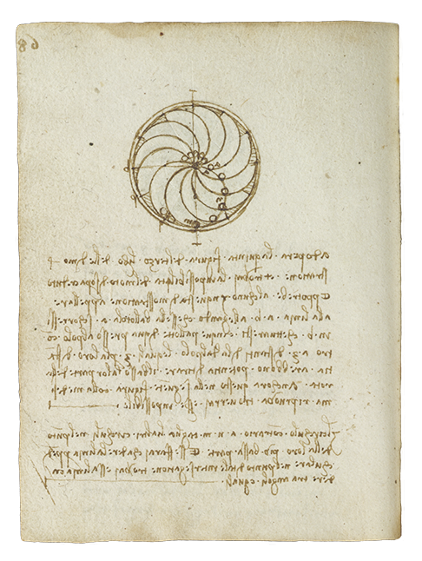
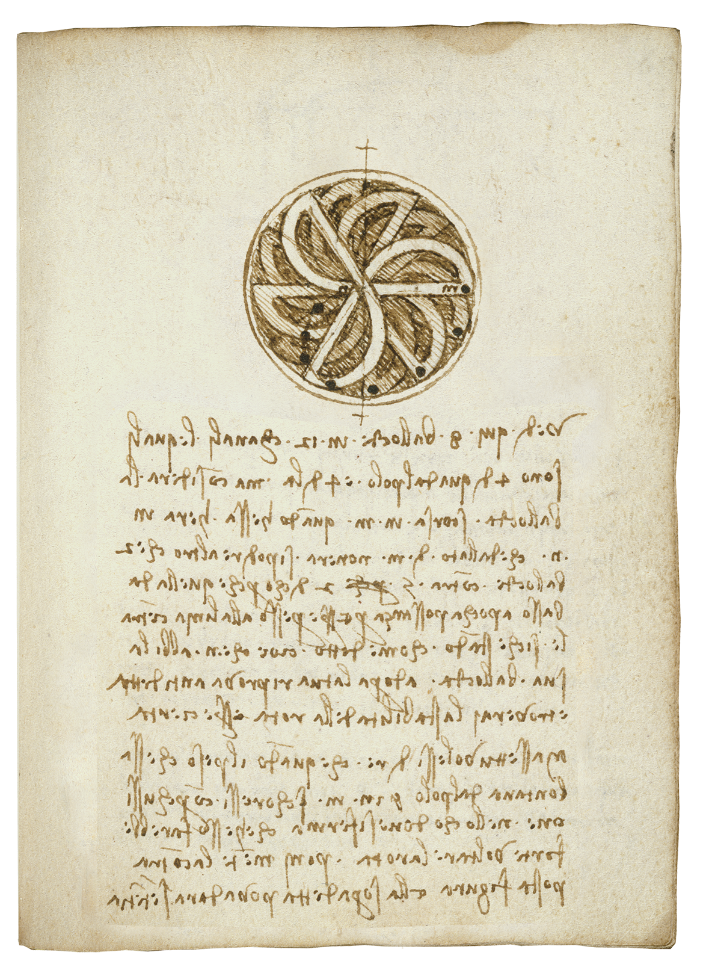

Fig. 3: Forster II (folio 90, Recto) Fig. 4: Forster II (folio 91, Verso)
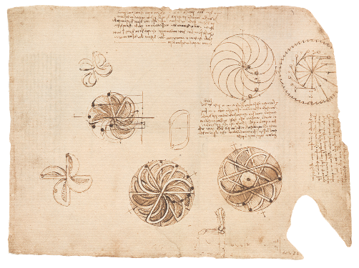
The second installation request, f.1062r, concerned a manuscript from the codex Atlantics, which is now in the Ambrosiana library in Milan.

Fig 6: Codex Atlanticus manuscript f.1062r, presently in the Ambrosiana library, Milan.

Research at any time can be understood as part of an ongoing discourse, as a means to establish what we know already from previous research and to encourage further interrogation and analysis into what we continue to not fully understand. To fully appreciate how our process of re-representation is part of a wider narrative in a long tradition of perpetual motion realisations. Research gathered by the Leonardo scholars on the team, Andrea Bernardoni and Juliana Barone, reveal a detailed trail that had already developed over many centuries and travelled across three continents. Although originating from India in the 7th century, the theme of perpetual motion arrived in Europe via manuscripts transcribed in Toledo in the mid-13th century; (Bernardoni, A., 2019, p 14). Designs of overbalanced wheels are found in the notebooks of European engineers from the 14th century onwards. However, the only medieval manuscript that has been passed down to us from this period is by the architect and engineer, Villard de Honnecourt. The codex Atlanticus, f. 1062r-v includes an interpretation of De Honnecourt’s design. It clearly indicates Leonardo was familiar with this earlier design and that he considered it worthy of further analysis. However, in itself this does not establish whether Leonardo believed these or other earlier designs had the potential to work. In fact evidence suggests he was of the opinion that all shared a general lack of prior empirical knowledge. This is supported by his comments in the 1490’s; “Among the superfluous and impossible delusions of man there is the search for continuous motion, called by some the perpetual motion wheel”; (Bernardoni, A 2019 p 24). All the more understandable then that he did not bother to build any of his designs.

Despite this repudiation Leonardo maintained an enduring interest in perpetual motion. He continued to work on possible solutions; while employed at the Sforza court in Milan between 1481 and 1499, as well as for some of his time, between 1500 and 1508, in Florence. In total Leonardo spent twenty years of his life pursuing perpetual motion solutions. However, as we have established, evidence suggests that Leonardo did not seem to consider perpetual motion possible. In which case what other incentives justify this extraordinary commitment of time and resources? One possible reason might be this period of history. It has been suggested the renaissance triggered a “cultural revolution”, when technical knowledge became most valued” (Bernardoni, A 2019 p 19) and was also a pivotal point in scientific rigor and professionalism. For the first time engineers began to write scientific treatises. Could Leonardo have simply chosen perpetual motion to support other more practical and theoretical questions? Might this subject be the enticing research question to further inform his general thesis on mechanics and physics? Yet another incentive might be how this alluring subject invariably raised more interest among Leonardo’s stakeholders and clients. A willingness to engage in new, potentially transformative, paradigm changing technical solutions, offered enticing returns and fame for any wealthy entrepreneurial spirit. In short, an effective implementation of perpetual motion offered “a revolutionary innovation to solve energy issues” (Bernardoni, A 2019 p 20). This would suggest Leonardo continued his studies in limitless energy to simply entice his prospective employers with this most elusive of subjects. Perhaps we will never fully grasp the reason for this though we have established two main lines of enquiry. One being that Leonardo used perpetual motion as a vehicle to explore and test his overall understanding of physics and engineering. Another is he might also have used it to attract business and lucrative employment. With this in mind my research will therefore now focus more on the feasibility of Leonardo’s perpetual motion designs.

However, this leaves open the question as to whether or not Leonardo evaluated where and why his own designs did not work? So we asked, “Can our present day knowledge of physics, engineering and simulations reveal specifically where this understanding is correct or flawed?” Reviewing prior attempts at modelling Leonardo’s designs, our research question became; is it possible to construct a plausible working model of these designs? Something that can be made, where the balls move around as illustrated by Leonardo in these drawings, despite, in reality, due to the impossibility of self-perpetuation, this not being achievable?

These questions were answered by means of a collaborative design process involving specialists from three main areas; Leonardo scholars from Birkbeck University of London, and the Museo Galileo in Florence, museum and heritage practitioners from the Leonardo Da Vinci Society and specialists in 2D, 3D and augmented reality techniques from Ravensbourne University London. Each stage of the modelling process was agreed upon in consultation with our academic and curatorial collaborators, in particular, Doctor Juliana Barone, Honorary Research Fellow at Birkbeck and Andrea Bernardoni from the Museo Galileo. Each stage of the modelling involved a research method comprised of four sequential processes: reflection, conception, argument and reconstruction.

What we achieved
Our research and testing of augmented reality solutions for the Forster, folio 91 and 92 manuscript, recto and verso, resulted in us designing a fully working interactive installation. It aligned with our ethical framework and challenged prior conventions of how museum experiences can be managed. The installation was situated, tactile, shared and inclusive. It appropriately revealed the hidden detail within Leonardo’s design in such a way as to make this learning fun and meaningful. This project resulted in our solutions being exhibited at two locations, in central London and finally in the Museo Galileo in Florence, Italy. Our research and installation solutions have revealed, to a wider audience, new knowledge about Leonardo’s experimentation in perpetual motion solutions.

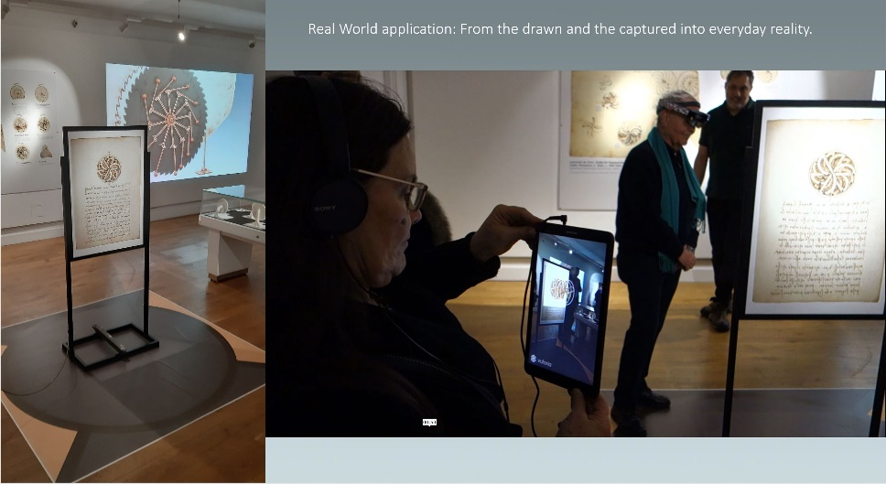
Fig.9; Concept of floor plan and final realisation; authors own 2019.

Research Context
Other creatives and researchers have attempted to produce physical models of Leonardo’s designs. For example, the models built by Giuseppe Schneider in 1929, which possess a tactile, real world immediacy. In contrast, a filmic, televisual, virtual alternative might; “make everything visible but nothing accessible” and as Heidegger would suggest, contribute to; “the worlding of the world as picture” (Causey, M. 2006 p 49).
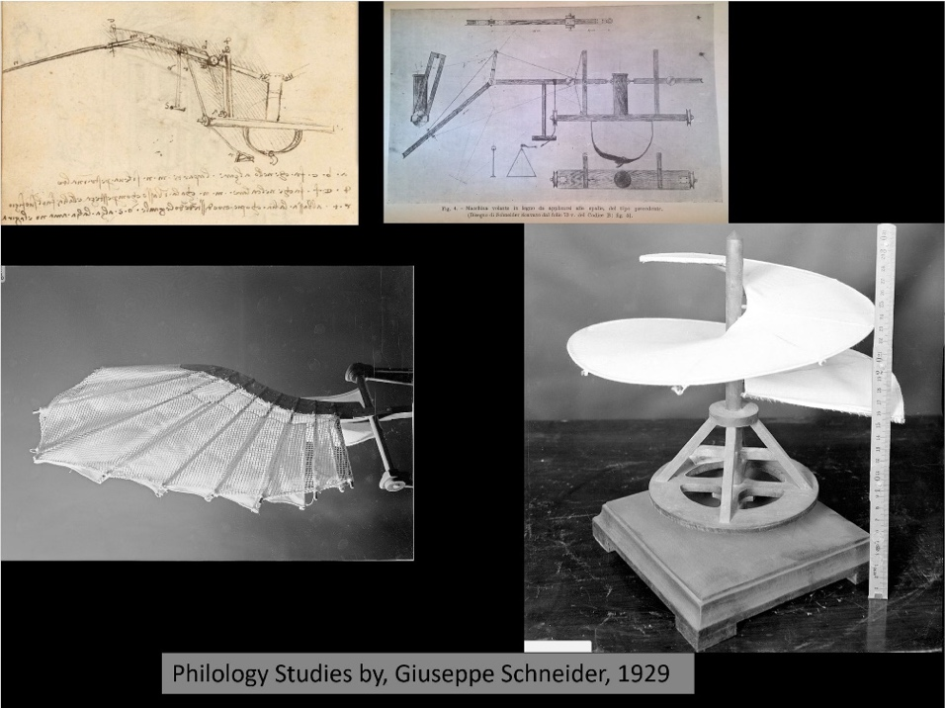

Fig.7; Representations of Leonardo’s designs; A. Bernardoni 2019.
[Just introduce and explain this model]
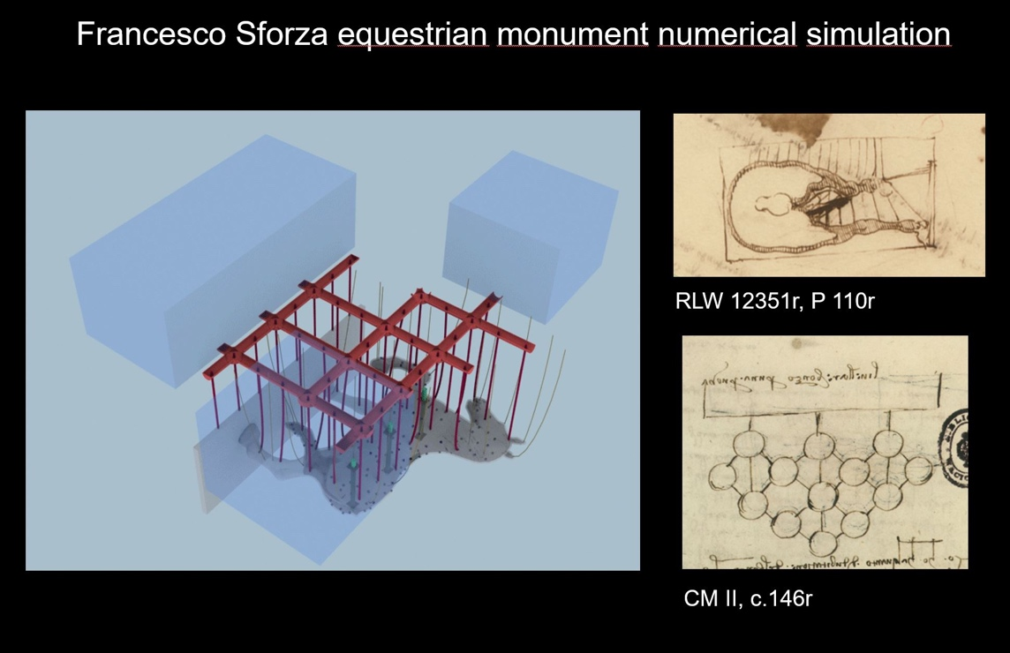
Fig.8; Representations of Leonardo’s designs; A. Bernardoni 2019

Furthermore, there is ample evidence of the existence of digital models of many of Leonardo’s engineering designs. However, there were no digital representations of his perpetual motion designs that were informed by Leonardo scholarship (Bernardoni 2019). More significantly no re –representations had attempted to make a visual link between the drawn design on the original manuscript and what it represented. Our Leonardo scholars also confirmed in the book written to accompany the exhibition; “Leonardo da Vinci and Perpetual Motion” that perpetual motion is impossible. It is also commonly understood among academics in this subject that Leonardo understood his designs could not work. Despite this, perpetual motion remains today as beguiling a myth as during the lifetime of Leonardo. In fact, Leonardo’s perpetual motion designs on the Atlanticus manuscript “remain the most popular perpetual motion designs on DIY and 3D printing sites” (Jones, J. 2019). All the more reason then for us to clearly establish in a public exhibition, that these designs, however elegant and intelligent, are intrinsically flawed.
Past attempts to model Leonardo’s perpetual motion designs and academic scholarship on the meaning and feasibility of the design led us to frame the following research question:
Can one construct models of Leonardo da Vinci’s perpetual motion designs that reveal new knowledge about the workability of those designs?

Research Method (see the Appendix for a fuller account of our collaborative method)
As noted in the introduction, our research methodology consisted of four continual loops; reflection, conception, argument and reconstruction. The first, reflection, defined the academic parameters of any problem and identified the objective or final outcome. Our Leonardo scholars, Juliana Barone and Andrea Bernardoni, decided what the creatives should focus on for each of the seven perpetual motion designs. However, despite their extensive specialist knowledge, they were not always certain of the specific order and speed that the motion should take place. Very often we would have to experiment on different solutions. In this way, the research entered new and unchartered territories of knowledge. No one before had attempted to build these particular designs to this detail. It was into this uncertain territory that the creative team began the second process of conception. The outcomes, initiated by the team presenting a multitude of initial visual concepts that triggered a variety of model making solutions and animations. This, in turn, generated debate and argument about which solution should be applied, often resulting in the creative team having to return to the conceptual stage.. In this manner the final reconstruction was realised and taken forward. So, in order to solve the many technical and aesthetic issues that developed, the creative team conducted continual iterative testing. Significant insights revealed themselves during these moments of extreme testing. It was as if disagreement between the scholars and creatives at times actually allowed new knowledge to reveal itself.

New Knowledge
We discovered how specific parts of the mechanics impeded the design rationale. This revealed new knowledge about Leonardo’s conceptual understanding of mechanics. The underlying question being continually asked was, at what speed should the turbine rotate? What speed accurately depicted Leonardo’s intention? Despite appreciating the design could never work our Leonardo scholars favoured a speed and pattern based on the order of representation on Leonardo’s drawings. However, when animated using real world gravity, the balls would not reach the speed to make them pass through the point “M” as indicated by Leonardo (Fig. 10). Instead of “M” being at 90 degrees, real world gravity indicated the balls would hit the edge of the turbine at 120 degrees (Fig. 11).

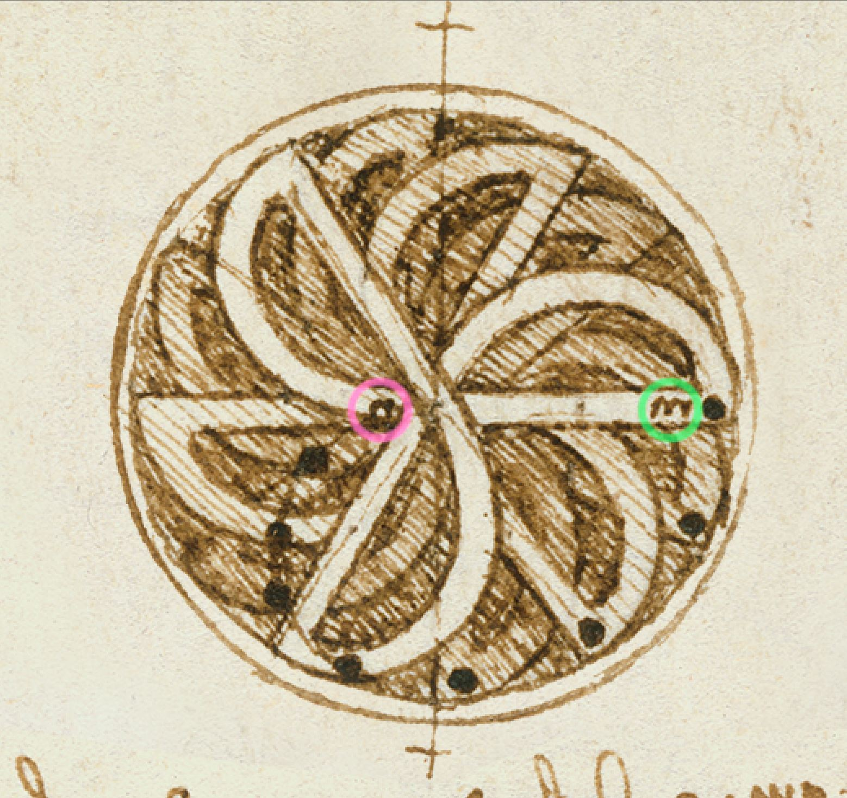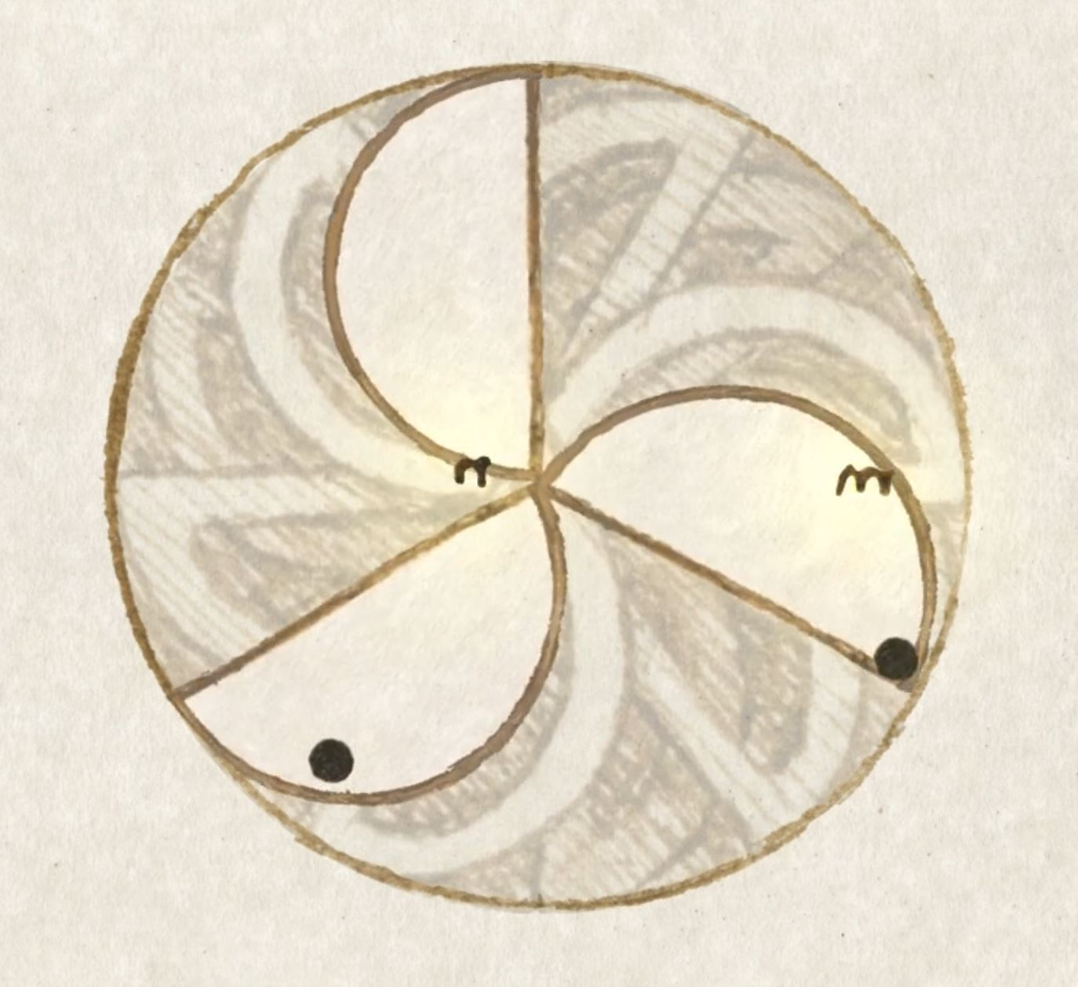

Fig.10: N highlighted in pink, M in Green Fig. 11: Using real world gravity ball contacts at
120 degrees, not 90 degrees as indicated by M.

This suggested that, in order for Leonardo’s design to work, irrespective of the interaction of the balls and the turbine, an acceleration of energy had to take place to have the ball reach the point “M” where Leonardo wished it to be. Because the balls cannot be in the places indicated in the design they can never produce the energy to achieve the perpetual motion. Despite only being able to imagine the desired motion, Leonardo understood that, in principle, this design would not work. His exceptional mind achieved this without the assistance of the tools, knowledge and modelling tools we now have at our disposal.

Research Outcome
Our work reveals exactly why Leonardo’s designs would not work; building into the model a burst of energy contravening the laws of physics, is necessary for it to function. We made the designs work but only by distorting nature.

More generally, this project suggests that appropriate technology solutions have the potential to achieve new understanding by revealing the hidden complexity of heritage artefacts. As a result my understanding of what is possible within my specialist field has been transformed.

What lies ahead
Such an intimate study of Leonardo’s designs has left me with an enduring curiosity and fascination for his work. Of all these, there is one area that, as an animator, I feel we share a particular interest. As Juliana Barone explains, “motion occupies a central place in Leonardo’s art and science” (Barone, J. 2019 p 36). This implies that although the core of his studies in motion involve his search for a perpetual motion machine it also informs his art. During the same period of studying perpetual motion in Milan; “we begin to witness unprecedented levels of dynamism in Leonardo’s artistic work. His rendering of human figures become increasingly lively and kinetic, as if they were about to change position in the course of their action and further interact with other figures or with the viewer” (Barone, J. 2019 p38). It is as if Leonardo is searching for a means to achieve what I accomplish through my specialist area, the process of animation. At the very least it suggests to me animation is the ideal medium to further explore his understanding of motion. In his “Treatise on Painting” Leonardo’s investigation into human motion, informed by his knowledge of the geometry of balance, results in a rationale of how the distribution of weight in the human body can inform motion. When I animate any object, specifically the human body, many of these rationales mirror my own animation techniques. This suggests, with my prior knowledge of Leonardo’s methodologies, I am ideally placed to pursue this line of enquiry. Using similar installations to those we created to reveal the complexity of his perpetual motion machines, I now intend to explore how I might establish a greater understanding of the relationship between how Leonardo perceived motion and how this informed his art. Then as now my ultimate objective will be to reveal new knowledge and present it through the most inclusive, accessible and entertaining of platforms.

Impact of Work
Our presentation to the Leonardo Society at the Arts Institute on 12th Jan 2018 resulted in the society officially recognising its achievements. The Royal Society also agreed to support the marketing of the project. Paulo Galluzzi, Director of the Museo Galileo, agreed to fund the research and development with the aim that it be included in a larger exhibition in Florence planned for October 2019. Another presentation later in the year at the British Library, 7th March 2018, resulted in this major museum acknowledging the works professional standard. The completed work was finally exhibited in the Peltz room at Birkbeck’s Department of Arts between 16th February and 12th March 2019. Overall footfall numbers for this period this period totalled 2,077 attendees.

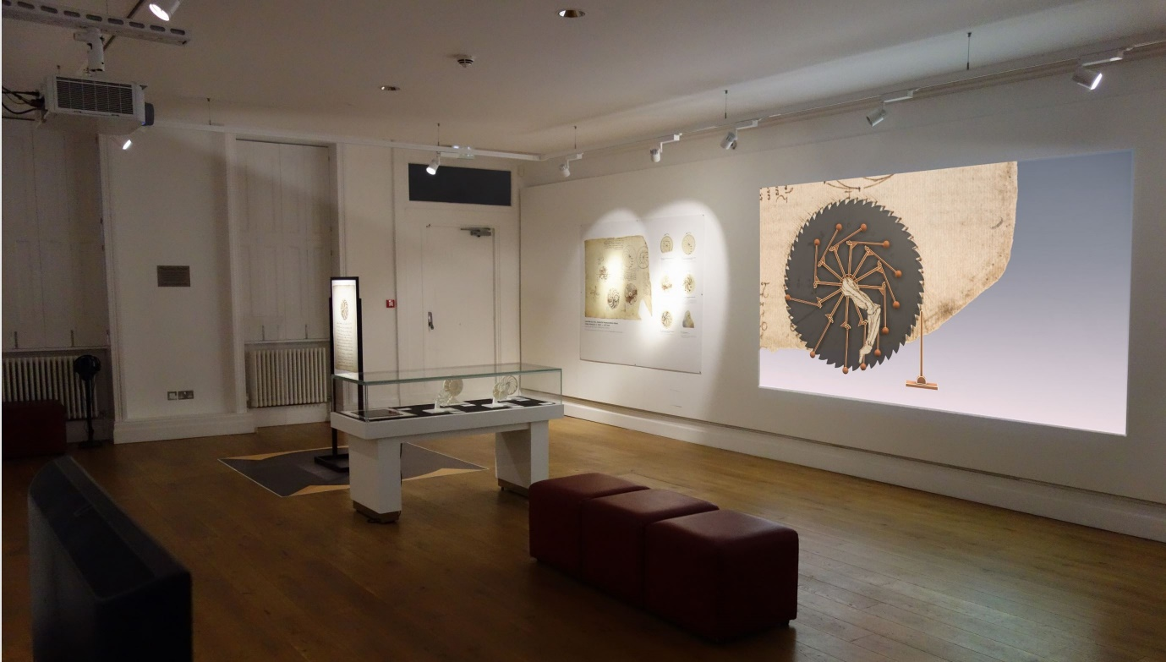
Fig.12; Peltz room and Leonardo exhibition, authors own, 2019.
It was curated by Dr Juliana Barone from Birkbeck's Department of History of Art and Andrea Bernardino from the Museo Galileo. A fully booked private view took place on the evening of 16th February, introduced by a keynote lecture, Leonardo da Vinci: the Motions of the Mind, by Professor Michael Kwakkelstein (Director of the Dutch Institute of the History of Art in Florence). Attendees for this event totalled 73.
Further evaluation of the visitor experience was gathered from the visitor book. The overwhelming number of comments were very positive. As an example L. Matteo commented “A great little exhibition. The reconstructions and visuals in motion, with their separations of Leonardo’s drawings, really clarified his intentions”. E. Saddon commented; “Thanks. A beautifully put together exhibition. Elegant and interesting”.
Coinciding with the Peltz exhibition, a symposium entitled, “Holograms in the Museum”; was held on 1st March 2019, at Birkbeck School of Arts. This interdisciplinary discussion brought together creatives and cultural studies scholars to consider the changing significance of holograms in artistic and cultural practice. The event had over 40 attendees and featured presentations from Chris Walker, MD of the creative design company, Bright White, as well as Nick Lambert, Jazz Rasool and myself from Ravensbourne. The presentations were followed by a panel discussion chaired by Dr Silke Arnold-de Simine, Reader in Memory, Media and Cultural Studies at Birkbeck College.
On 12th March, Ravensbourne Research Office organised a symposium at Ravensbourne University to present the project findings. The symposium aimed to evaluate how effectively our methodology had informed the final work. Interrogating our workflows and methodologies, we reflected on how successfully we had transformed Leonardo’s drawings into 2D animations, 3D models and augmented, holographic images. We evaluated the legitimacy of our choices in recreating missing parts, and concluded from the primary research gathered from attendees and visitor notes that our choices of materials used were appropriate and enhanced understanding of the subject. A historical account of similar re representations of Leonardo’s designs was presented by Andrea Bernardoni from the Museo Galileo entitled; “History of Mechanical Philology, from the Wooden to the Virtual Model.”
Since the opening exhibition in London the work has received interest from a number of stakeholders in the heritage and online sector. The animation and VR elements of the exhibition were restaged at the “Digital Weekend” that took place at the Victoria and Albert Museum on 21st-22nd September 2019. Three weeks later the installation was installed in a larger exhibition at the Museo Galileo in Florence (October 2019 - January 2020). Discussions have also taken place with Google Arts and Culture to have the exhibition displayed on their globally recognised site.

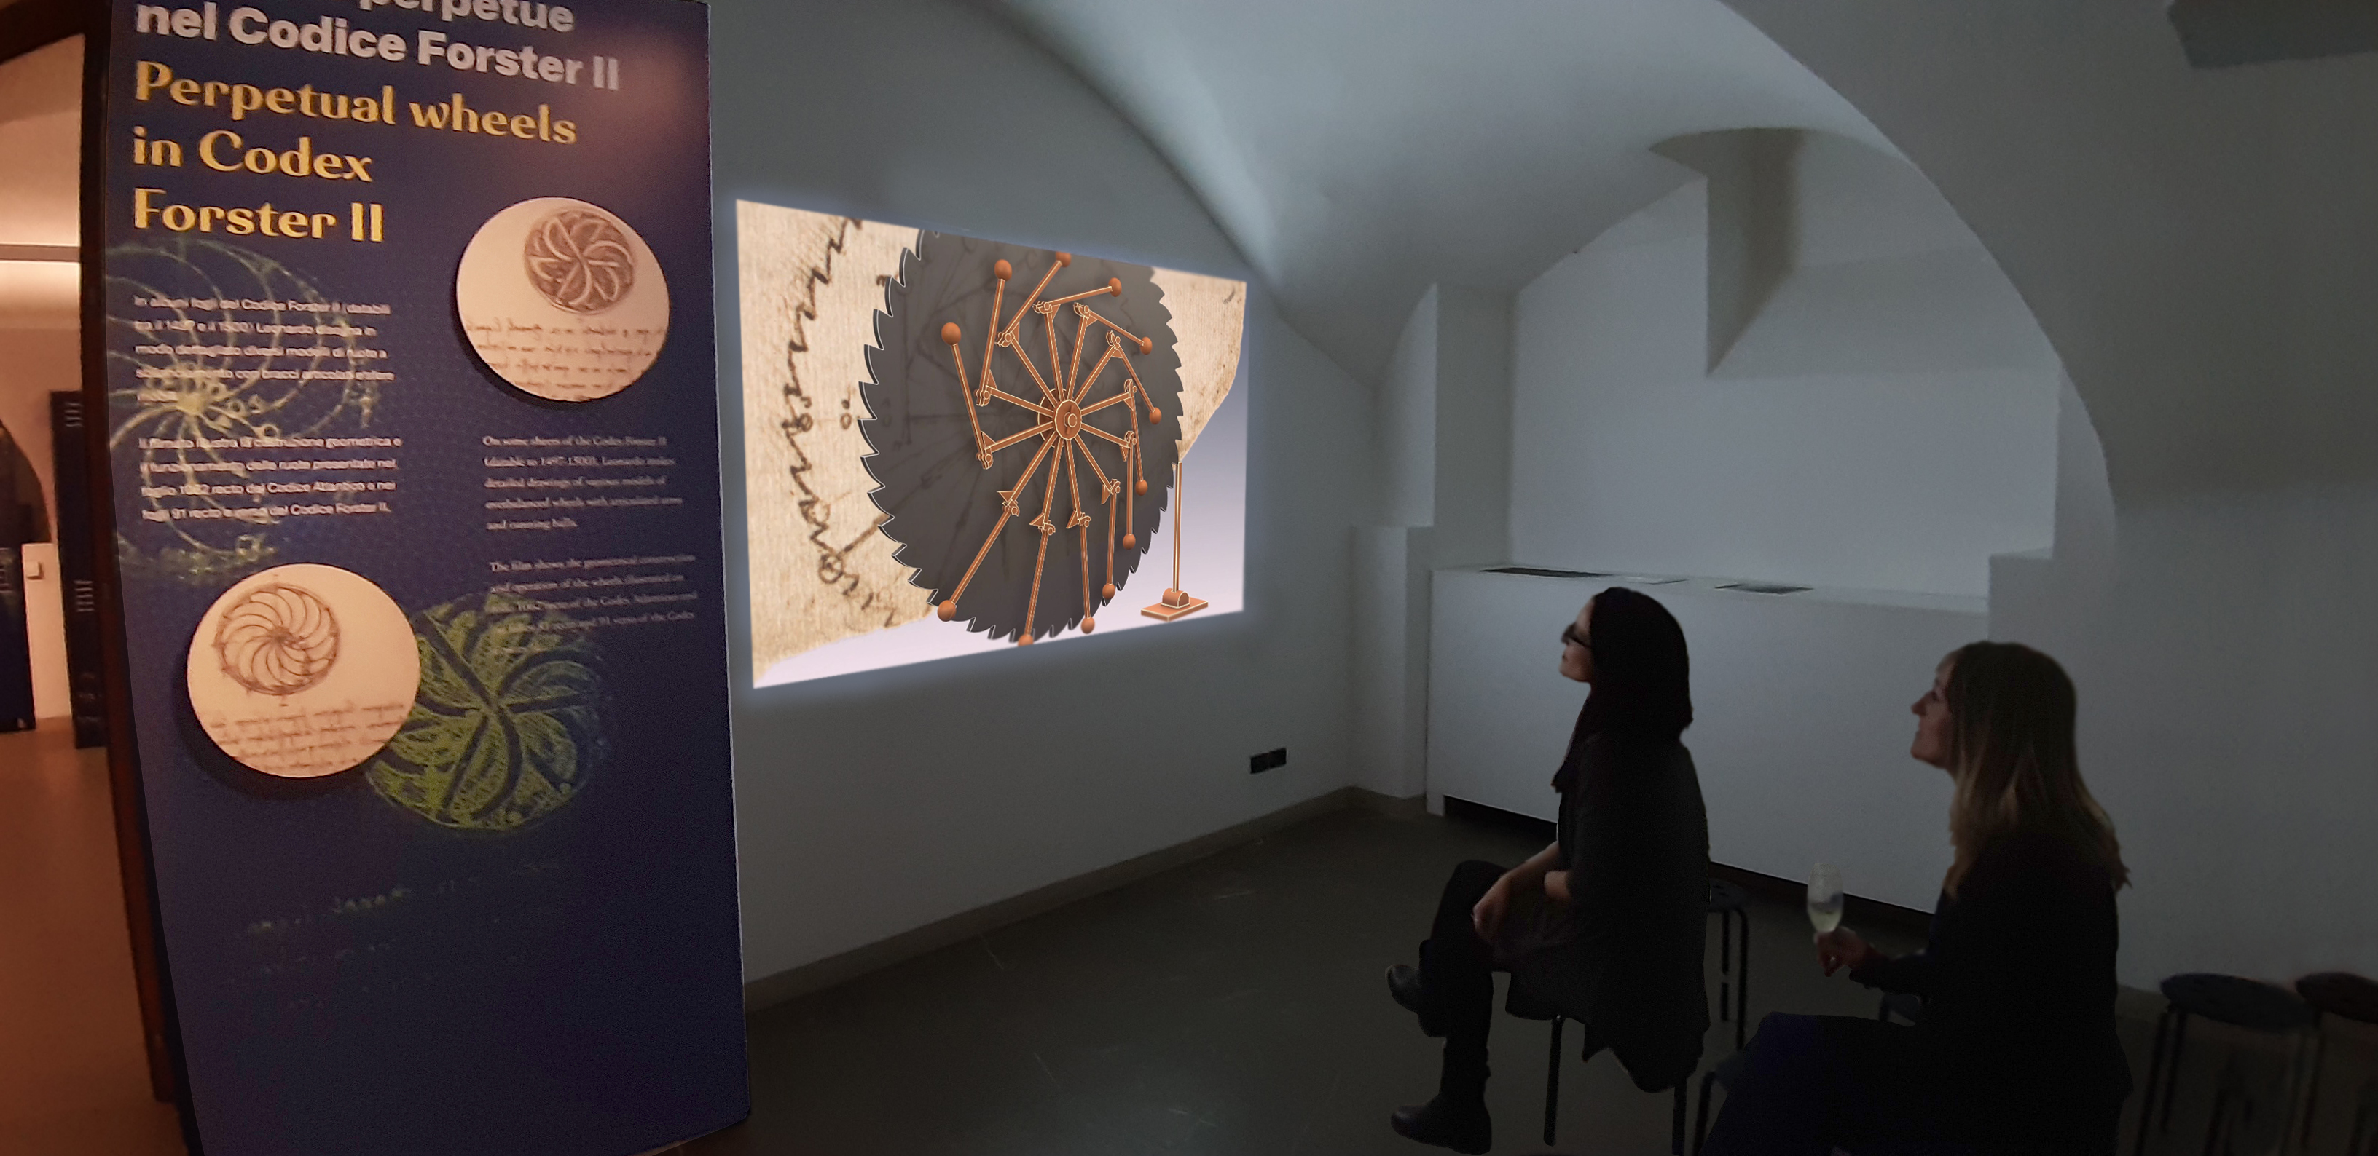
Fig 13; Final film in situ in the Museo Galileo, authors own; October 10th 2019

Conclusion
My animations, like Leonardo’s drawings, are a fiction; in that much our conclusions are identical. We were both trying out and exploring the possibilities of self-perpetuation. Leonardo explored these ideas on paper. He based them on the current knowledge of motion at that time. My research was carried out using the technologies of my time, 2D and 3D computerisation techniques and augmented reality. The system we built had physical properties built into it that, when we applied initial energy, within our natural world’s physical laws would always result in stasis. Instead what we animated is what the physics would need to be for Leonardo’s design to work. We created a world where perpetual motion would work. Though it is not our world, the installation shows what it would need to be like in order for these designs to work. Leonardo understood the world was not like that. For those who might still continue under the misapprehension these were workable designs, our research demonstrates that this is not the case. Our evidence, established by creating an environment outside of our planets gravitational laws, is further re-enforced by us establishing the exact point where Leonardo’s design, Forster 91v, meets resistance. This being the requirement that the ball arrives at point “M” in his drawing. These new contributions add to our understanding of Leonardo’s design thinking and suggest that they are better understood as ingenious but, nevertheless, inherently flawed proto-types.

List of illustrations in text.
Fig.1; Representations of Leonardo’s designs; A. Bernardoni 2019.
Fig.2; Representations of Leonardo’s designs; A. Bernardoni 2019.
Fig.3: Forster II Recto
Fig.4: Forster II Verso
Fig.5: One of three bound volumes donated by John Forster showing recto design on right (the verso design being on the back of this page) V&A collection.
Fig 6: Codex Atlanticus manuscript f.1062r presently in the Ambrosiana library, Milan.
Fig.7 & 8; Representations of Leonardo’s designs; A. Bernardoni 2019.
Fig.9: N highlighted in pink, M in Green
Fig.10: Using real world gravity ball contacts at 120 degrees, not 90 degrees as indicated by M.
Fig.11; Concept of floor plan and final realisation; authors own 2019
Fig.12; Peltz room and Leonardo exhibition, authors own, 2019.
Fig.13; Final film in situ in the Museo Galileo, authors own; 10th October 2019

Bibliography;
Bernardoni, A. (2019) Leonardo da Vinci and Perpetual Motion. Giunti.
Bernardoni, A. (2019) Symposium title; ‘History of mechanical philology, from the wooden to the virtual model’, 5th March, 2019 Ravensbourne
Birkbeck University of London, “V&A, Leonardo’s note books, Codex Forster II” opens at The Peltz Gallery from 6 February – 12 March 2019, Available at: https://www.vam.ac.uk/articles/leonardo-da-vincis-notebooks
Birmac, Birkbeck interdisciplinary Research in Media and Culture, “Holograms in the Museum”. Available at: http://www.bbk.ac.uk/birmac/2019/01/08/holograms-in-the-museum/
Crary, J. (1990) Techniques of the Observer. Cambridge, Mass.: MIT Press.
https://www.gutenberg.org/files/46915/46915-h/46915-h.htm#Chap_LXVI
Kidd, J. (2014). Museums in the new media scape Farnham: Ashgate.
MoMar Inaugural show; “Hello, we’re from the internet”, March 2nd – May 3rd 2018. Available at: https://vimeo.com/258568920
Tate Modern, behind the scenes, Modigliani VR. Available at: https://www.tate.org.uk/whats-on/tate-modern/exhibition/modigliani/modigliani-vr-ochre-atelier
Jones, J. 2019. Open Culture, Leonardo da Vinci’s Elegant Design for a Perpetual Motion machine
http://www.openculture.com/2019/08/leonardo-da-vincis-elegant-design-for-a-perpetual-motion-machine.html

Appendix: Overall methodology

As explained in the main body of this contextual information, our intention was to develop a digital representation, which offer limitations and affordances in modelling terms. As curator of the exhibition, Juliana Barone agreed to the suggestion we identify an interactive solution for the Forster Verso and Recto designs and create a screen based solution for the Atlanticus manuscript. However, our initial findings suggested virtual reality could deliver a solitary and isolating experience. An example of a VR learning experience in a similar exhibition was installed at the Modigliani exhibition at the Tate in 2017;
https://www.tate.org.uk/whats-on/tate-modern/exhibition/modigliani/modigliani-vr-ochre-atelier

Whereas at MoMar’s inaugural show in 2017 we see disruptive AR content that responds to specific elements within the museum space, providing a shared and collective experience for all the visitors.

https://vimeo.com/258568920

Based on this research the consensus of opinion between the three collaborative institutions was we design a fully inclusive, situated, augmented reality experience. AR allowed us to offer the viewer a virtual, collective experience while still within the reality of the exhibition. At the same time the viewer could potentially study Leonardo’s animating drawings from any angle or distance. It had the potential to revolutionise the museum experience, be inclusive and make learning fun and meaningful. In this respect it perfectly aligned with our ethical framework. To properly appreciate how augmented reality was finally used in the exhibition please view the movie link below;

https://vimeo.com/342608232

Pre-Production, Visualisation and Concept

With this in mind we began work on the Forster Verso and Recto designs. As 2D and 3D Animation specialist I managed and directed the artistic and technical workflows for these mediums and liaised with the AR specialist. My first task in the summer of 2017 was to create a 3D working proto-type installation of the Forster design.

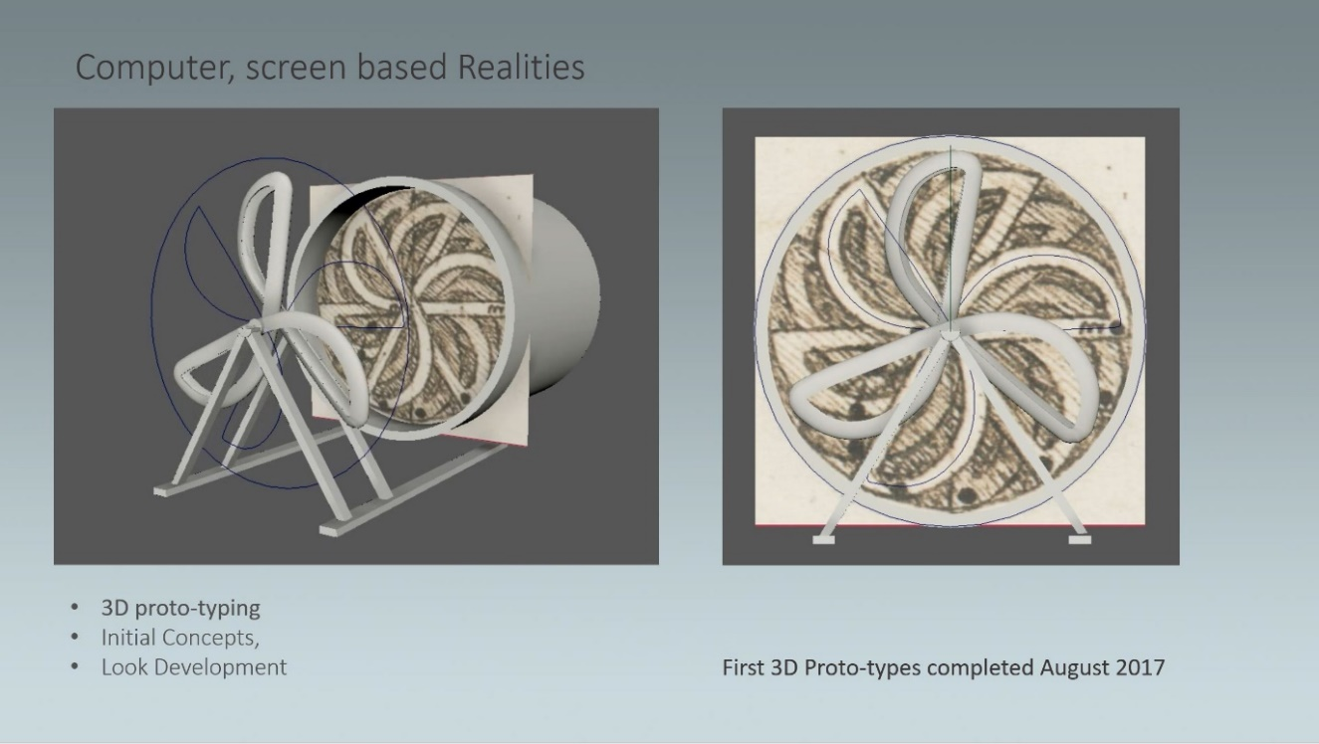
Fig. 7, 3D proto-typing; authors own 2017

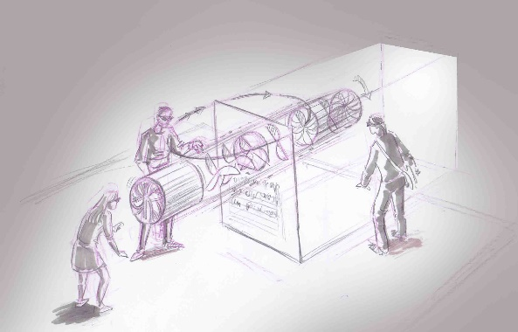
Fig. 8, In order to make sure all collaborators agreed with our ideation a number of initial visual concepts were created.

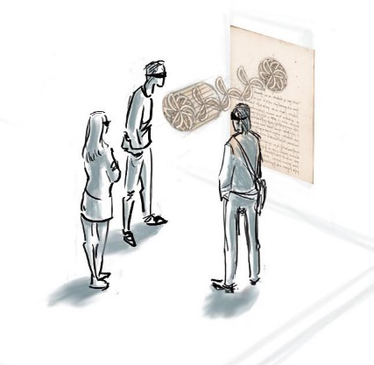
Fig.9, these concepts were used to clearly present our ideas to stakeholders, firstly at a meeting held at the Arts Institute in February 2018 with the Leonardo society and again, at a later meeting, at the British Library, in April of the same year.

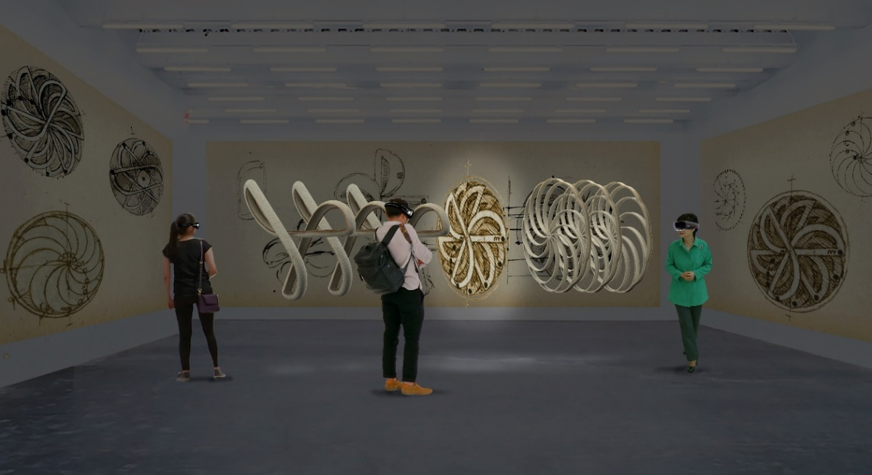

Fig. 10; Photographic previsualisation; authors own 2018.

We then set about planning how to situate this augmented experience within the Peltz exhibition space. The Forster perpetual motion designs were drawn by Leonardo on the front and back of one page, Recto and Verso. To celebrate this tactile anomaly we set about planning how to encourage the visitor to walk around the page and view both designs from many angles. This suggested experimenting with a free standing object, like a portable and reusable exhibition system, that could be placed anywhere in the room. It offered the potential to playfully use the available space around itself, to allow the audience to move round it and appreciate the augmented experience from many different angles. It involved accommodating the requirements of the curatorial team and then exploring how best to choreograph visitors around the available space in the Peltz. Below are images demonstrating initial concepts for this choreography and the final outcome.

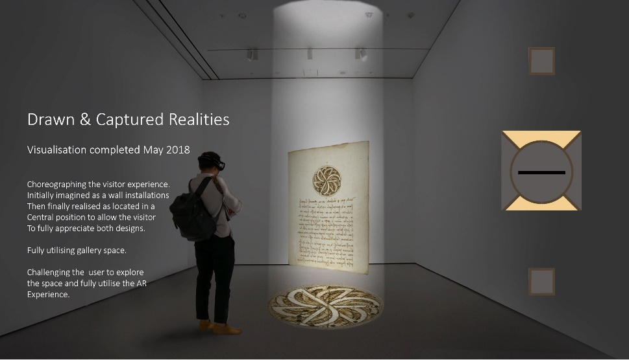

Fig.11 & 12; Concept of floor plan and final realisation; authors own 2019.

Methodology: Forster II
Once proof of concept was approved we began the 2D animations and the 3D modelling of Leonardo’s designs. Completed by a recent Ravensbourne Animation graduate these models were built using the strict specifications supplied by our Leonardo scholars.
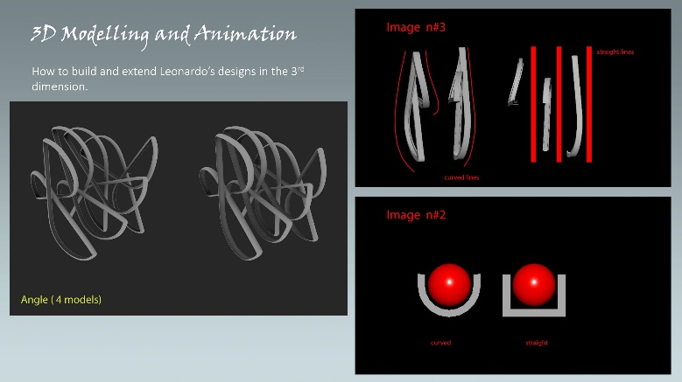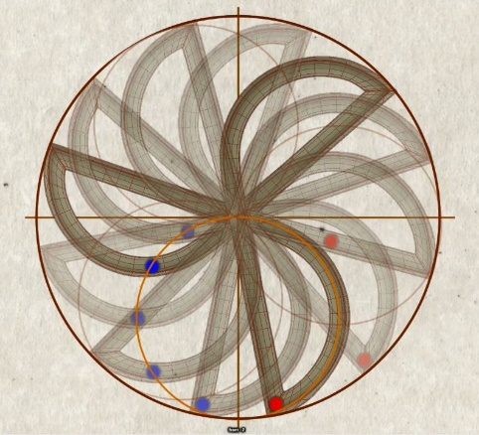
Fig.13 & 14; 3D modelling iterations; authors own 2019.

As explained in the main body of this contextual information, there was much debate around how to release Leonardo’s design which I have shown led to an appreciation of exactly what aspect of the design was not phyisically achievable. Further testing revealed additional intriguing anomalies. As an example; despite using gravity simulators to animate the balls in the turbines and changing the speed of the turbine rotation, the balls would not form the pattern illustrated in the Forster II manuscript (as indicated in fig, 11) eventually, this was achieved by stretching the clips of the real world gravity animated layers until they all finally aligned to the secondary circle. These inconsistencies, defying the principles of physics and engineering, underscored the temporal nature of these designs and that they should be understood more as thought experiments than working designs.
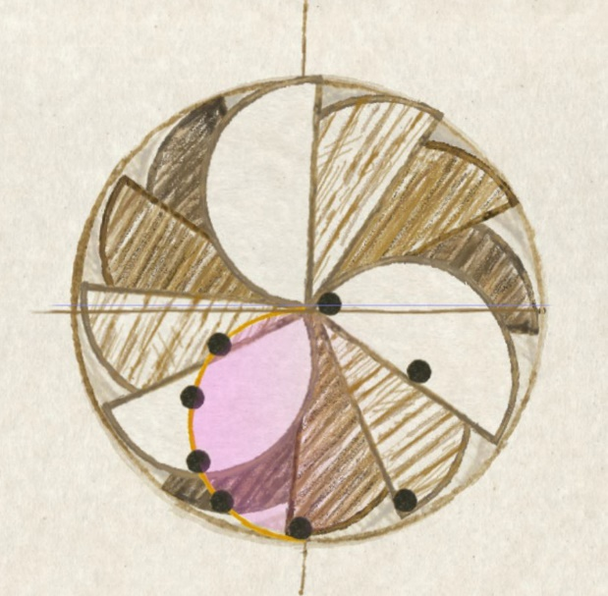
Fig. 17: Semi-circular pattern of balls trajectory
Authors own.

These production tests ultimately broke the deadlock that had arisen. By finding a route that looked plausible from an animation point of view we could build the object in 3D so that it produced Leonardo’s pattern of movement. Now the object could be properly reconstructed, incorporating many of the academic arguments.

Narrative and Script
The template for both moving image pieces rested on the writing of a robust, lucid script. This became the defining framework on which the narrative content. The scripts were provided by our Leonardo scholars, Juliana Barone and Andrea Bernardoni. From these an overhead narration was recorded. It was used a guide to more accurately time out the content. Any updates became iterative versions until the storyboards could then be signed off and an animatic produced. This cycle of creative development continually informed the decision making and allowed all parties to discuss and approve each stage.
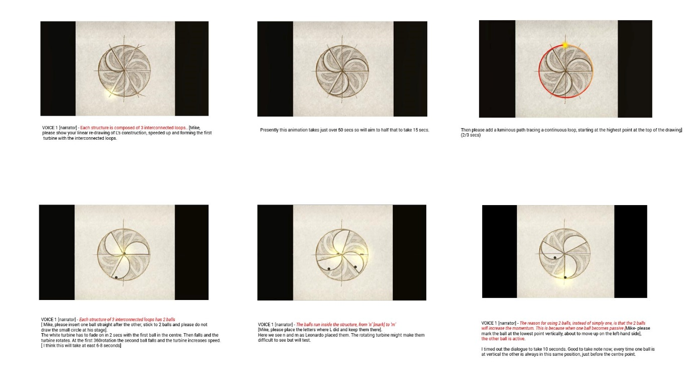Fig.18; Storyboard panel from Forster II installation; authors own 2019.
With this structure in place work started on planning and animating the 2D representation of how Leonardo sketched the Forster verso design. Continual tests and iterations were closely informed and reviewed by our Leornardo scholars.
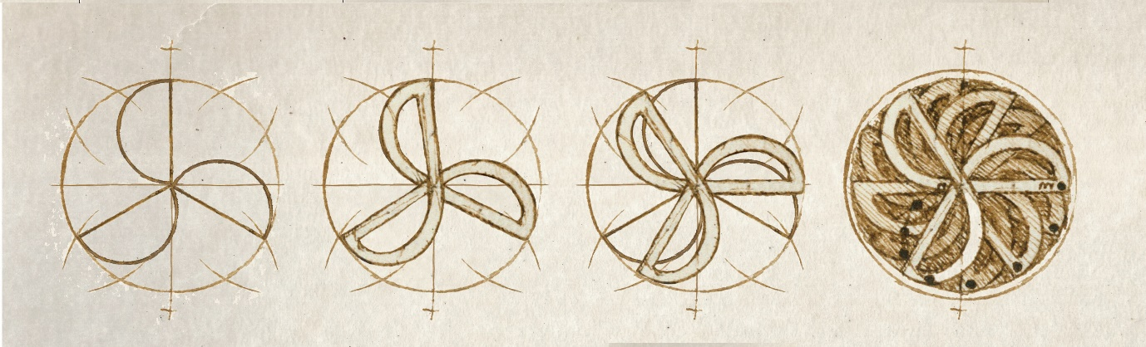
Fig.19; Concept experimentation for 2D animation process; authors own 2019.
With the 2D look established animation commenced. Once the rotational speed of the turbine was agreed the 3D models could then be animated to align with the 2D animation. These animations were then sent to our AR specialist who took the 2D and 3D content and completed a number of tests to establish how best to present it as an augmented experience.
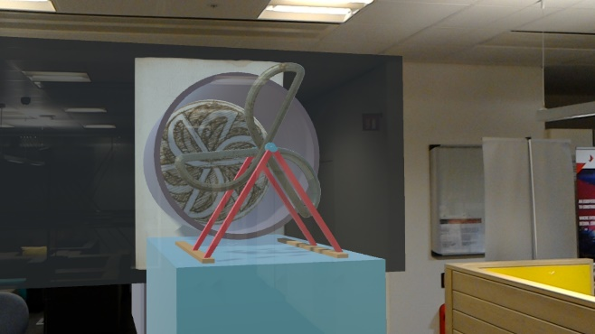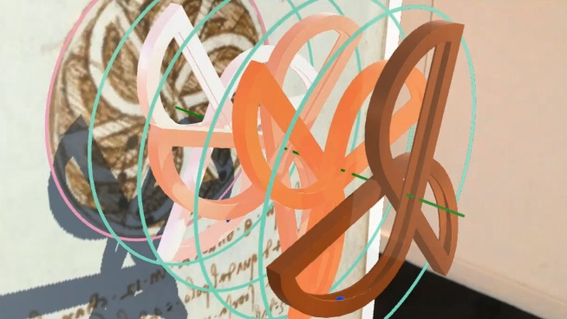
Fig.20 & 21; Early Augmented reality tests; authors own 2019.

Methodology: Codex Atlanticus Screen based solution.
As the curatorial team had requested the installation to celebrate the codex Atlanticus manuscript would be screen based. It was decided as we had explored the interactive possibilities a mix of media in the exhibition would be more interesting for the visitor and aesthetically pleasing. A screen based solution allowed a greater freedom to engage with a multitude of filmic solutions. The quality of the image, it’s texturing, lighting, cinematography and rendering, could be significantly controlled and finessed.
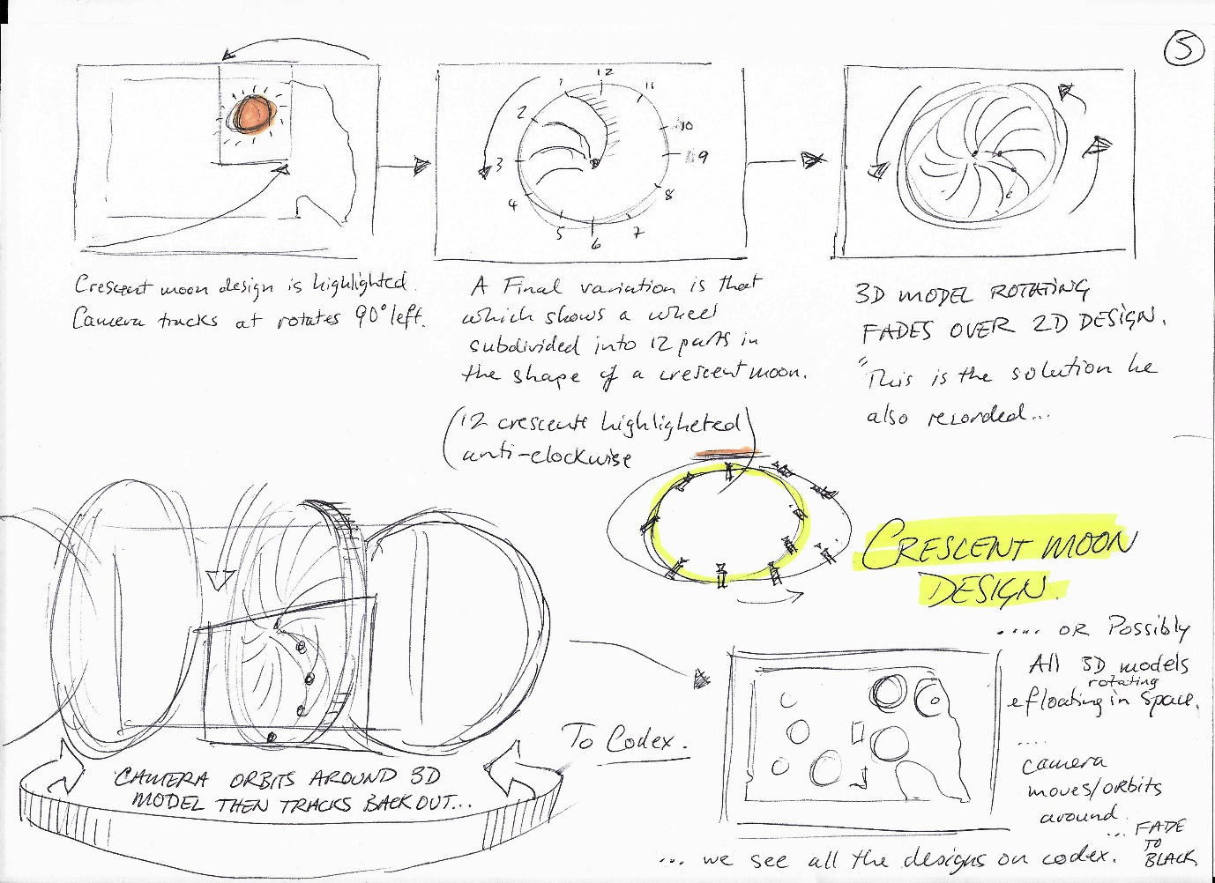

Fig.22, Previsualisations for camera moves; authors own 2019.

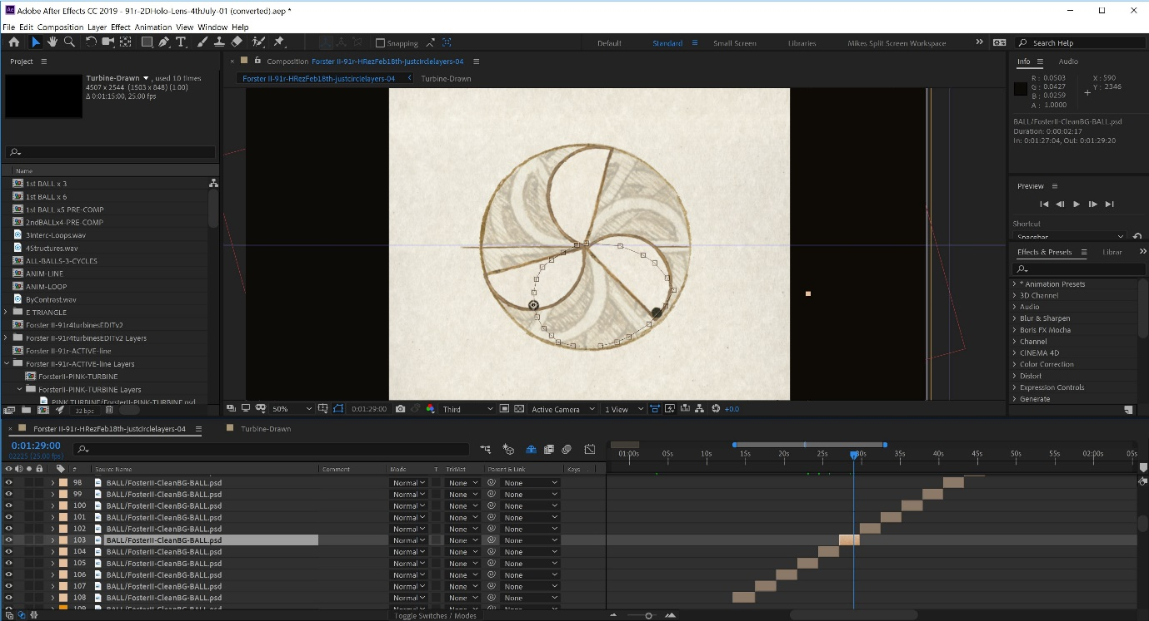
Fig.23, 2D animation workflow in Adobe After Effects; authors own 2019.

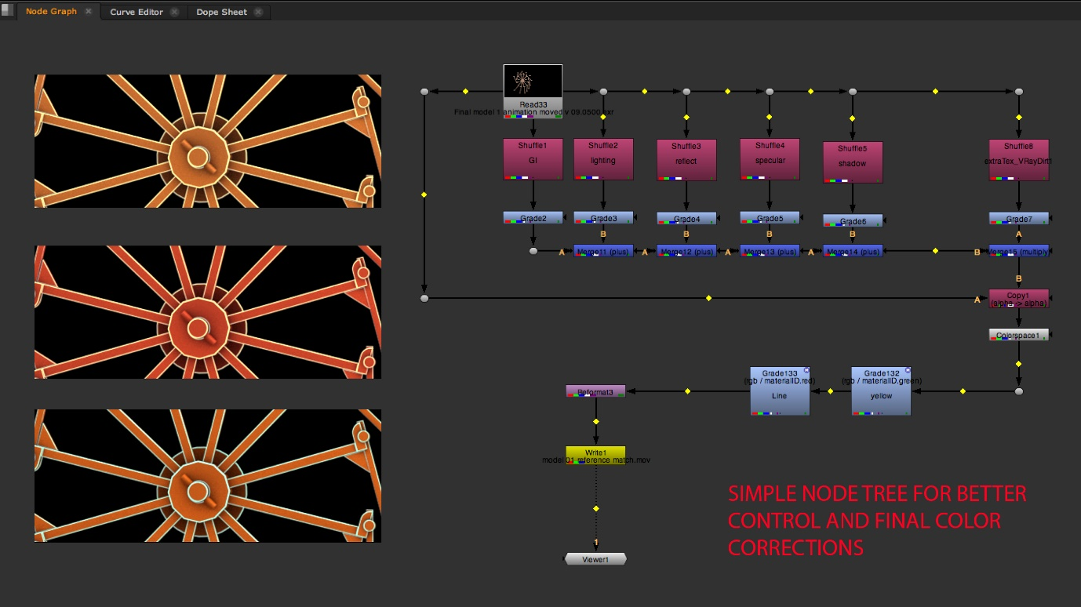
Fig.24, Post manipulation of layers in Nuke; authors own 2019.

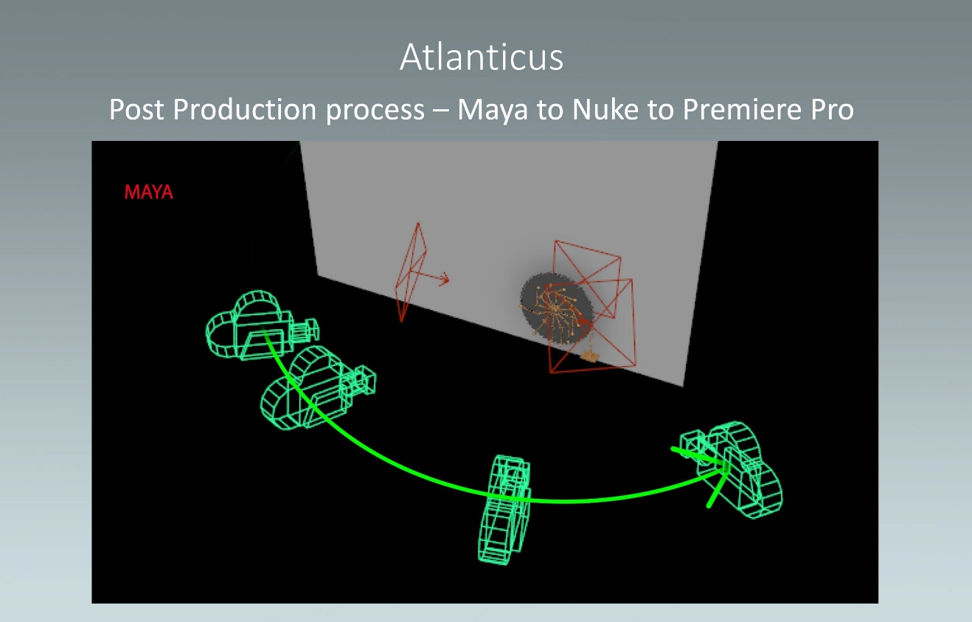
Fig.25, Atlanticus post production workflow techniques; authors own 2019.

Near the end of the process a student on Ravensbourne’s sound and music BA Hons course joined the team to produce copy right free sound effects and music. These had to be appropriate to the subject and in keeping with the needs of every user in and around the public space of the exhibition. I imagined the music would be most effective if it compliment the repetitive rotational cycles of the turbines. With this in mind I considered the music of Philip Glass. With its attention to minimalism and cyclical harmonic progression, his music had the potential to embody the rotational cycles of Leonardo’s turbines and establish a contemplative soundscape, suitable for this shared, public space. In particular I suggested the music student refer to the film score for “The illusionist”, specifically to the “Orange Tree” sequence. This resulted in him composing a highly appropriate and harmonious score. All of these processes and workflows resulted in a crafted film that celebrated the range and complexity of Leonardo’s perpetual motion designs. Placed within the structure of a timed overhead narration, accompanied by music and sound effects, it endeavoured to appropriately set the mood of the exhibition space, encouraging the viewer to be placed in a contemplative frame of mind.

url: Atlanticus Film - Final

