Time Keeper - 1616-2016
A Creative Solution for the 2016 Anniversary Celebrations to celebrate the 400-year anniversary of the building of the Queen’s House Greenwich

Output Description
The work submitted for assessment consists of one screen based installation. It was exhibited in the Queens’s House Greenwich between March and November 2017 as part of the anniversary celebrations for when building work commenced on the Queen’s House four hundred years ago. The installation can be viewed using the link below;

https://vimeo.com/211663847

This short film is designed to reveal to the viewer the significance of the location of Queens House. Its intention is to reveal how this site is part of a landscape possessing the necessary geographical landmarks to make it of unique strategic importance. In its panoramic sweep it encompasses all of maritime Greenwich and celebrates the unique nature of these interconnected sites; Royal Park, Observatory, Naval College, Museum and Cutty Sark, collectively known as “Maritime Greenwich”, recognised by the United Nations Educational, Scientific and Cultural Organisation UNESCO as being of "outstanding universal value" and reckoned to be the "finest and most dramatically sited architectural and landscape ensemble in the British Isles".

To capture the unique geographical nature of Greenwich I searched for an image that could act as a reference point for how Greenwich looked 400 years ago. I finally chose to focus on an etching from the National Maritime museum collection “On the banks of the Thames at Greenwich” by Wenceslas Hollar.

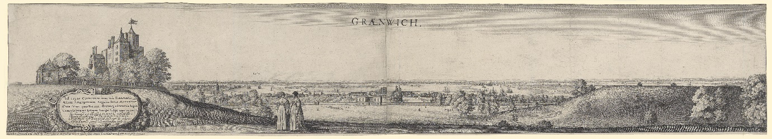
Fig.1 “On the banks of the Thames at Greenwich”, Wenceslas Hollar, 1637; NMM collection.

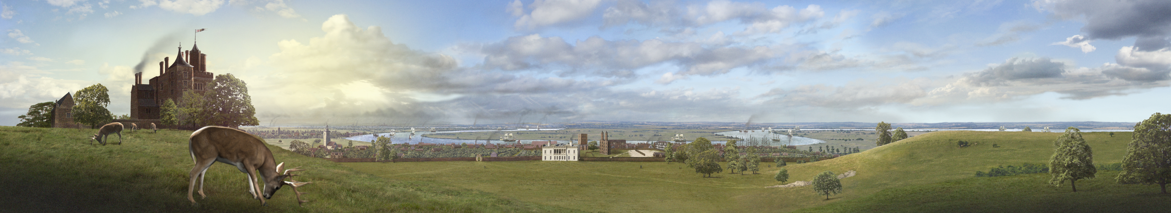
Fig. 2 Opening visual from the situated time based panorama; “Time Keeper”. Authors own

Etched 21 years after the start of construction on the Queen’s House, Hollar’s panorama reveals how unique the classical architecture was, it being the earliest surviving example of its type in the British Isles, It stands defiantly out of place, surrounded by its medieval and Elizabethan counterparts and acknowledges the ground breaking originality of the architecture of the Queen’s House and the genius of its architect, Inigo Jones.

Funding
I received payment of £6,500 for the completion of the film. This was negotiated in the last six months before installation. As well as paying to make sure the film was delivered on time this fee also covered my time spent on the project as well as the many technical expenses and travel expenses incurred from gathering primary and secondary research.

Introduction
The seed of the idea was born from returning to Greenwich in 2005, after a 30 year interval. It was here, from Observatory Hill, I viewed the vista, now populated by the skyscraper skyline of Canary Wharf. Curiously, once seen, I found it very difficult to retrieve my memory of the earlier landscape. Fascinated by this erasure was the seed for exploring the meaning of place and time passing. As Johnson notes; “Sustaining the slow hunch is less a matter of perspiration than of cultivation. You give the hunch enough nourishment to keep it growing, and plant it in fertile soil, where its roots can make new connections. And then you give it time to bloom '' (Johnson, S. 2010 p74) Ten years later, using the same view, I experimented a test alignment of Wenceslas Hollar’s 1633 panorama with the same view and sent it to the National Maritime museum. They invited me in to discuss and develop the idea, and in March 2016, offered me an internship in their design department.

Literature Review
The National Maritime Museum department responded positively to this initial idea and would consider the installation worthy to be exhibited during the 400 year anniversary. For this event the Queen’s House was to be completely renovated. With this information I was encouraged to research pieces produced by other creatives for similar launches and establish my research context. Firstly, exploring work with considerable budget and the ability to invest in the latest video projection technology, I considered exploiting the panoramic vista with the same scale and circumference as the stunning installation by T.J. Wilcox at the Whitney museum of Modern Art.

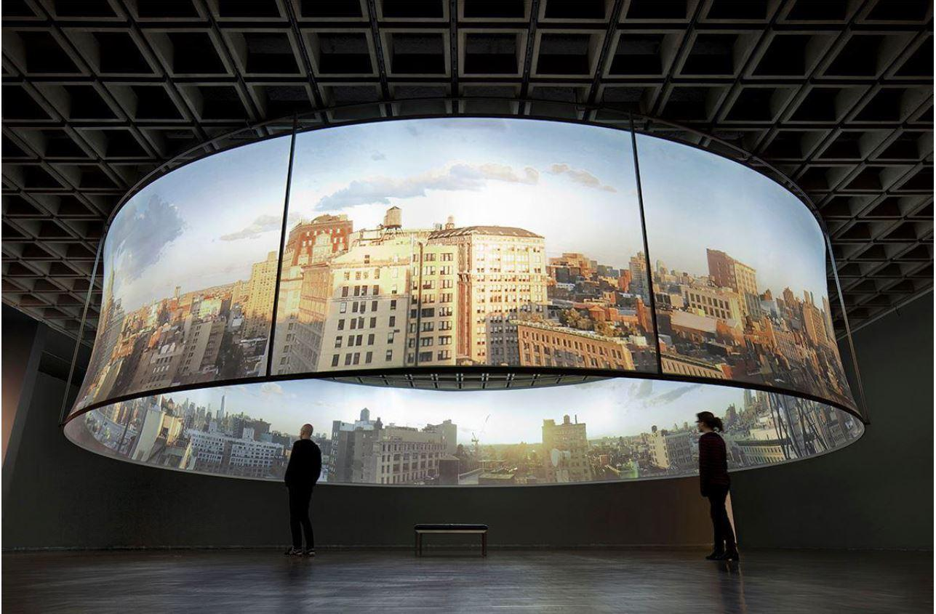
Fig 3: T.J Wilcox: In the Air. Panoramic film installation.

This installation presents a 360 degree, cinematic record of a day in the city, compressed into a 30 minute film interrupted with six short films inspired by the different views of the city. Despite the exhibition’s location in Grand Rapids Michigan, the distance from its geographical location suggests that, even though it demands that the viewer imagine themselves connected to the place, a connection with an iconic landmark can be achieved offsite. What this installation did make me appreciate was that the success of any re visualization of place depends on its unique historical and geographical quality. I realised Observatory hill contains more than enough shared cultural memory to be presented anywhere in the world. It would have the potential to imbue a personal connection with place. At the same time, by being able to exhibit the installation in situ, further opportunities became available for creating a more personal connection with place.
Another contemporary installation that influenced my thinking was an immersive moving image piece from 59 Productions installed at the time in Hampton court.

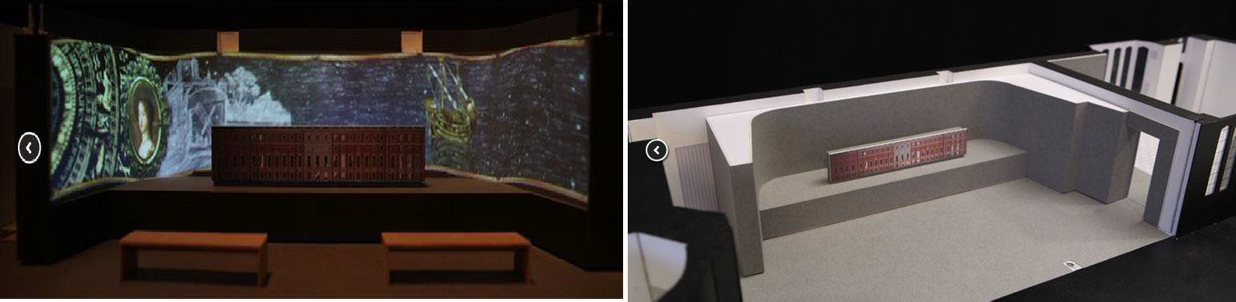

Fig. 4/5 59 Productions; The Baroque Story, installation at Hampton Court (59 Productions 2016)
I would argue this non-virtual, tactile installation approach combines the filmic, televisual, with a tactile intervention that breaks the illusion of world made as picture. It becomes an intriguing re-evaluation of one’s space in relation to the room, the model house and the palace. Like Gulliver we stare into the miniature rooms and watch as the hidden secrets of the doll’s house are revealed.
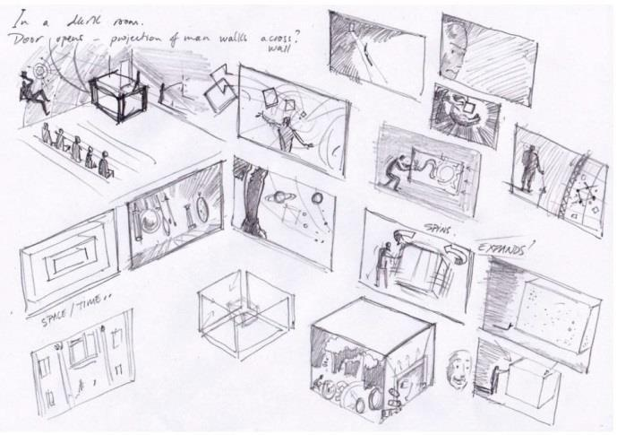
Fig 6: Author’s concepts for 3 dimensional and projection mapping installation (October 2016) authors own

I suggested these installation approaches to the National Maritime Museum team and this helped to focus attention to identify suitable available space in the Queen’s House. Although I was eventually assigned a fairly small space, an encouraging development was the promise of a bank of screens to showcase its panoramic scale. These offered me the potential of fully engaging my skills as a visual effects artist and guaranteed I could achieve the quality image and intricate camera moves, currently prevailing in film and television content.

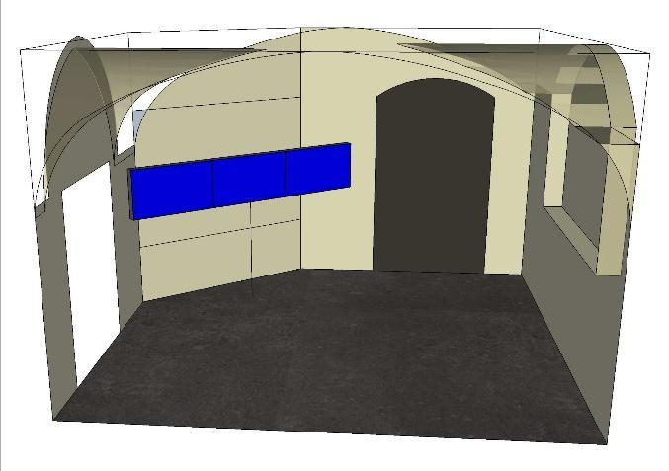

Fig. 7, NMM 3D visualization plans to inform the Panorama screen; NMM installation department.

The installation was eventually assigned space along the route visitors would walk to complete a tour of the house. As such it became fully integrated within the exhibition. The installation allowed the visitors to gain an overarching context of the site and put the building and its 400 year anniversary into context. It was presented on 3, 46-inch NEC hi-resolution Multi-Sync video monitors, each 1024mm wide by 578.6mm total a final aspect ratio of 11.5 feet long by 1 ft 10 inches wide. The screens were hung at a height of 5 foot within a false wall which supported the screens weight and hid the power cables and DVS media player. To enhance the immersive experience 5.1-surround speakers were installed.

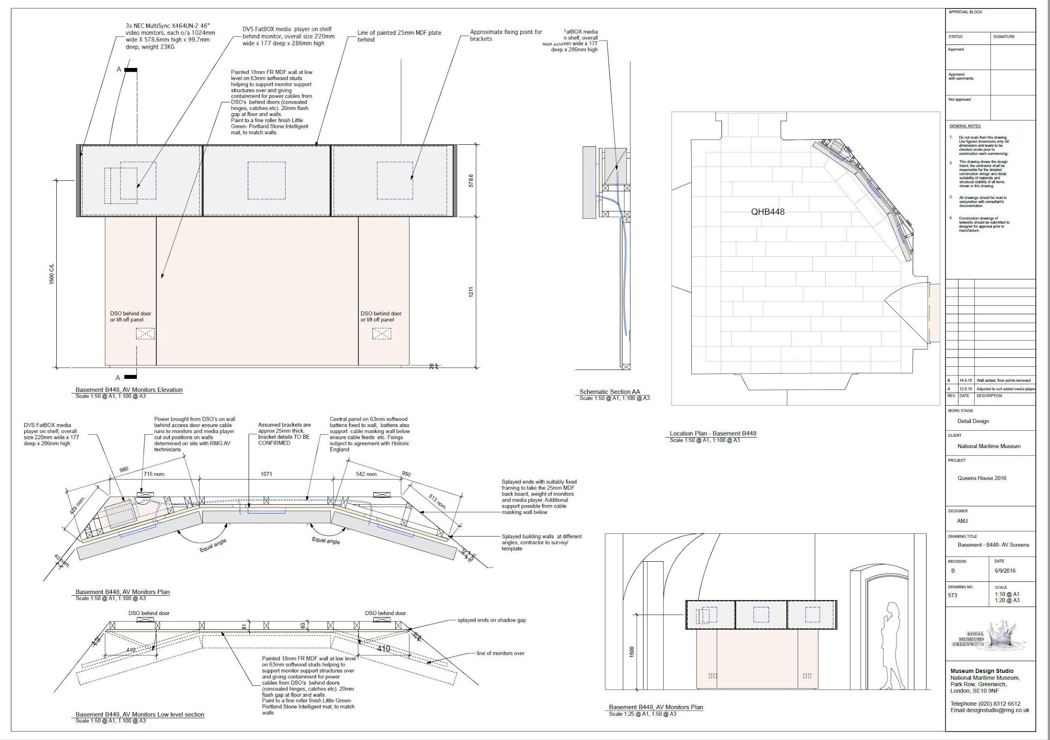

Fig.8 NMM engineering plan for 3 screen installation.

Impact of Work
Sophie Richards, Interpretation Curator, recently confirmed the positive impact the panorama installation has already had for the National Maritime Museum;
“The panorama has been on display in the basement of the Queen’s House since March 2017 and has been used as a stop on tours of the Queen’s House where a guide uses the film to introduce visitors to the changing landscape of Greenwich. I also included the panorama in my presentation given at the Queen’s House Study Day in November 2016 on the new interpretation strategy for the House”. There were 40 attendees at the Study Day; interested members of the public as well as professionals working in the museums and heritage sector. I am occasionally asked to present the interpretation of the House to other interested professionals or academic groups and I usually include the film in that presentation as an example of situating heritage in a changing landscape, and helping visitors to visualise the history that we are presenting in the House”. Temporarily replaced during Autumn/Winter 2017-18 with a film on the conservation of the Armada portrait the panorama will continue to have public exposure during this period through its online presence on the Royal museums Greenwich website. The installation has been very popular and every occasion, reactions have been very positive with people pausing and sitting in on the benches and standing, watching the installation”

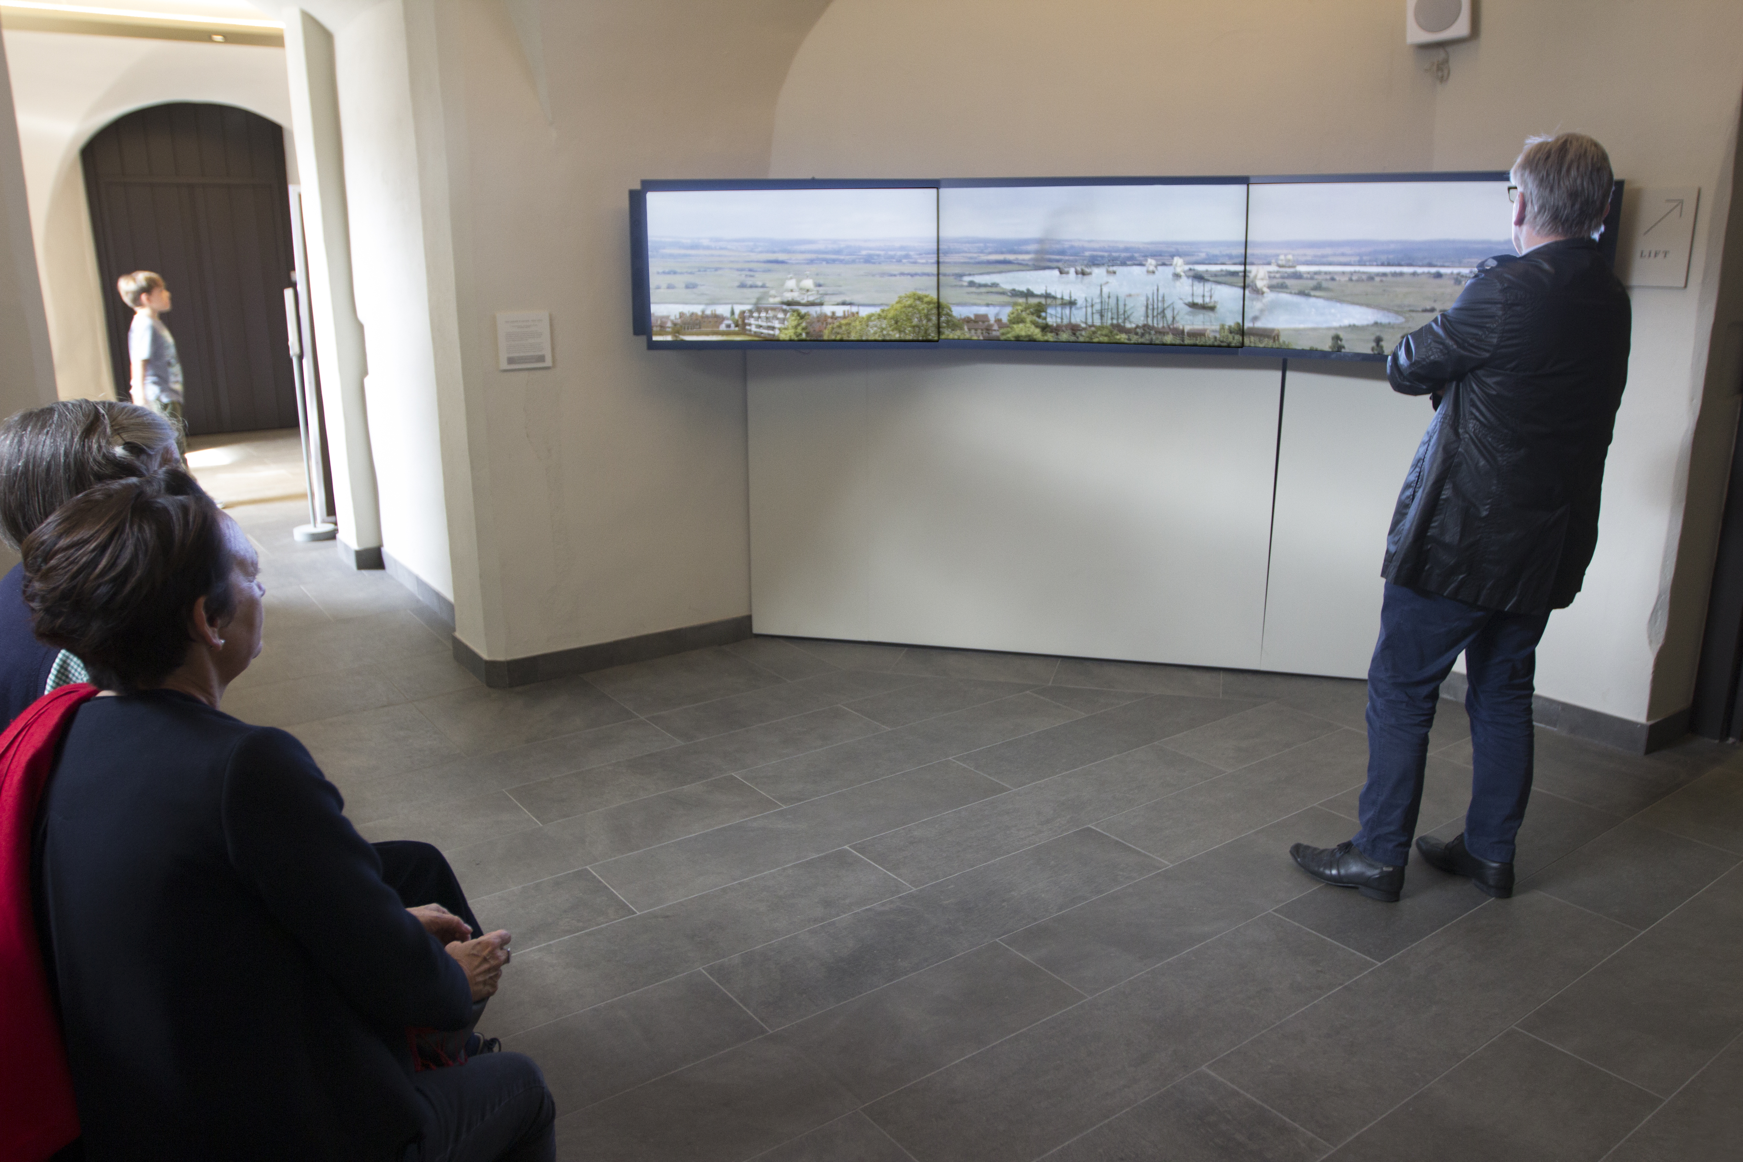
Fig. 16 Panorama installation in the Queens’ House, national Maritime Museum, 2017 authors own

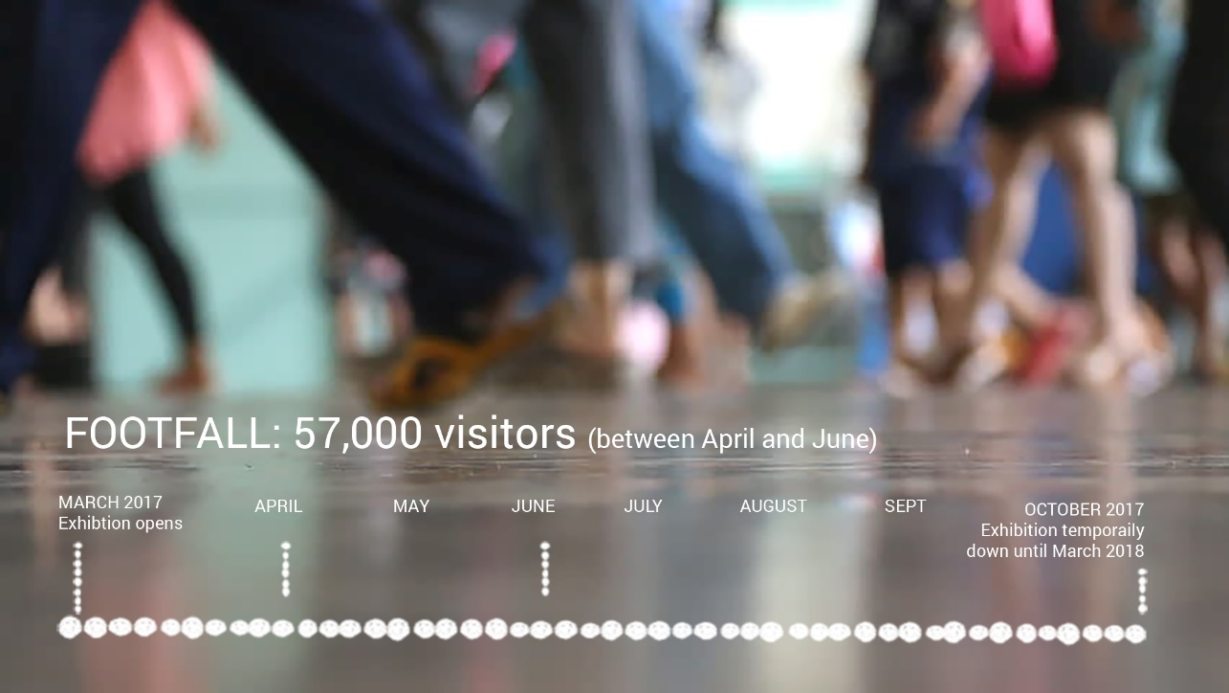
Fig.17; NMM Footfall March-October 2017. Authors own

The installation is located in a prime location to benefit from this increase in footfall positioned along a key route past the entrance to the Queen’s House and between the stairs and lift to the upper floors. The installation opened to the public in the Queens House in March 2017. Between April and June alone, 56% of visitors to the Queen’s House were international, indicating approx. 32,288 of the 57,658 visitors to the House in this period were from overseas. These figures suggest that during only three months in April, May and June 2017 alone the panorama installation has already experienced a footfall exceeding 50,000 people. Including September and early October the numbers could potentially exceed 60,000 footfall. The National Maritime Museum ranks nationally as the 10th most visited UK museum and has had an overall footfall this year of 2,451,023 visitors. These figures are from the museums official marketing statistics.

Research Outcomes
Mike Sarna, head of 3D objects, exhibitions and digital content at the national Maritime Museum, summarised the value he recognised in the panorama installation by saying; “People are just amazed by Greenwich. So that people can appreciate the importance of the site and the river, organized tours of the area have to be in context and I believe that’s where the value of the tools you have are so valuable. They can show people that there is a historical reason for the geography, buildings and objects”.

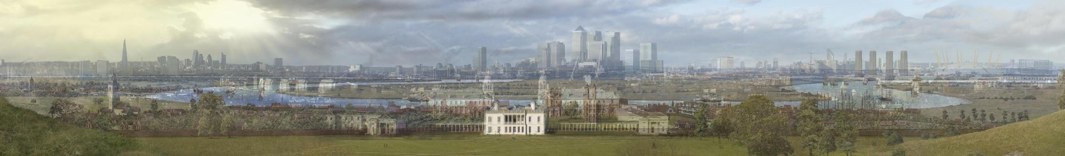

Fig.16; The view from Observatory Hill including visuals of multiple time layers illustrating, the geographic, ecological and human structural growth that has taken place in the last 400 years. Authors own

In August 2017, I gave a talk at an event organized by Martha Burns Findlay, youth projects producer at the Greenwich museums. Inviting me to take part in a two-week project, involving young volunteers from the borough of Greenwich, Martha designed a brief for the young people to design their own alternative trail of the Maritime Greenwich World Heritage site and create a film trailer or paper based trail. As a fusion between the historic and contemporary landscape of Greenwich, the panorama became a source of inspiration and inquiry for the local group. For me, this was particularly satisfying as it aligned with my original intention for the Panorama to be a situated experience, establishing a connection with place and reinforcing the importance of local community and identity.

Research Question
My core intent was to deliver a project which would take place in or around its location. That it would reinforce a connection with place. Finally that it would be as accessible and relevant to an international audience as well as for the local community. With this in mind I established the following overarching research question;

“How can I take Storytelling beyond the Confines of the Building and Make a Connection with Place?”

Research Method
I initially applied a quantitative research methodology. This approach statistically assessed my data and facts in relation to the technical and logistical questions involved in realizing the film. However, I needed to also align this data within a historical narrative. This required me to implement an over-arching qualitative approach. It allowed me to make lateral connections, identify trends and make informed generalizations. So I could make informed creative decisions and then reduce and interpret that data into creative moving imagery, I set about rigorously researching my subject. To inform myself about the Queen’s House and the Greenwich area I had the pleasure in researching a multitude of historical books and articles many of which were supplied by the National Maritime Museum’s collections. These early 17th century views of Greenwich greatly assisted in establishing an informed overview of how my research shaped the production of the piece.

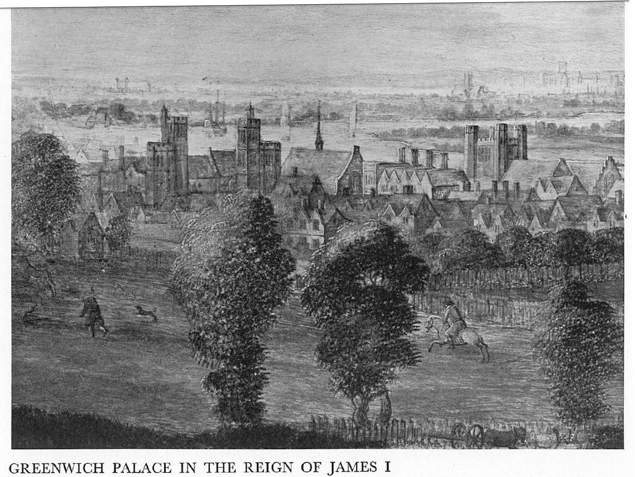
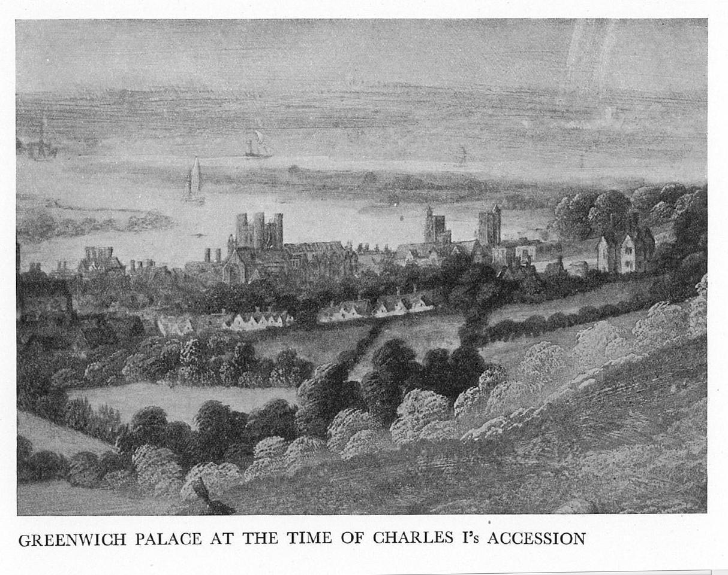
Fig; 9&10. 17th century Etchings of Greenwich, NMM collection.
It directed my research to see if any similar buildings are still standing, to visit them and gather primary reference to further inform me of the buildings in the Hollar Panorama and where appropriate, photo manipulate elements of them to inform the piece. My visit to Hampton court revealed to me its architecture was similar and of the same period as the palace of Placentia. Using primary photo reference I manipulated the images to rebuild Humphrey’s castle.
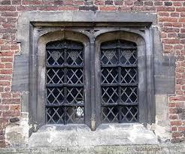
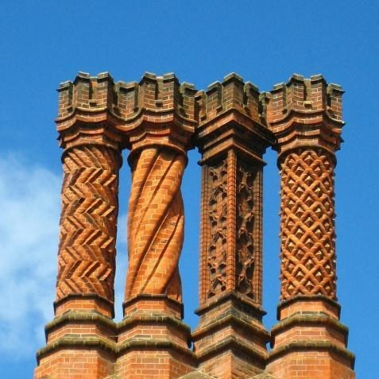

Fig 11, 12. Window reference taken at Hampton Court palace.

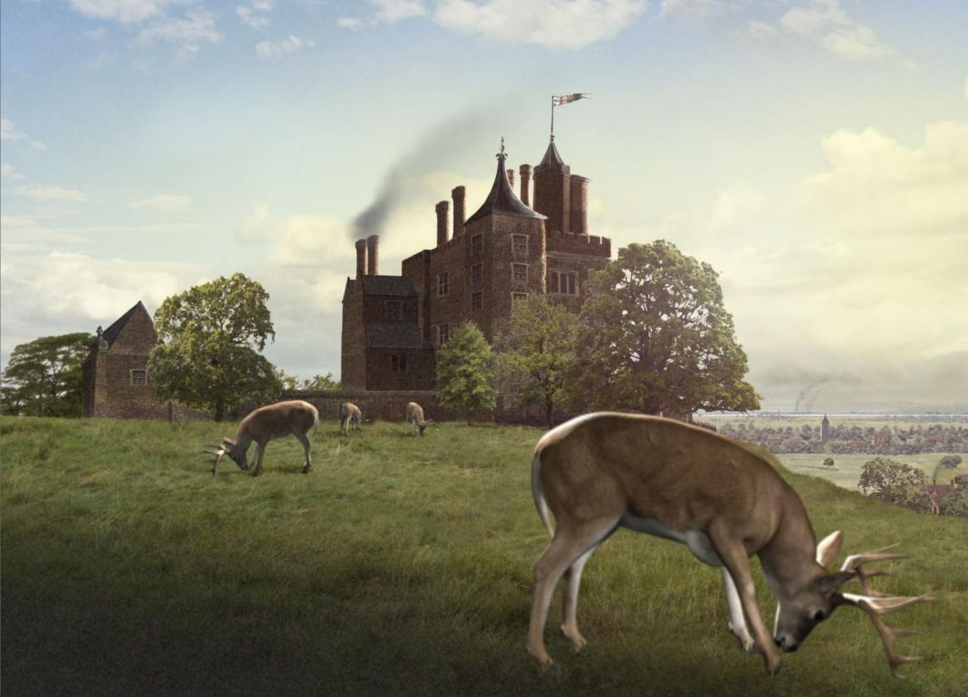
Fig 13. Time Keeper representation of etching below. Authors own.

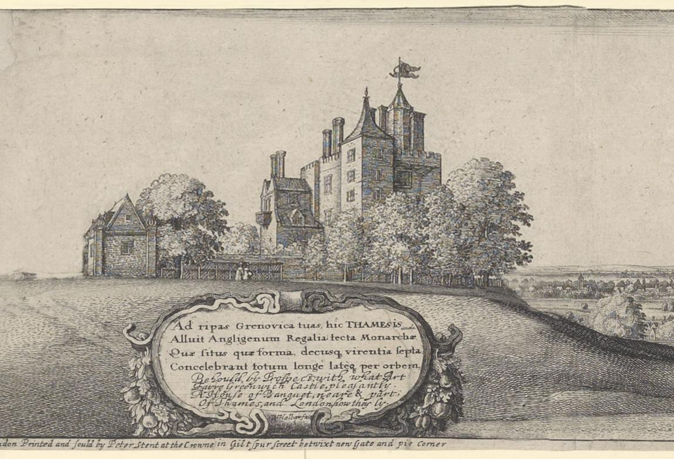
Fig 14. Corresponding section from Hollar’s etching

Historical research also revealed that despite 17th century London being surrounded by fields and countryside the coal burning fires from the city of London created a smog over the city which would occasionally drift with the wind. John Evelyn, who lived in nearby Deptford, was so incensed by the foul smelling smog he wrote in his Fumifugium of 1661; “railed against the burning of sea coal in grates, in the brewing, baking and boiling trades, in the thousands of glass houses, potters kilns, blacksmiths and gunship shops, and dyers yards that choked the backstreets”(Porter, p120). To capture this world I created a multitude of 3D particle smoke animations and then scaled and multiplied them throughout the piece. I then added a distinct smog cloud above the city of London.

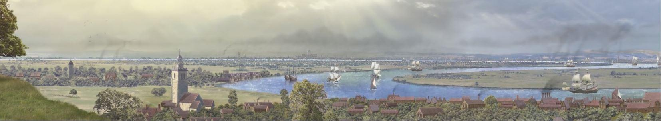
Fig. 15 Time Keeper view towards London with Smog and chimney smoke. Authors own.

Conclusion
My aim was to reveal, as if through a collective memory, 400 years of urban development. While intending to entertain I also encourage learning and contemplation. I now appreciate there are boundaries in this sector a creative must respect and acknowledge; museums are not theme parks. They are ultimately places of learning, dialogue and contemplation. Museums can greatly benefit from engaging with visual technology solutions but these solutions must be appropriate. Both global and local communities might ask from this interpretation, how might London most effectively deploy its resources to create a future global city and community? I hope this installation has encouraged debate about how past, present and future current political, ecological and social decision making has and will affect future generations. If it has in any way revealed to the visitor a historical perspective, that by standing back and viewing, as if from a vista, a sudden insight and awareness of a connection with one’s past, present and future, then this installation has successfully challenged our understanding of time and the human legacy. I present as evidence of this success the results of the youth project I attended at Greenwich along with the comments listed above, made by Mike Sarna, Sophie Richards and the considerable numbers of people who saw the panorama, in total over £30,000 international visitors and 20,000 UK and local people.
This was the first time I had engaged with a museum client and the experience revealed to me that museums are in a process of re-inventing themselves. They are no longer the custodians of a nation's heritage. By challenging colonial and imperial concepts museums can now act as spaces to re interpret the past, give meaning to the present and curate possibilities of our future. Art works in their collections can be continually re represented to present alternative, playful views of any cultural context. Their meaning can be challenged and re-interpreted. In this way famous art can be more than just venerated objects in impersonal, sterile gallery space. My conclusion suggests the role of the museum is to no longer act “as gatekeepers to the interpreters of cultural memory” (Kidd, J 2014 p22) but rather to become the distributors and fictive suppliers of premium, specialized and situated knowledge. I believe a community can still derive a shared understanding of place. As a media maker, I relish the possibilities my creative content might have to enrich our shared cultural understanding.

Bibliography
My research for this project was informed by the following references;

Craig, C., Diprose, G. and Seaborne, M. (2009). London's changing Riverscape. London: Frances Lincoln.

El Beyrouty, K. and Tesslar, A. (2013). The Economic Impact of the UK Heritage Tourism Economy. Oxford: Oxford Economics.

Kidd, J. (2014). Museums in the new media scape Farnham: Ashgate.

Oleksijczuk, D. (2011) The First Panoramas. Minneapolis: University of Minnesota Press.
Paiech, S. (2015) Scenography and Genius Loci [online] Artship, a San Francisco Cultural Initiative. Available at: http://www.artship.org/inquiry_paper_scenography.html [Accessed 14 Aug. 2015].

Salter, J. (2015) Towards an NMM Audience Development Strategy 1st ed. London: NMM.

Tindall G, (2002) The Man Who Drew London, Random House, London.

Vaz, M. and Barron, C. (2002). The Invisible Art. San Francisco: Chronicle Books.

UNESCO world Heritage site: online
Available at; https://whc.unesco.org/en/list/795/ (accessed 3rd Aug 2017)

