Chapter 29
Digital Roadtrips: the shifting landscape of digital art shows
This is a post-peer-review, pre-copyedit version of a chapter published in Giannini T., Bowen J. (eds) Museums and Digital Culture. Springer Series on Cultural Computing. Springer, Cham.

The final authenticated version is available online at: https://doi.org/10.1007/978-3-319-97457-6_7.
Dr Nick Lambert, Head of Research, Ravensbourne University London
Abstract Digital art exhibitions have been held since the early 1960s. Over fifty years, they have stimulated artists using computational media to develop their work. Several key exhibitions helped to define the area of “digital art”, insofar as it exists as a separate area of art practice, and have assisted this developing medium by favouring certain aesthetic and critical preferences. This paper will look at selected exhibitions and prizes, and consider their influence and impact. Key questions include: issues of scale, the perception of digital art, the development of the forms within it and the expectations of artists involved; and promotion of this medium to the general public.
Introduction
Art made with computers has been shown in a variety of settings since the mid 1960s when the first digitally-mediated works were shown in Stuttgart and New York. At that time, there was a broader interest in art created using various forms of high technology, and groups such as Experiments in Art and Technology were founded. Beyond this, the emergence of kinetic art and video / TV art demonstrated that new artistic media gained some acceptance in the post-World War II artworld. In the decades since then, video art has been largely accepted as a gallery medium and kinetic art has a place within the wider area of installations, but computer-mediated art (i.e. both created and shown using digital systems) has only attracted sporadic interest in the mainstream. According to art historian Christiane Paul:

The term "digital art" has become an umbrella for a broad range of artistic practices and does not describe one specific aesthetic. Artists have used digital technologies as a tool for creating an art object, such as a sculpture created through rapid prototyping, a print, or a digital photo and video. In some cases, these works display distinctive characteristics of the digital. In others, it is not easy to tell whether the work has been created by means of digital or analog technologies. [Paul, 2003, p472]

Therefore there are degrees of “digitalness” evident in these works that rather determines their reception as obviously computational or not. Certainly the general public has become used to reading images as “digital” due to obvious characteristics such as pixellated edges; however the diversity of digital artworks does not depend on the presence of these forms. However, the philosopher of aesthetics Dominic McIver Lopes distinguishes between “digital art” in the general sense and a more specific class of “computer art”. Whereas digital technologies can be used to extend earlier artforms – viz digital filmmaking, digital photography or digital music – McIver Lopes looks for a more fundamental difference between computer art and other areas. He comes up with a theory of computer art that hinges on interactivity as a key characteristic of the new art form:

an item is a computer art work just in case (1) it’s art, (2) it’s run on a computer, (3) it’s interactive, and (4) it’s interactive because it’s run on a computer. [McIver Lopes 2010, p27]

On this basis, McIver Lopes identifies aspects of the interactive experience that engages the viewer in a more direct way than previous artworks. He also extends the “art” boundary to include video games, connecting to work that usually sits outside the typical art gallery but has risen to become a new area of creative endeavour to rival the film industry. Certainly, many interactive art works partake of a gamelike experience, and some games have been exhibited as works of art.
In my own thesis, I proposed an additional aspect: the impact on the artist of the intrinsic qualities of the digital medium. The immaterial yet quasi-physical aspects of the computer image make it malleable, ephemeral and yet an expression of mathematical processes; in other words, the medium itself is significant. Without this, the interactive aspects would be impossible.

[There] is a twofold rupture between Computer Art and all traditional art because:

i. the artist manipulates information directly, without the limitations that are intrinsic to a physical medium;
ii. the computer can respond to the artist during production and the viewer after production, or even act as a creative agent in its own right if programmed to do so.
I propose that artworks must satisfy both points in order to qualify as Computer Art, which is distinguished from other artforms because these two qualities occur in combination. [Lambert, 2003]

With this in mind, it is appropriate that the term “computer art” existed in distinction to “digital art” and is not merely historically defined as belonging to the early period of experimentation with computers (as Christiane Paul suggests). Rather, computer art points towards something new. It was this fact that led to the foundation of the Computer Arts Society in the UK in 1968 with a manifesto that focused on the computational aspects of the arts (in plural, and not merely the visual). It is also significant that the first artistic project by the CAS was in fact an interactive work called Ecogame (1970).
In terms of its history, the earliest computer art arose in the climate of general experimentation with advanced technologies in the arts and undoubtedly benefited from the attention given to Art and Technology. This resulted in some large and well-funded exhibitions such as “Nine Evenings”, organised by Experiments in Art and Technology (EAT) at the New York Armory in 1966. Until the early 1970s, these shows tended to receive funding and support from museums and patrons, but a changing social and economic climate consigned the large-scale art and technology movement to the utopian aspirations of the 1960s.
Despite this changing context, computer-based works of art were shown in smaller galleries, some museums and non-art venues such as computer trade shows. Organisations like CAS fostered an art scene that continued in spite of official indifference to this new art form. Following the emergence of Net Art and New Media art from the mid 1990s onwards, computer-based art has attained a higher profile but exhibitions at large venues remain comparatively scarce. The typical venue for much digital art remains festivals, conferences, and small art galleries. These require flexible approaches to display and presentation that utilise the advantages of digital formats but also require a high level of technological support that is rarely found in the domain of art galleries. Thus travelling exhibitions of computer art have to provide their own expertise and understanding to meet the needs of these smaller venues whilst showing the work to its best advantage.
Over the past six decades, computer artists have innovated in significant ways but many of the concepts they explored were never taken to conclusion due to primitive technologies and changing art practices, which consigned many of these ideas to obscurity. An initial burst of enthusiasm for “Art & Technology” in the 1960s was followed by several decades of widespread disinterest in the mainstream artworld for computational art.
A conference I co-organized in 2010 at the British Computer Society was inspired by this suggestion in Brian Reffin-Smith’s article in White Heat, Cold Logic:

There is a mine, a treasure trove, a hoard - I cannot emphasize this too strongly - of art ideas that emerged in the early decades of computer art that still have not remotely been explored. We know how this happens. The next big thing comes along and the Zeitgeist has its demands: things get left behind… [Reffin-Smith, 2008, p388]

In response to this, I gathered together computer art pioneers, theorists and historians under the title “Ideas Before their Time” to discuss areas in which computer arts had emerged in the period 1960-2000. I well remember the splenetic reaction of Alan Sutcliffe, one of the three original founders of the Computer Arts Society, who attacked the very title of the conference. “They were not ideas before their time,” he declared, “they were ideas of their time.!”
This stuck with me and I have since looked for the continuities between the early computer artists and their precursors, instead of simply emphasizing the break between previous artforms and the digital; though this rupture formed the basis for differentiating computer art. From Jack Burnham onwards, theorists of the digital medium have often emphasized its radically disjunct nature, its unprecedented arrival and the division between the virtual and the real. Yet there is also a case for seeing it as the organic evolution of a desire for externalizing the human visual imagination onto a new surface, be it the walls of the cave, canvas, silver nitrate paper or a CRT screen.
For artists who grew up since the 1980s and might be considered "born digital", computer imagery is ubiquitous and therefore part of a widespread culture. To utilize computational processes in creating art does not suggest subscribing to a set of shared values. Whereas the pioneer computer artists were strongly influenced by High Modernism and also the first wave of Conceptual Art, the disparate range of influences on modern digital artists is much larger and often drawn from digital culture in the widest sense.
Obviously there are artists who work with data and whose aesthetic is based on their source material. Ryoji Ikeda's 'Test Pattern' series is one such example, and the recent staging of test pattern [N°12] in September 2017 at the Store X on the Strand in London showed the impact of large-scale digital works on the public. [Spice, 2017] Visitors’ responses to being immersed in a room-sized projection of live AV data visualized as monochrome bars demonstrated a growing familiarity with the tropes of digital imagery that suggests a broader appreciation for computer-based art. Ikeda’s work was projected in a large dark space and the audience was fully contained within the projections, an experience that could seem hypnotic and disorienting at the same time. It was dynamic and sculptural, an all-encompassing work with a suitably driving soundtrack.
In some respects the linear data-driven imagery of Ikeda connects back to the classic works of nascent "computer art" from the 1960s. These generally followed a Constructivist schema and was mostly highly abstract, as much a consequence of the technology of the time as the aesthetic preferences of its main exponents. With the exception of early animations by Ed Zajec and Tony Pritchett, and robotic and cybernetic sculptures, the majority of computer-based art was experienced as prints on paper because this was the primary graphical output from computers of the era. Early interactive computer systems were rare and staggeringly expensive, attached to mainframes and therefore unavailable for public access. However, the promise of computer-mediated art was already drawing significant interest by the time of “Cybernetic Serendipity” at the ICA in 1968, and as will be described below, a series of very large art shows drew attention to the creative potentials of computers and allied visual technologies.
This paper will contrast the scale and budget for these early exhibitions with the “grassroots” efforts that kept promoting computer-based art after the significant reaction against the “Art and Technology” paradigm in the 1970s. This curtailed the availability of large venues with significant technical budgets until the re-emergence of digital art as “Net Art” and “New Media Art” in the late 1990s. In this interim period, organizations such as the Computer Arts Society and later SIGGRAPH and Digital Salon promoted computational creativity through smaller exhibitions.
Fortunately, this period also witnessed the rise of desktop and home computers with significant graphical and multimedia capabilities, and the development of increasingly high fidelity display systems that made the public display of born-digital art feasible. It is still rare for galleries to be fully equipped with sufficient hardware to mount large digital art shows, but computer artists and curators have faced this challenge by developing their own technical expertise. The examples of the New York Digital Salon and the more recent Lumen Prize demonstrate the significant technological overheads that need to be overcome in order to exhibit computer artworks in their own medium.
As well as works that are wholly computer-based, there are new kinds of "electronic art" where the computer is merely part of the infrastructure of the work. However the digital aspect brings with it a significant overhead in terms of installation, electrical power, mounting and positioning of screens, projectors and digital interfaces, and the overall presentation of the work in a traditional gallery setting. Having spent much time installing and presenting computer art, as well as writing on it, I would like to reflect on these aspects in the course of this essay.
EAT and Cybernetic Serendipity
Billy Kluver and Robert Rauschenberg first conceived of Experiments in Art and Technology (EAT), the progenitor of much of the technological arts activity that followed, in 1966 following Kluver’s earlier work with Tinguely on behalf of MOMA in 1960. EAT intended that artists should be able to utilize the latest in contemporary electronic equipment. With the support of Bell Labs and later other corporate sponsors, they commanded budgets in excess of $100,000 and significant technical support as well. A series of performances was held in October 1966 at the New York Armory by artists and performers including John Cage, Lucinda Childs, Robert Rauschenberg, David Tudor, and Robert Whitman. They collaborated with over 40 engineers and scientists from Bell Telephone Laboratories using specialist equipment that was used as an integral part of the event. [Vasulka, 1998] This was due to Bell Labs’ support for Kluver’s ideas and the perceived benefits for their corporate image.
The scale and availability of expertise meant that the first EAT show was produced on a scale associated with theatrical events rather than an art exhibition. Given its ‘live’ nature and the complexity of the setup, it is hardly surprising that the failure rate was high and it was lambasted for its numerous technical issues. However its scale of ambition certainly inspired other similar events.
When Jasia Reichardt assembled the funding for ‘Cybernetic Serendipity’ in 1968, on a model inspired directly by EAT’s activities, the Institute of Contemporary Arts (ICA) in London managed to raise £20,000 including £5,000 from the Arts Council. This was about a third of the cost of the contemporary Matisse show at the Hayward Gallery (at £60,000) and the equivalent amount in 2018 would be around £330,000. [MacGregor 2008, p86]
By comparison the ICA spent a total of £604,585 on its exhibitions in 2017, which provides some idea of the scale of Cybernetic Serendipity. [Institute of Contemporary Arts, 2017] When costs of current UK travelling art shows were assessed in a 2016 survey by the Touring Exhibitions Group, it found that the average cost of a touring exhibition is £62,500 although many groups are producing them with budgets of £5,000 or less. [Dew, 2016] Even today, then, Cybernetic Serendipity would rank as a very significant art exhibition.
Despite its subsequent success in terms of visitor numbers, Cybernetic Serendipity never gained as much corporate support as intended. Brent MacGregor records the results of the ICA’s fundraising which started in December 1966:

The ICA held a press conference in December of 1966, announcing the planned exhibition and commencing the process of fundraising [...] letters went out to over two hundred firms seeking support. This eventually futile search for sponsors led to some of the tight-fisted corporations being named and shamed at the exhibition press launch. [MacGregor, 2008, p85]

Cybernetic Serendipity joins the somewhat ignominious list of large 1960s Art and Technology ventures begun by Experiments in Art and Technology’s ‘Nine Evenings’ show in 1966 that Jack Burnham lists in his doleful article “Art and Technology: The Panacea That Failed.” He estimates the cost of ‘Nine Evenings’ at around $100,000 plus a further $150,000 of donated time and equipment; its Pepsi Pavillion at Osaka in 1970 at $405,000 (which caused Pepsi Co to pull out funding the event); ‘Software’ at the Jewish Museum NYC in 1970 at around $75,000; and Maurice Tuchmann’s five year ‘Art & Technology’ programme at the Los Angeles County Museum of Art at ‘between $500,000 and $1,000,000’. [Burnham, 1980] For comparison, $100,000 in 1968 is worth around $700,000 in 2018.
One of Burnham’s principal lines of attack on these “mega projects” was the paucity of their artistic results versus the cost and complexity of staging them, in which he includes his own Software exhibition. Even so, Cybernetic Serendipity’s reputation has survived the years rather better than the others and was measurably more successful at the time, in terms of visitor numbers and positive press coverage.
Whatever the outcomes of individual shows, the phase of large technological art exhibitions of the 1960s was never again repeated and the largesse given to these exhibitions resulted in the mythology surrounding them later.
The Computer Arts Society
By contrast, the low-key model of small exhibitions practiced by groups such as the Computer Arts Society was more durable and as the availability of computers increased through the mid-1980s onwards, it became possible to show various kinds of digital outputs in a variety of venues. Although cost remained a key factor, the other constraints around technology became somewhat less problematic as display devices multiplied.
The first Computer Arts Society exhibition, ‘Event One’ was staged at the Royal College of Art in 29-30th March 1969 following the Society’s foundation in 1968. The show was intended to showcase the range of artistic outputs that were being developed using computational means at the time, hence the “Arts” in the Society’s title rather than “Art”. This resulted in different media including sculpture, a DEC PDP-7 minicomputer, performances and computer-generated films, as well as the pen plotter drawings that came to characterize this era of computer-based art.

As with other art and technology exhibitions that were located in educational establishments, ‘Event One’ benefitted from the collaborations that existed between the RCA and nearby Imperial College:
The Royal College of Art was chosen as a venue because a number of CAS committee members had associations there. This included the architect Ian Pickering who was teaching there. In addition Lansdown knew Patrick Purcell, an advocate of interdisciplinary work at the RCA since 1964 […] Purcell persuaded Professor Bill Elliott at Imperial to loan the PDP-7. [Mason, 2009]

Thus the cost and complexity of mounting such a technically challenging exhibition were mitigated by the expertise available to the organisers. As a launch for the new Society it was a considerable success with over 700 visitors; however its range of media meant it required significant ongoing technical support for the duration of the show. [Mason, 2008, p121]
For this reason, many later CAS exhibitions were on a much more modest scale and consisted solely of prints and some films, which toured as a collection to various galleries in the UK and internationally. When the Society’s collections were archived in the early 2000s there was little digital material amongst them, in terms of magnetic media and other formats. Ironically this facilitated their preservation by the Victoria and Albert Museum where CAS provided the original bequest to their Computer Art Collections. The V&A were able to use their considerable expertise in conserving prints and drawings to preserve the paper-based archive from CAS and the two-dimensional works are now regularly exhibited in various venues. It would seem that CAS’s “low tech” approach to exhibitions paid dividends in terms of creating a future legacy.
The later Computer Arts Society exhibition “Interact: Man, Society, Machine” (1973), was part of the Edinburg Festival Fringe. This typified another venue where computer-based art was often represented: arts festivals. With a total budget of £3000 from the Scottish Arts Council (worth around £30,000 in 2018) [Mason, 2009], CAS commissioned four artworks: Edward Ihnatowicz’s The Bandit, John Lifton’s Green Music, Anna Valentina Murch’s Tent and Stephen Willats’s Edinburgh Social Model Construction Project; in addition to prints of graphic output by Manfred Mohr, Herbert Brun and others; and various live events. With the scope afforded by this grant, CAS was able to curate and present another technically complex exhibition. [Computer Arts Society, 1973]
CAS continued to stage various exhibitions until it was effectively suspended in 1985, returning in 2006 as part of the CACHe Project to reflect on the history of computer art. Since 2006, CAS’s funding model has consisted mainly of charitable support from its parent body, the British Computer Society plus additional funding from the Arts Council England for specific projects, such as “Null Object: Gustav Metzger Thinks About Nothing” with London Fieldworks, Gustav Metzger and Black Dog Gallery in 2013. [Gilchrist & Joelson, 2012)
In my capacity as Chair of CAS, I have helped to stage and curate exhibitions in conjunction with Kinetica, the Lighthouse in Brighton, the Phoenix in Leicester and numerous other organizations. These are all collaborative events with larger arts organizations and typically involve around 12 to 20 artists’ work. The majority of the exhibits are shown on screens, though printed and 3 dimensional works of various kinds are often shown. The budget for these shows is usually around £2000 and rarely exceeds £5000 but we benefit from contributions of time, space and effort from our collaborators. Obviously the artists themselves often provide equipment and expertise in setting up their work. Such exhibitions continue the CAS tradition of small grassroots computer art shows.

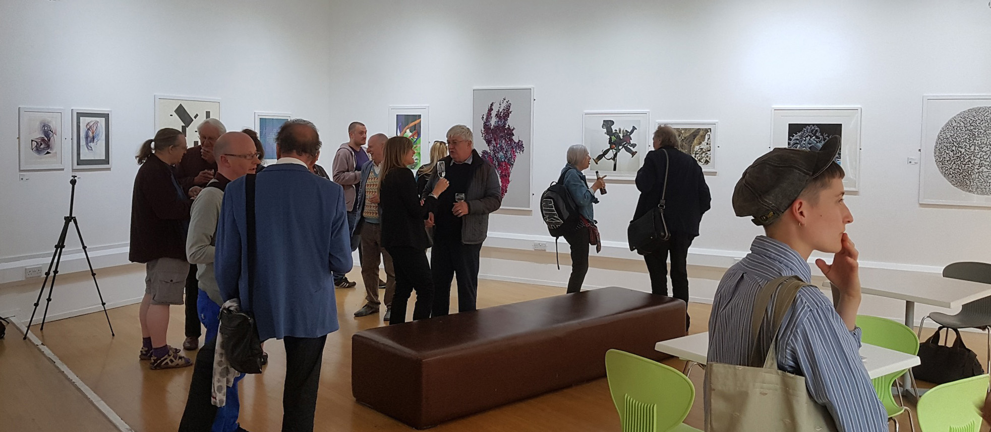
Fig 1.1 CAS50: Fifty Years of the Computer Arts Society exhibition at the LCB Lightbox Gallery in Leicester, 23rd May 2018

From the 1970s onwards, in the face of limited interest from large cultural institutions concerning the area of computer-based art (as opposed to, say, video art in the same period), there was an increased tendency towards small exhibitions within conferences and trade shows. This route was praised by Jonathan Benthall in 1970 when he reviewed the Computer Arts Society’s seminal contribution to the Computer 70 trade show, the Ecogame:
The Computer 70 exhibition at Olympia in October was not the first trade exhibition to have included an art contribution as the centrepiece. The idea seems a good one, and could become a traditional medium of patronage. Such occasions involve the exchange of large sums of money, so that the costs of financing the art contribution (whatever it may be) can be absorbed. [Benthall, 1970 pages 229-230]

The Ecogame was itself a significant piece of early computer-driven interactive art that received sponsorship from Computer 70 and was later presented at the inaugural European Management Forum at Davos in 1971.

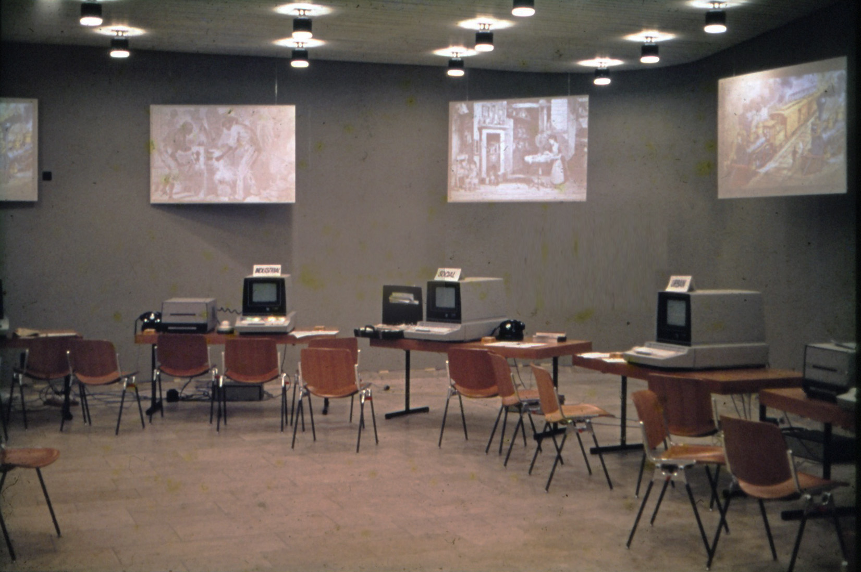
Fig 1.2 Computer Arts Society Ecogame at Davos European Management Forum in 1971. (Courtesy of George Mallen)

The SIGGRAPH Art Show
Benthall’s prediction also proved quite prophetic in terms of the development of the computer art exhibition at the SIGGRAPH computer graphics trade show in the USA. SIGGRAPH had run since 1974 as a Special Interest Group within the Association for Computer Machinery (ACM), which had shown occasional exhibitions of computer art at conferences, such as that in New York in 1970. In 1980 that the artist Darcy Gerbarg proposed a dedicated art show, Computer Culture Art, at SIGGRAPH 81. Though its scope was initially limited, Gerbarg made use of an existing exhibition, High Art Technology, that had been shown at the Library of Congress in April 1981. The works themselves were two-dimensional prints that could be mounted and displayed in a traditional gallery setting, and were a cross-section of contemporary American digital artists. [Prince, 1989 pp. 3-5]
By 1985 the SIGGRAPH Art Show had considerably enlarged and diversified into new media, including early examples of networked artworks. Patric D. Prince, who chaired later SIGGRAPH art shows and extensively documented this period, notes the scope of the 1985 show:

The SIGGRAPH '85 Art Show was based at the Moscone Convention Center in San Francisco, but held events at several San Francisco locations. Over 100 works were exhibited at the Moscone Center. These included environmental, interactive, on-line, and traditional [printed] works. The Student Poster Animation Competition and Exhibition (SPACE) took place at the Academy of Art College Gallery. A computer graphics festival entitled "Input/Output" was held in the North Gallery of the San Francisco Museum of Modern Art. Two installations were mounted at the Exploratorium, and a performance was staged at the Palace of Fine Arts. [Prince, 1989, p5]

Given position as part of the preeminent computer industry tradeshow for graphics and digital media, the SIGGRAPH Art Show was probably the main locus for computer artists for nearly two decades from the early 1980s to the early 2000s. In this role, it displayed the work of many of the most significant exponents of computer-based art and continues to have an important position despite the emergence of other annual venues such as Ars Electronica.

Copper Giloth’s useful Chronology of Computer Art details the major exhibitions up to 1990, and though not entirely comprehensive captures the occasional nature of computer art shows. [Giloth and Pocock-Williams, 1990, p283] One of the more significant ones was "Computers and Art" in 1988 at New York: IBM Gallery of Science and Art, curated by Cynthia Goodman who also published the influential and useful catalogue Digital Visions that documented the exhibition. It drew together a large number of works, as noted by this contemporary report in the Christian Science Monitor:

There are 141 works in all, including several collaborative pieces, by more than 150 painters, sculptors, architects, and video artists, all of whom have utilized computers at some point in the creative process. These works represent almost every stylistic approach, from traditional oil paintings to ``high-tech'' video and 3-D ``synthetic'' images, and include examples by, among others, Andy Warhol, Philip Pearlstein, Robert Rauschenberg, Larry Rivers, and Kenneth Noland. [Wolff, 1988]
The New York Digital Salon
In 1993, another long-lasting series of annual computer art exhibitions was inaugurated by Bruce Wands, who was until recently Chair of the MFA Computer Art Department and the Director of Computer Education at the School of Visual Arts in New York. For over twenty years, the New York Digital Salon provided a venue for digital arts in NYC.
In the course of running Digital Salon, Wands encountered a series of technical hurdles as well as issues of acceptance despite the growing maturity of the digital art field. As the founder of the course at the SVA, which itself demonstrated the acceptance of digital art within an established visual arts college, Wands had a significant insight into the most recent developments in this area, and the rising profile of the digital creative industries. This combined with his location in New York provided the backdrop to the development of the Digital Salon.
The first venue for Digital Salon was the Art Directors Club in Manhattan and only consisted of prints. There were over 600 entries and Wands and his judges rigorously reviewed the submissions,. Many of the rejected images lacked aesthetic content, good use of color and composition and were more or less experiments on what the software was capable of. The curatorial decisions were not based on purely technological issues but took into account the way the computer was used in some during the creative process. The aesthetic aspects were paramount: for prints, it was the visual uniqueness, creativity, composition, color and content. Installations were chosen based on the quality and unique nature of the interaction, as well as user friendliness. Works that needed extensive instructions on how to operate them and maintenance were not curated into the exhibition. Video and animation were judged on the same criteria as the prints.
As the Salon evolved, the organizers required artists to supply all of their technology. One of the challenges was to get the work into operating condition and have a gallery assistant turn everything on and off each day. Surprisingly only a few artists attended the installation of the exhibition, therefore the installers asked for clearly written instructions. The complexities of the technology required frequent phonecalls to the artists and other technical support to cope with breakdowns, software glitches and similar failures. Wands was able to employ a systems administrator to do the troubleshooting when needed.
As the Digital Salons toured abroad, the costs of shipping the equipment and art was considerable, especially for venues in Spain, Italy, Portugal and elsewhere in Europe. The Salon organizers relied on the venues and corporate sponsors to support these costs.
Wands evolved a formula for exhibitions of 40-50 prints, an hour each of digital video art and computer animation, 5-10 websites and 8-12 installations. This enabled a proportion of the work to be presented in a live digital format whilst minimizing the overall technical overhead. In his role as curator, he would train the gallery staff in the operation and troubleshooting of the installations, in order to overcome as far as possible the issues caused by breakdowns.
By the late 1990s most venues had video equipment and hanging the show was a standard procedure. However for web-based works internet access was difficult even at that time, which was just when broadband was beginning to displace modem-based access over phonelines. Wands recalls in one venue that he had to hack a public phone line to get it. As for wireless access, this was quite rare until after 2000.
In terms of current interest in exhibiting computer-based art, Wands said:

Early gallery interest was mainly a result of the gallerists’ interest in this art form. Very few of them had the technology needed. As time passed, many galleries did start to acquire laptop computers, monitors and have WiFi access. However, for any exhibition with complex technical requirements, a gallery assistant with knowledge of the works was needed. We would often have students act as docents in the gallery. Today, this is still the norm: even museum curators are still relatively new to digital art. While they do incorporate public demand as a criteria for putting on these type of shows, very few have an extensive knowledge of digital art.

Wands stated that one “outstanding exception to the rule” is Christiane Paul, who was early on an Adjunct New Media Curator at the Whitney Museum of American Art and now oversees the galleries at Parsons - The New School in New York City. Another American curator Wands sees as an active promoter of digital art is Steve Deitz, who started as a New Art Curator at the Walker Art Center and is still actively curating digital art exhibitions.
Carla Rapoport and the Lumen Prize
Whilst the Digital Salon benefitted from strong institutional support in New York and built an international reputation through its strong connections to the digital arts community, another approach was developed in Cardiff, Wales by digital arts entrepreneur Carla Rapoport. A financial journalist by training, she was intrigued by the possibilities suggested by David Hockney’s 2012 exhibition “A Bigger Picture” at the Royal Academy that featured Hockney’s work on his iPad. Rapoport swiftly realized there was a significant amount of born-digital art and started to put together an art prize to recognize this area. She was not under any illusions about the acceptability of digital art in the mainstream artworld, however:

The contemporary art scene has a love/hate relationship with work created digitally. Curators are afraid it won’t work, museums worry that the equipment will become obsolete and galleries aren’t comfortable with art that can’t be framed, shipped and sold.

The purpose of the Lumen Digital Art Prize was to enable digital practitioners to gain more recognition and also gather together a cross-section of the best digital art around. From the year of the first Call in 2012, Lumen had little support from larger entities. However the City of Cardiff gave around £10K over 3 years and Cardiff City Hall was therefore the first venue for the awards ceremony. Therefore Lumen benefitted form opportunities available in this small capital city, which although somewhat removed from the art scene of London was attractive to new creative ventures in the early 2010s. A small space was made available in the digital industry hub Cardiff & Co and after this shut down, Lumen’s office was located in the Cardiff Business and Technology Centre at the university.
Through an introduction to Professor Gaynor Cavanagh of Cardiff School of Art & Design, Lumen forged a relationship with this arts institution, and Cavanagh then got the lecturers involved in the first exhibitions in this space. Around this time Rapoport hired her first assistant, Alex Miller, who was followed by James Britton. These assistants were directly responsible for setting up and running all the technologies used by the exhibiting artists, as well as maintaining the Lumen presence on social media and promoting the prize.

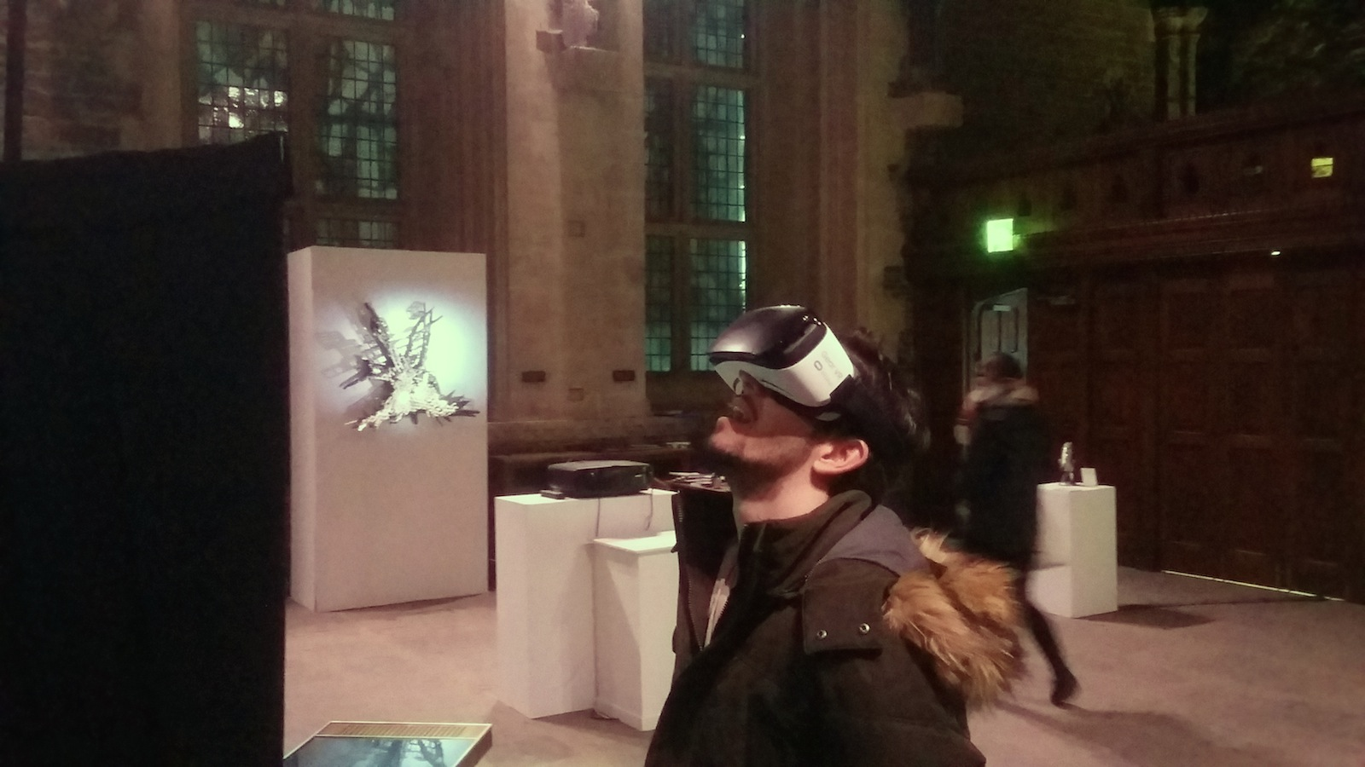
Fig 1.3: The Lumen Prize at Caerphilly Castle, South Wales, in November 2016

The Prize was also able to secure some key figures from the art world as judges, not least Bruce Wands and Douglas Dodds of the Victoria and Albert Museum, who brought together the national collection of Computer Art at the museum and was Senior Curator in this area. Awarding prizes in several areas of endeavor such as Still Image, 3D animation, Interactive, and Virtual Reality, the major prize each year has gone to artists who typify new approaches to digital art.
Carla Rapoport underwrote the Prize from the start and acted as the main promoter, finding venues for the travelling exhibition across the globe. Lumen shows have appeared in Athens, Riga, Shanghai , Amsterdam and New York as part of Creative Tech Week. Whilst it recoups money through the entry fees to the Prize, and receives commissions from festivals and other venues where the show is exhibited, it operates on the small to medium scale with a lean organizational structure.
Throughout this period, Rapoport and her fellow organizers were keen to provide digital audiences to existing arts groups, for enlarging audiences and widening participation. She discovered that digital festivals were often key to this area and participated in several festivals. This brought the prize to the attention of the Onassis Cultural Centre in Athens that staged a major show in November 2014, perhaps the point at which Lumen “broke out” into the wider cultural arena. Since then, the prize has attracted hundreds of applicants each year and provides a good cross-section of the creative works in this area.
Nevertheless, Rapoport remains closely involved, both on a personal and financial level, because she knows it is necessary in order to direct Lumen’s evolution and cannot yet step back because it is at a crucial phase. Between her and Lumen’s assistants, the pressures of assembling and delivering a series of travelling exhibitions is a year-long activity that involves significant investments of time and finance. At present, some of the major outcomes are specific exhibitions in larger museums, rather than selling artwork as with other areas in the art market.
Artist Jack Addis, a graduate of the MA in Digital Art programme under Jonathan Kearney at Camberwell College of Art, became involved with Lumen in 2015. It was in fact through this connection that he helped to produce a Lumen Prize exhibition and Carla Rapoport realized he had a strong skill set in installing the artworks. This skill set came about due to the fact that he had been a gallery technician for various galleries since 2010.
As a technician, the focus of Addis’s work was coordinating the artists and artworks to arrive on time to and to make sure that the exhibition was finished to the best standard it could be. Through his work with Lumen, his role has now developed with a focus on curating and partnership management. In putting on exhibitions of digital art, Addis’s main goal is to create exhibitions or events that are able to reach and inspire wide and diverse audiences, who would not typically go to museums or galleries; all the while trying to set and keep standards of paying artists a fair fee for the labor. He works closely with Lumen's partners to get the best results for our artists in terms of paid opportunities alongside providing skillsets in installing and curating digital art, that in-house teams lack at this time.
The recent exhibition at Eureka! The Children's Museum in Halifax (UK) provides a good case study. As Addis notes:

Lumen presented a wide range of interactive artworks and the young visitors really engaged for a long time learning the quirks or mastering the controls of the artworks on display, spending I would say more time than an adult would interacting with individual artworks. However, if an audience is able to get over the wow factor present in many digital works engagement is usually very strong, and people are keen to learn more. Something I notice is that visitors like to touch and use interactive artworks and if they are not able to 'get' a reaction or interaction immediately they move on to something else. Meaning that the artwork has to 'work', and ideally be robust enough for 100s of users to enjoy. Not that I advocate the dumbing down of an artist's practice to meet an audience - I think it can be a fine balance.

In terms of the issues of transporting and setting up digital artworks across the globe, Addis believes the main issue is that of time differences between venues in different countries. Global coordination is possible, even for a small team of exhibitors, provided they work together using social media. Applications like Team Viewer or Skype mean that an artist who is not able to be physically at the exhibition can still be telepresent from their studio, as their artwork is being installed on the other side of the world.
Addis avers the most important skill is good project management with setting up digital works around the world, and bringing a big bag of adapters! Transporting artworks is again not a huge issue as long as there is time for customs processes, or a local version of an artwork to be made to the artist’s specification.
From his point of view, Lumen is aiming to do more for artists and audiences; to provide a lot more than just gallery or museum type exhibitions. The organization is currently planning commissioned artworks in cultural institutions, large site-specific outdoor public artworks, and residences aimed at working with local communities, all with the twin goals of bringing art and technology to new audiences and supporting the artists making this work.

Conclusion
In the 52 years since “Nine Evenings” launched ‘Art and Technology’ into the public sphere, the area of computer art exhibitions has gone through some significant upswings in fortune as well as periods of near-decline. Had the model for technological art remained that of the corporate-funded blockbuster then the area might have faded into obscurity with the changing cultural climate of the 1970s. However, the emergence of artists and organizers with considerable technical proficiency and an adaptable approach to small venues and new technologies meant that computer-based art shows continued in a variety of settings.
Now there are several organizations at different levels actively promoting digital artists, the area seems more sustainable than previously and as the skills and outputs diversify in a population that is increasingly “born digital” the role of computer-based artworks is gradually entering the mainstream artworld. Although the transition will not be sudden, nor as revolutionary as the original pioneers of digital art hoped, it is gradually changing expectations of the way that art is presented in galleries and museums. Interactive and dynamic works are rapidly becoming an accepted medium and this can only bolster the visibility of computer art.
In this regard, it is notable that the Lumen Prize no longer uses the phrase “digital art” but rather has the strapline “The Global Award for Art and Technology”. [see https://lumenprize.com/] The organisers now believe that the ubiquity of digital devices means that merely referring to “digital art” is no longer sufficient and a more general approach to technology should be highlighted. In this respect, Lumen is returning to the origins of this area with EAT and other groups in the 1960s. This approach is to be welcomed so long as the special characteristics of “computer art” are still recognised.
References
Benthall, J. Technology and Art 20, Studio International, Vol 180, No 928, December 1970
Burnham, J. Art and Technology: The Panacea That Failed. In Woodward, K. The Myths of Information, (Coda Press, 1980)
Computer Arts Society, Interact documentation, 1973 at:
http://www.bbk.ac.uk/hosted/cache/archive/CAS/Interact%20Documents%201973.pdf
Dew, C. An Analysis of Touring Exhibitions Practice in the UK, Economics of Touring Exhibitions Survey Report, Touring Exhibitions Group (TEG), April 2016
Gilchrist, B & Joelson, J. NULL OBJECT: Gustav Metzger thinks about nothing (2012) https://londonfieldworks.com/Project-2-NULL-OBJECT%3A-Gustav-Metzger-thinks-about-nothing
Giloth, C. and Pocock-Williams, L. A Selected Chronology of Computer Art: Exhibitions, Publications, and Technology. In Art Journal, Vol. 49, No. 3, Computers and Art: Issues of Content (Autumn, 1990)
Institute of Contemporary Arts Limited, Report and financial statements for the year ended 31 March 2017, http://apps.charitycommission.gov.uk/Accounts/Ends48/0000236848_AC_20170331_E_C.PDF
Lambert, N. A critical examination of 'computer art' (Unpublished thesis, submitted to University of Oxford, 2003) http://computer-arts-society.com/static/cas/computerartsthesis/index.html
MacGregor, B. Cybernetic Serendipity Revisited. In Gere, C. Brown, P. Mason, C. & Lambert, N. (eds.) White Heat Cold Logic, (MIT 2008)
Mason, C. "The Fortieth Anniversary of Event One at the Royal College of Art", presented at EVA London 2009, http://www.catherinemason.co.uk/pdf/TheFortiethAnniversaryofEventOneEVA09.pdf
Mason, C. Interview with Colin Emmett, A Computer in the Art Room (JJG Publishing, 2008)
McIver Lopes, D. A Philosophy of Computer Art (Routledge, 2010)
Paul, C. Renderings of Digital Art. In Leonardo, Vol. 35, No. 5, Tenth Anniversary New York Digital Salon (2002), pp.471-474+476-484
Prince, P.D. A Brief History of SIGGRAPH Art Exhibitions: Brave New Worlds. In Leonardo, Computer Art in Context Supplemental Issue. (1989)
Reffin-Smith, B. From 0 to 1. In Gere, C. Brown, P. Mason, C. & Lambert, N. (eds.) White Heat Cold Logic, (MIT 2008)
Spice, A. “Ryoji Ikeda premieres mind-bending new A/V artwork test pattern [N°12] at The Store X”, 10th September 2017 https://thevinylfactory.com/news/ryoji-ikeda-new-test-pattern-n12-store-studios/
Vasulka, W. Experiments in Art an Technology. A Brief History and Summary of Major Projects 1966 - 1998. Berkeley Heights: Experiments In Art And Technology (1998)
Wolff, T.F. The computer as artistic collaborator. Shows at IBM Gallery feature computer art and John Sloan works. In Christian Science Monitor May 16, 1988

From author’s interview with Bruce Wands, 20th June 2018
From author’s interview with Bruce Wands, 20th June 2018
Interview with Carla Rapoport at Niio Blog: https://www.niio.com/blog/the-lumen-prize-a-conversation-with-founderdirector-carla-rapoport/
Email interview with Jack Addis, conducted on 20th June 2018.
From interview with Jack Addis, June 20th 2018

